THE HIGH COURT
Record No. 2022/1456 P
BETWEEN:
DAVID EGAN AND SHARON BROWNE AND EMMANUEL LAVERY
Plaintiffs

-And-
MINISTER FOR HEALTH, AN TAOISEACH, AND HSE

Defendants

Affidavit of David Egan

I, Redacted, of Redacted , aged eighteen years and upwards, MAKE OATH and says as follows.
In accordance with the rules of the High Court and the law and the Irish Constitution, and the rules governing Disclosure in court cases, I submit this sworn affidavit to the High Court, the judge and to the opposing party, the defendants.
1. I say the following evidence is submitted as corroboration of and in support of previous evidence and affidavits submitted to the High Court and the defendants.
2. I further say that the Plaintiffs in this case are entering this High Court and presenting this High Court case as living men and women. We are representing the interests of living men and women and children, including families, who are the people of Ireland as defined in the Irish Constitution of 1937. And as such we are entitled to the protections, rights and privileges offered by this Constitution including the right to have our case heard in court free of obstacles and obstructions including use of the weapon of Costs to deprive us and the people of Ireland of justice under law and a fair trial in courts. It is the lives of living men, women and children which are being put at risk of death and serious illness or disability from these covid19 vaccines which is the issue in this court case.
The Irish Constitution of 1937 has stated that the rights of living men, women and children which encompasses family, are ‘inalienable and imprescriptible rights, antecedent and superior to all positive law’ and our High Court case involves these particular rights and breaches of these rights by the government, Department of Health and HSE. And there are also breaches of Articles 40 to 44 of the Constitution which deal with Fundamental rights including the right to informed consent and bodily integrity. The Irish Constitution states clearly that the people of Ireland are sovereign and supreme and the government, the Ministers, the Department of Health and HSE are the servants of the people of Ireland. These servants of the people should be serving the people and this includes being fully accountable to the people, providing Full Disclosure to the people, and exercising their duty of care to the people. Serving the people does not mean Non Disclosure and withholding vital and important information about a new and experimental vaccine which was not properly tested for safety (proper safety tests take 4 – 5 years) and is still in Phase 3 trial, and depriving them of full decision making and full and valid informed consent, thus exposing the Irish people to serious injuries, illnesses, disabilities and premature deaths, which is now the case all over Ireland. This is evidenced in the large rise in excess mortality after mass covid19 vaccinations from mid 2021 onwards and the worst hospital crisis in Irish history in 2022 and into 2023. This is NOT serving the people of Ireland. It is the exact opposite. That’s why we are here in the High Court with this legal case.
And serving the people does not mean covering up the aforementioned activities and harms caused by the experimental vaccines / boosters and refusing to carry out Coroners Inquests and autopsies into this, and deceiving the Irish people and using the press and media to fuel this deception. And misusing the press and media to repeat the false mantra that the vaccines and boosters are “safe and effective”. This is not serving the people of Ireland. The courts must differentiate the great difference between serving the people of Ireland as defined in the Irish Constitution and serving vested interests including powerful foreign interests and conflicts of interest which are part of that.

These Constitutional ‘inalienable and imprescriptible rights, antecedent and superior to all positive law’ and Fundamental rights under Articles 40 to 44 of the Constitution including the right to informed consent and bodily integrity are highly protected rights which should not have been interfered with and undermined by certain politicians and senior civil servants in the context of unscientific and unnecessary lockdowns which have imposed massive human costs and economic costs and experimental vaccines which have proven to be unsafe and ineffective and caused premature deaths, serious illnesses and disabilities for living men, women and children including families around Ireland. This High Court must address and resolve through Injunctions and other remedies the serious breaches of these rights. As many deaths of living men and women and children have resulted from these covid19 vaccinations and boosters, we ask that the High Court give this case the highest priority of all. And that this includes the hearing of this case outside normal court hours and normal working days, to include Saturdays and Sundays. This is of the first order of magnitude and must take precedence over every other case before the High Court.

This case is being taken by living men and women and represents the interests of all living men, women and children in Ireland. We ask that the High Court remove all presumptions of “person” or artificial person or the living man or woman as a “corporation”, or “dead to the court” or “dead at sea” or “lost at sea” in relation to the Plaintiffs and the living men, women and children whose interests we represent in this court case and to acknowledge that living men and women are Plaintiffs before the High Court seeking to protect the lives and well being of all living men, women and children including families in Ireland. And that deaths and serious illnesses will continue to result from a failure of the courts to institute such protections for the general public as advised by the Plaintiffs. And that courts have always viewed death or deaths as very serious and worthy of court actions, including injunctions, in the past and present. And that the disabling of living men, women and children and families by vaccines is also seen as serious by the courts and worthy of remedy by the court.
2a. I further say that that the aforementioned ‘inalienable and imprescriptible rights, antecedent and superior to all positive law’ and the Fundamental rights under Articles 40 to 44 in the Irish Constitution and breaches of these important rights and other Constitutional rights are the basis of this High Court case, and this qualifies this case as a Public Interest case and qualifies it for a Protective Costs order in the High Court. Other grounds for granting Protective Costs in this case involve breaches of international Human Rights laws, Irish laws and EU laws and international laws and treaties which adversely affect or damage the Common Good and the Public Interest in Ireland and are cited in the previous two affidavits filed in the High Court in November and December 2022.
Furthermore, The Coroner for Mayo, Mr. Patrick O’Connor has described the sudden and unexpected death of a healthy 14 year old boy in Mayo, shortly after getting a covid19 vaccination as an issue of ‘significant public concern’ at the opening of the inquest in November 2022. The issues in this court case revolve around sudden and unexpected deaths of covid19 vaccinated people and the sudden onset of serious illnesses and disabilities after covid19 vaccinations and the role of full and valid informed consent in this, and this is of significant public concern and involves the Public Interest. This is a Public Interest case and qualifies for a Protective Costs Order.
The HSE and Minister for Health and Department of Health do not wish to address the scientific, medical, autopsy, and statistical facts and evidence in court and the denial or deprivation of full and valid Informed Consent for those who are vaccinated or considering vaccination but are relying on using the weapon of Costs to deny us Protective Costs in court and deprive us of justice under law and a fair hearing in the High Court. The facts and evidence in this affidavit and our other affidavits and books of evidence clearly show that this is a Public Interest case and involves the Common Good and Public Interest and it clearly and unequivocally qualifies for a Protective Costs order. This attempt to deny us Protective Costs, and the use of costs as a weapon to deny justice and a fair hearing in court, is a breach of the Irish Constitution of 1937 and Article 6 of the European Convention on Human Rights and are breaches of other national and international laws as outlined in my affidavit filed with the court in November 2022. The state parties have the use of millions or billions of euros of taxpayer’s money to fight such cases in court and deprive the people of Ireland and the nation of Ireland of justice under law and a fair hearing under law.

The High Court can remedy this by granting us a Protective Costs order so that this case can proceed in court.
3. I say that a recent published scientific study stating that informed consent was not being given by covid19 vaccine recipients as vital information was and is being withheld from them and the general public and this is very relevant to our court case.
This corroborates our other evidence in the books of evidence and sworn affidavits and exhibits.

Informed consent disclosure to vaccine trial subjects of risk of COVID-19 vaccines worsening clinical disease
Cardozo et al. 2021. Int J Clin Pract
https://pubmed.ncbi.nlm.nih.gov/33113270/
Conclusions drawn from the study and clinical implications: The specific and significant COVID-19 risk of ADE should have been and should be prominently and independently disclosed to research subjects currently in vaccine trials, as well as those being recruited for the trials and future patients after vaccine approval, in order to meet the medical ethics standard of patient comprehension for informed consent.

4. I further say there is one other important court precedent regarding informed consent which applies in our high court case. We are adding this legal precedent to the existing precedents cited in our previous affidavits. The case of Canterbury v. Spence (464 F.2d. 772, 782 D.C. Cir. 1972) in the USA was a landmark federal case decided by the United States Court of Appeals for the District of Columbia Circuit that significantly reshaped malpractice law in the United States and internationally. It established the idea of "informed consent" to medical procedures. The major legal implication of the decision was that it largely shifted the culture from a ‘professional practice standard’ to a ‘reasonable person standard’ in malpractice cases. This was a very similar verdict to that of Montgomery vs Lanarkshire Health Board in the Supreme Court in the UK in 2015. Both courts used the ‘reasonable person standard’ and what a reasonable person felt was important and significant in terms of disclosure by the medical professional. Both cases are relevant to our High court case as there has been non disclosure of the material risks and dangers of covid19 vaccines, and the results have been catastrophic for many vaccinated people and their families.

A recent court case in the USA, illustrates this point. Donna and Dennis Lawhead sued Dr. Jan Paul Muizelaar and the UC Regents for medical malpractice in the Superior Court in California. The Lawheads also alleged dependent adult abuse, battery, fraud, negligent misrepresentation and loss of consortium.
The surgeon was successfully sued and removed from his position at UC Davis for non disclosure of important and significant information to the patient. News report below
https://www.courthousenews.com/uc-regents-face-big-problems-from-doc
and https://web.archive.org/web/20160202041826/http://www.sacbee.com/news/investigations/article2578591.html
4a. I say that a recent judgment of the Supreme Court of New York in the USA has created a precedent which is very relevant to our High Court case. In a groundbreaking ruling, the New York State Supreme Court on January 13 2023, struck down the state’s COVID-19 vaccine mandate for healthcare workers, declaring it “null, void, and of no effect” and holding that the New York State Department of Health (NYSDOH) lacked the authority to impose the mandate. Moreover, the court ruled that the state’s mandate was “arbitrary and capricious” on the basis that COVID-19 vaccines do not stop transmission of the virus, thereby eliminating any rational basis for such a policy. This is one of the reasons we gave for why full informed consent was not and still is not being given and is one of several reasons given for our request for an Injunction in the High Court. And is also one of the grounds for fraud which we are pleading in this High court case and are an additional reason for this Injunction. By fraud, we mean that informed consent was and is being obtained by fraud and deception.
This Supreme Court ruling in New York is a victory for Freedom, Democracy, Scientific Truth and Honesty, Human Rights and the Rule of Law. It has set an important precedent for courts all over the USA and all over the world including in Ireland.
News report: https://childrenshealthdefense.org/defender/chd-win-new-york-covid-vaccine-mandate/
4b. I say that scientists and medical doctors and legal personnel representing the HSE and Department of Health and the Taoiseach have presumed to question my scientific knowledge in their affidavits. I merely present the scientific, medical, statistical and autopsy facts and evidence from around the world to support my case in court. I do this without conflicts of interest. I have expert witnesses, including top medical doctors, scientists, cardiologists, oncologists, professors, pathologists, embalmers and medical professionals who are supporting me in this court case and who can corroborate what I have stated in the affidavits and books of evidence. I have seen that the other parties have failed to present honest and accurate reports of the dangers and ineffectiveness of these covid19 vaccines and their obvious Non Disclosure of this to the general public including parents and guardians which has completely undermined and deprived people of full and valid informed consent and placed lives in danger. And Non Dislcosure of their own conflicts of interest. I would strongly suggest that they rectify their own shortcomings in these matters.
5. While on the subject of scientific and statistical evidence, I say that in Exhibit 30 which I present to the court, the CSO statistics for Ireland for 2020 and 2021 show a mere 1% increase in mortality in 2020 compared to 2019 and a 3% increase in excess mortality in 2020. This did not indicate a pandemic where large numbers of people were dying. In contrast, 2021 had a 4% increase in mortality compared to 2020 and a 6% increase in excess mortality. The indications so far for the year 2022 show a large double digit rise in excess mortality in 2022. This is being termed a ‘Pandemic of covid vaccine deaths’. We present evidence of this in sections below.
The CSO statistics show that 2021 the year of mass covid19 vaccinations were worse for deaths than 2020 the year of the pandemic ! and new statistics being released by the CSO and GRO in 2022 shows that mortality is much higher in 2022 than in 2021 and 2020. The statistical and scientific evidence points towards a ‘Pandemic of vaccine deaths and illnesses’ in 2022 and into 2023. This was not explained to parents and guardians of children, yet it was and is vital to the obtaining of full and valid informed consent.
I further say that the covid19 numbers and deaths were over-inflated in Ireland and in other countries, and the risk from covid19 was greatly exaggerated, overstated, and over-blown in order to create mass fear and panic and sell covid19 vaccines. The testimony of a leading NHS director and doctor states that patients being admitted and dying with very common conditions such as Old Age, Myocardial Infarctions, End Stage Kidney Failure, Haemorrhages, Strokes, COPD & Cancer etc were all now being certified as Covid-19 via the Medical Examiner System. Hospitals were financially incentivised to report Covid-19 deaths over normal deaths, as the government was paying hospitals additional money for every Covid-19 death that was being reported.
Source: https://nakedemperor.substack.com/p/insider-reveals-truth-about-covid
And evidence presented below in this affidavit shows that only 3.5% of all covid19 deaths were deaths from covid19 only and with no other co-morbidities in Britain. And that similar mislabeling occurred in Ireland and in the USA and some other countries.
I refer to Point 32, page 115, in the previous affidavit filed in the High Court in December 2022
‘I have already mentioned the Infection Fatality rates earlier which show it was equivalent to a flu season which we have had for hundreds of years. The CSO figures in Ireland now show that a total of 183 deaths (or 3.4%) reported Covid-19 as the single cause of death. While 5,201 (or almost 97%) of deaths with Covid-19 were certified as having had Covid-19 with at least two other medical conditions on the death certificate. Four in five deaths from Covid-19 had at least three medical conditions mentioned on the death record with 4.2 conditions being the average per person according to the CSO data release. The mean or average age of death was 82 years old and the median was 84 for the year 2020. The vast majority of deaths were over 73 years old and had co-existing illnesses. Most would have died in 2020 or 2021 even if covid19 never existed.
Source: CSO and Journal.ie, https://www.thejournal.ie/covid-deaths-pneumonia-conditions-5841803-Aug2022/ .’
This was not explained to vaccine recipients and the general public, thus depriving them of full and valid informed consent for the vaccine. This was not explained to parents and guardians of children, yet it was and is vital to the obtaining of full and valid informed consent for the vaccine.

An article in the Wall Street Journal on December 20th 2020 outlined the central role that medical mistakes, errors and incompetence played in the high numbers of covid19 deaths
Hospitals Retreat From Early Covid Treatment and Return to Basics
Wall Street Journal. December 20th 2020
https://www.wsj.com/articles/hospitals-retreat-from-early-covid-treatment-and-return-to-basics-11608491436

I further say that evidence in book of evidence number 1 and other books of evidence show that bad medical practices and medical mistakes, errors, and incompetence in hospitals and the refusal to provide early treatment for covid19 using medicines such as Ivermectin, Hydroxychloroquine, Tyson and Fareed protocol or the Zelenko protocol and levels of high Vitamin D caused over 50% of the deaths of covid19 patients. This is confirmed by top medical doctors including Dr. Peter McCullough and Dr. Pierre Kory and his front line doctors alliance and many other medical doctors and scientists referenced in our books of evidence. This led to the high number of covid19 deaths in Ireland and many other countries. Another factor is that hospitals were given grants or financial incentives involving a lot of money to classify patients as covid19 patients, put them on ventilators and use sedatives whether or not they needed these treatments (which caused deaths in over 50% of cases), give them remdesivir (which killed people), and directly or indirectly cause the deaths of “covid19” patients or classify deaths regardless of cause as “covid19”. These were Perverse Incentives which actually increased the number of deaths labeled as “covid19 deaths”. This over estimate of covid19 cases and deaths also created mass panic and paranoia fuelled by the press and media and an artificial demand and desperation for covid19 vaccines and vast profit potential for certain parties.
This was not explained to vaccine recipients and the general public, thus depriving them of full and valid informed consent for the vaccine. This was not explained to parents and guardians of children, yet it was and is vital to the obtaining of full and valid informed consent for the vaccine.

5a. I say the risk of dying from covid19 for certain age groups is presented below. These are taken from official CSO statistics in Ireland.
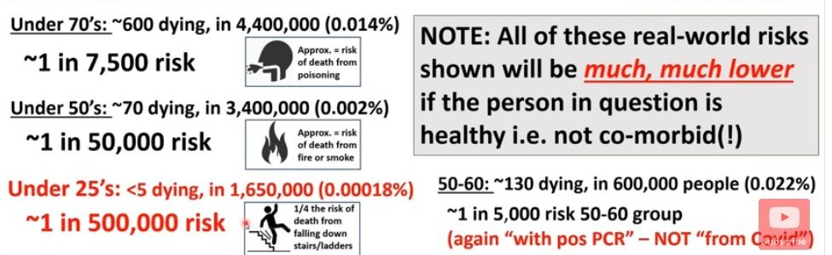

The risk for children and young adults who are under 25 is 1 in 1,650,000 or 0.00018%. Studies abroad found that the risk for those persons under 18 is 1 per 2 million. So there is a correlation between Ireland and international figures. The risk for children aged 5 to 11 is smaller again and would be 1 in 3 million. This is smaller than colds and flus. This was not explained to parents and guardians of children, yet it was and is vital to the obtaining of full and valid informed consent. This corroborates what we have stated in previous affidavits and books of evidence that full and valid informed consent has not been given for these covid19 vaccines.
5b. I say that there is more corroborating evidence showing that covid19 poses no significant risk to children
Published scientific studies show that children have a very tiny risk of dying from covid19, at about
1 per 2 million. And this risk is even lower for those children who get early medical treatment with Ivermectin, Hydroxychloroquine, Tyson and Fareed protocol or the Zelenko protocol. And medical and dietary and lifestyle changes to strengthen natural immunity reduces this risk further. The risk is zero or is very near zero when early treatment is used for this low risk category. Dr. Pierre Kory, one of our expert witnesses, can confirm this fact to the court.
And it is very rare for children to end up in ICU, the evidence shows that flu poses a great danger to children in this regard. There were only 3 deaths in children and young people under 20 who didn’t have an underlying health condition in Britain according to an FOI request by Professor Norman Fenton to the Office for National Statistics in November 2022. And only 3.5% of all covid19 deaths were deaths from covid19 only and with no other co-morbidities in Britain.
Source: https://www.ons.gov.uk/aboutus/transparencyandgovernance/freedomofinformationfoi/covid19deathsandautopsiesfeb2020todec2021
and
https://dailysceptic.org/2022/12/15/hold-the-front-page-the-world-wakes-up-to-what-sceptics-knew-all-along/
Scientific studies showing that covid19 poses no significant risk to children listed below:

Risk factors for intensive care admission and death amongst children and young people admitted to hospital with COVID-19 and PIMS-TS in England during the first pandemic year
Ward et al. 2021. Nature Medicine
https://www.medrxiv.org/content/10.1101/2021.07.01.21259785v1

Deaths in Children and Young People in England following SARS-CoV-2 infection during the first pandemic year: a national study using linked mandatory child death reporting data
Smith et al. 2021. Nature Medicine
https://www.medrxiv.org/content/10.1101/2021.07.07.21259779v1

Which children and young people are at higher risk of severe disease and death after SARS-CoV-2 infection: a systematic review and individual patient meta-analysis
Harwood et al. 2021. eClinicalMedicine
https://www.medrxiv.org/content/10.1101/2021.06.30.21259763v1

News report about this published in Nature
https://www.nature.com/articles/d41586-021-01897-w#ref-CR1
5c. I say that a censored scientific study shows risks of the vaccine are far greater than benefits for children.

Why are we vaccinating children against COVID-19
Kostoff et al. 2021
https://www.sciencedirect.com/science/article/pii/S221475002100161X

ABSTRACT
This article examines issues related to COVID-19 inoculations for children. The bulk of the official COVID-19- attributed deaths per capita occur in the elderly with high comorbidities, and the COVID-19 attributed deaths per capita are negligible in children. The bulk of the normalized post-inoculation deaths also occur in the elderly with high comorbidities, while the normalized post-inoculation deaths are small, but not negligible, in children. Clinical trials for these inoculations were very short-term (a few months), had samples not representative of the total population, and for adolescents/children, had poor predictive power because of their small size. Further, the clinical trials did not address changes in biomarkers that could serve as early warning indicators of elevated predisposition to serious diseases. Most importantly, the clinical trials did not address long-term effects that, if serious, would be borne by children/adolescents for potentially decades. A novel best-case scenario cost-benefit analysis showed very conservatively that there are five times the number of deaths attributable to each inoculation vs those attributable to COVID-19 in the most vulnerable 65+ demographic. The risk of death from COVID-19 decreases drastically as age decreases, and the longer-term effects of the inoculations on lower age groups will increase their risk-benefit ratio, perhaps substantially.
I further say that censorship of science is illegal, unlawful, unConstitutional and anti science and fundamentally corrupt.
5d. I say that the Cost-Benefit Analysis for covid19 vaccines and boosters for children, under 18, shows that the vaccines and boosters have far more costs than benefits for children. And that this should be a major consideration point for the High Court in its decision on an Injunction.
Risk from Covid19 vaccines
- Risk of serious adverse event including death from the covid19 vaccine / booster: 1 in 800 or 1,250 per million according to a published peer reviewed scientific study. This is higher than previous vaccines in the past. And the numbers for serious illnesses, disabilities and deaths are much higher. This is verified from reports from government databases such as VAERS and many others worldwide and scientific studies about this have been provided in previous affidavits and in our books of evidence. More scientific studies about this are included later in this affidavit. And also verified from Pfizer’s own internal documents released under court order in the USA in 2022.
- Risk of myocarditis or pericarditis or late gadolinium enhancement or serious heart inflammation and illnesses : ranging from 23,000 per million to 1 per 1,000 (1,000 per million) according to published scientific studies. These figures could be higher according to more recent scientific studies.
In one recent scientific study, 100% of covid19 vaccinated children had late gadolinium enhancement.
Source: Admission and follow-up cardiac magnetic resonance imaging findings in BNT162b2 Vaccine-Related myocarditis in adolescents
Ozen et al. 2022
In another scientific study, 763 students (17.1%) had at least one cardiac symptom after the second vaccine dose, mostly chest pain and palpitations
Source: https://link.springer.com/article/10.1007/s00431-022-04786-0
Scientific studies about this have been provided in previous affidavits and in our books of evidence. More scientific studies about this are included later in this affidavit. In Ireland, the health authorities did not bother to check for this in covid19 vaccinated children and adults. This is evidence of serious neglect and of failure in their duty of care to the public. They should have included that fact in the documentation they sent to our legal team for this High Court case.
- CDC Study found 49% of Children Ages 5 to 11 Experienced Systemic Reactions After Getting the New COVID Booster. Of 3,259 children in the age group who received an updated Pfizer or Moderna vaccine and were registered in the v-safe system, nearly half experienced a systemic reaction, CDC researchers found. Seven hundred and two children experienced a health impact, such as being unable to attend school or being unable to perform “normal daily activities.”
Sources: https://www.cdc.gov/mmwr/volumes/72/wr/mm7202a5.htm
News report: https://childrenshealthdefense.org/defender/cdc-children-systemic-reactions-covid-booster-et/
- Higher risk of excess mortality as verified in official statistics provided in this affidavit and the previous affidavit filed in the High Court. This includes the massive rise in “sudden deaths” from mid 2021 to the present, 2023.
- I refer the court to Points 6a., 6b., and 7. of this affidavit which provides shocking official statistical evidence of a big rise in excess mortality for children after mass covid19 vaccinations of children starting in mid 2021.

- The evidence in this affidavit and previous affidavits and in our books of evidence and in published scientific studies and reports worldwide show that these vaccines and boosters are a losing all effectiveness after 5 months due to vaccine induced mutations, immune priming and antibody dependent enhancement. I cite part of Point 58 of this affidavit
‘ 58. I say that new scientific evidence corroborates our existing evidence and clearly shows that the covid19 vaccines lose all effectiveness after 5 months. Vaccines and boosters are losing effectiveness after 3 months and all effectiveness after 5 months due to vaccine induced mutations which create newer variants, immune priming and antibody dependent enhancement. And that the Ineffectiveness of covid19 vaccines is also based on use of the outdated Wuhan strain of 2020 in vaccines and the use of outdated strains in boosters as the virus keeps mutating including mutating to escape the vaccines and boosters. All of these factors created Negative Effectiveness for covid19 vaccines and boosters, which means they increase one’s risk of getting infected. This is Basic Science. All time peak infections occurred after mass vaccination. A total failure for the vaccine and boosters and glaringly obvious.’
Against
Risks from covid19 infection
- Risk of dying of covid9 infection for children: no child in Ireland died of covid19 during the pandemic according to the CSO. The risk for children and young adults who are under 25 is 1 in 1,650,000 or 0.00018%. Studies abroad found that the risk for those persons under 18 is 1 per 2 million or 0.5 per million. So there is a there is correlation between Ireland and international figures. The risk for children aged 5 to 11 is smaller again and would be 1 in 3 million. This is smaller than colds and flus. According to Dr. John Ioannidis the risk for under 19 year olds is 0.0003%
And this risk is much lower for those children who get early medical treatment with Ivermectin, Hydroxychloroquine, the Tyson and Fareed protocol or the Zelenko protocol. Deliberately depriving people of these medicines increased the risk of death for all age groups. These medical drugs also promote natural immunity to eliminate covid19 from the body. The risk is zero or is very near zero when this early treatment is used for children. Dr. Pierre Kory, one of our expert witnesses, can confirm this fact to the court.

- Aforementioned medical treatments accompanied by dietary, vitamin, and lifestyle changes to strengthen natural immunity is also a factor. For example, being obese and having diabetes gives one a higher risk of dying of viral infections, bacteria infections, cancers and cardiovascular death. This dietary, vitamin and lifestyle factor is in fact the highest risk factor of all for these type of deaths but has been and is being ignored by medical doctors, the medical council and the government and health authorities in Ireland and in other developed countries. This is a significant failure and places the general public at great risk. Ignoring a problem does not make it go away.
The risk reduction promoted above also applies to all other age groups. Many scientific studies have shown that natural immunity was and is superior to covid vaccine induced immunity, and these listed in previous affidavits and our books of evidence. T cell memory and immune system memory derived from naturally defeating an infection can last for over 90 years according to scientific studies.
- The Omicron variant and BA variants and XBB variants are weaker and less threatening than previous variants. The Omicron variant was highly infectious and infected almost everybody on earth and acted as an immunization agent against covid19, giving nearly everybody natural immunity against covid19. Scientific studies cited in our affidavits and books of evidence show that natural immunity is superior to vaccine induced immunity. This reduces the risk factor for children down further, by a factor of 3 or more. Variants continue to be similarly weak, as sars-cov2 has reached the endemic phase, which occurs with all epidemics. Unfortunately, the covid19 vaccines are generating new mutations and variants which can escape the vaccine. This is scientifically known as antibody dependent enhancement or immune priming and is well known to science and medicine. The scientific evidence shows that the vaccines and boosters can increase one’s risk of being infected with these variants (vaccine induced mutations). It is scientifically possible that constant vaccinations and boosters could initiate a new mutation which is deadly and could kill high numbers of people.
- Natural immunity in children is far stronger than in adults. Natural Immunity has been proven to be superior to covid19 vaccine induced immunity according to hundreds of published scientific studies.
I cite the Brownstone web site which has listed
150 scientific studies proving that natural immunity is superior to vaccine induced immunity as regards covid19. The title is ‘150 Plus Research Studies Affirm Naturally Acquired Immunity to Covid-19:’
https://brownstone.org/articles/79-research-studies-affirm-naturally-acquired-immunity-to-covid-19-documented-linked-and-quoted/
Scientific studies cited in this affidavit and previous affidavits and in our books of evidence confirm these facts. And a recent article in the Washington Post referenced many scientific studies showing that natural immunity is superior to covid19 vaccine induced immunity
Natural immunity to covid is powerful. Policymakers seem afraid to say so.
Washington Post. September 15 2021
https://www.washingtonpost.com/outlook/2021/09/15/natural-immunity-vaccine-mandate/
The evidence clearly shows that the costs exceed the benefits. But, these facts may interfere with the profit and financial motives of vaccine companies and politicians, doctors, scientists and senior civil servants who have serious conflicts of interest, and abuse their powers.
This was not explained to vaccine recipients and the general public, thus depriving them of full and valid informed consent for the vaccine. This was not explained to parents and guardians of children, yet it was and is vital to the obtaining of full and valid informed consent for the vaccine.

6. I say that this High Court case revolves around the covid19 vaccinations of children. In Ireland, Britain and Europe the Pfizer covid19 vaccine has been and is being offered to children. The following statistics show a sudden, unexpected and large rise in excess mortality for children aged 0 to 14 years old after covid19 vaccinations began for this group after week 21 in 2021. Excess Mortality goes from negative figures to positive figures and keeps rising after covid19 vaccinations of children. The High Court must address this point and the fact that this vitally important information has been concealed and hidden from the parents and guardians of children in Ireland and throughout the European Union. I attach charts from EuroMomo the official statistics body for the European Union and European bodies.

Prior to covid19 vaccinations of children
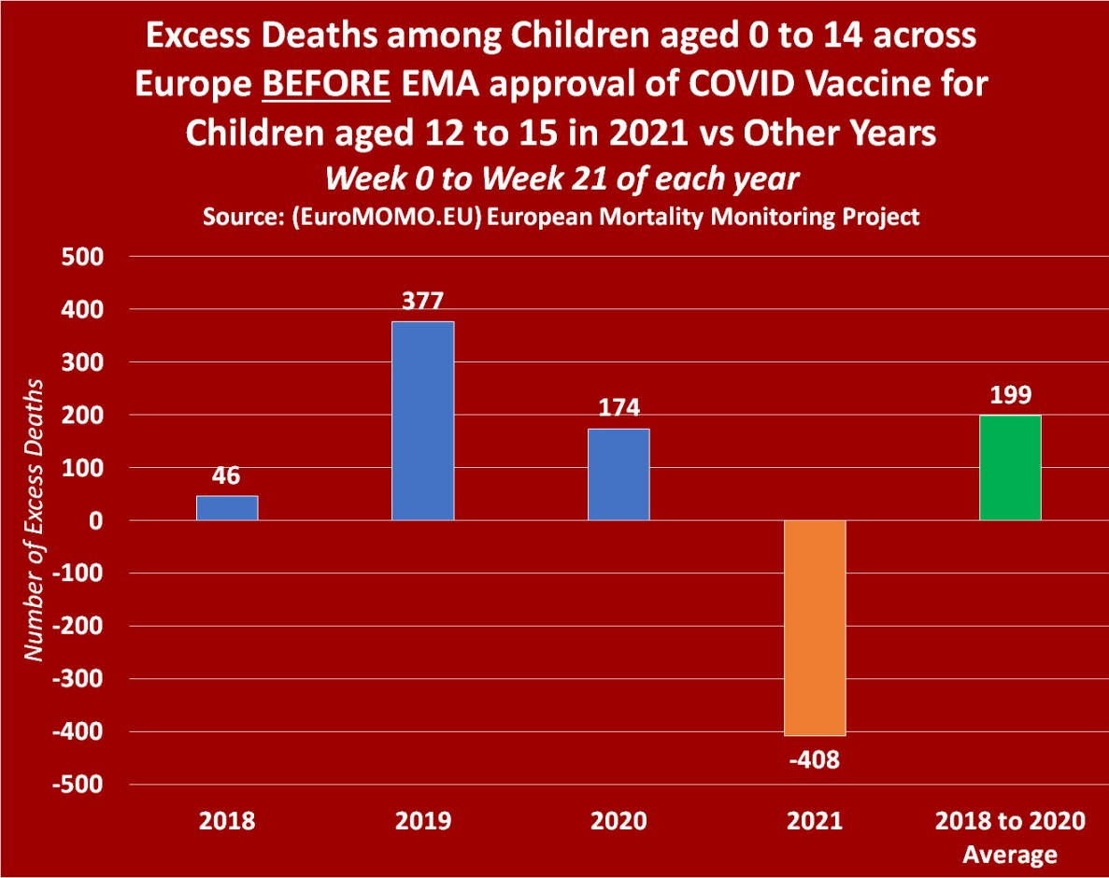

After covid19 vaccinations of children
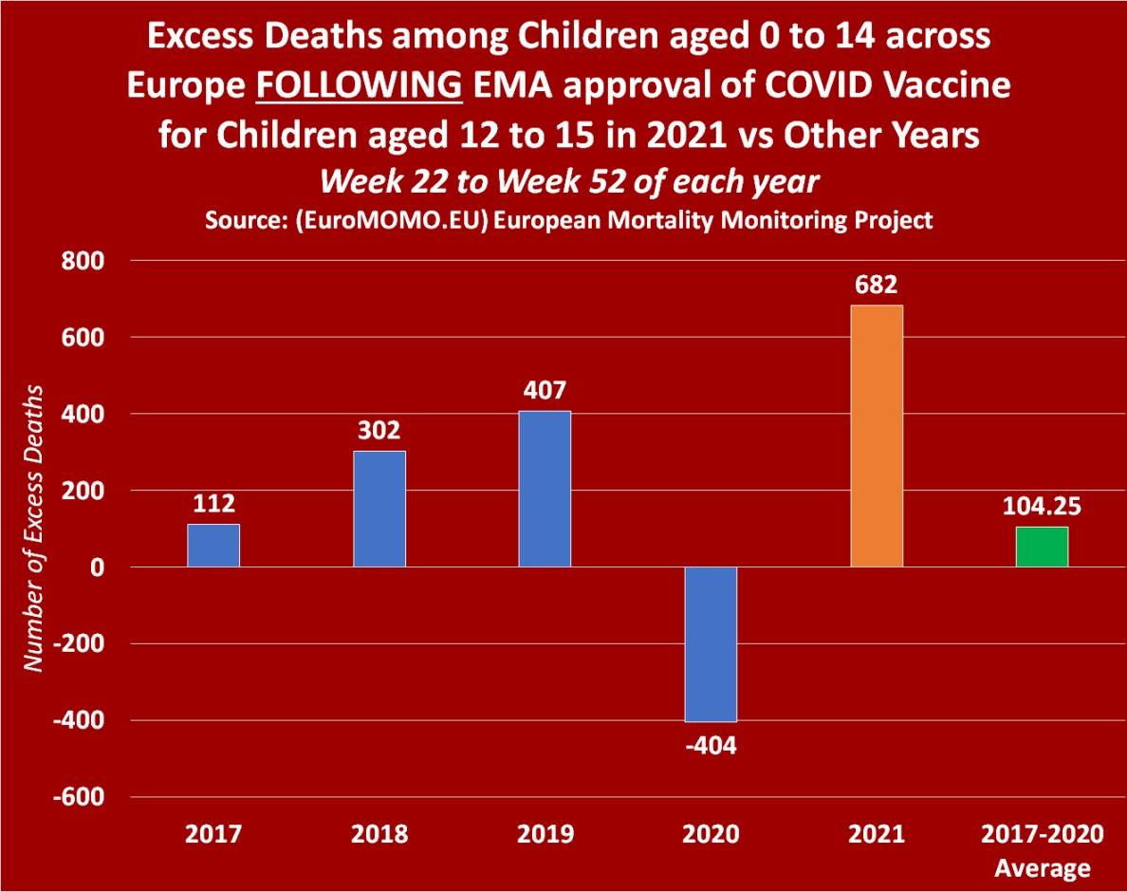
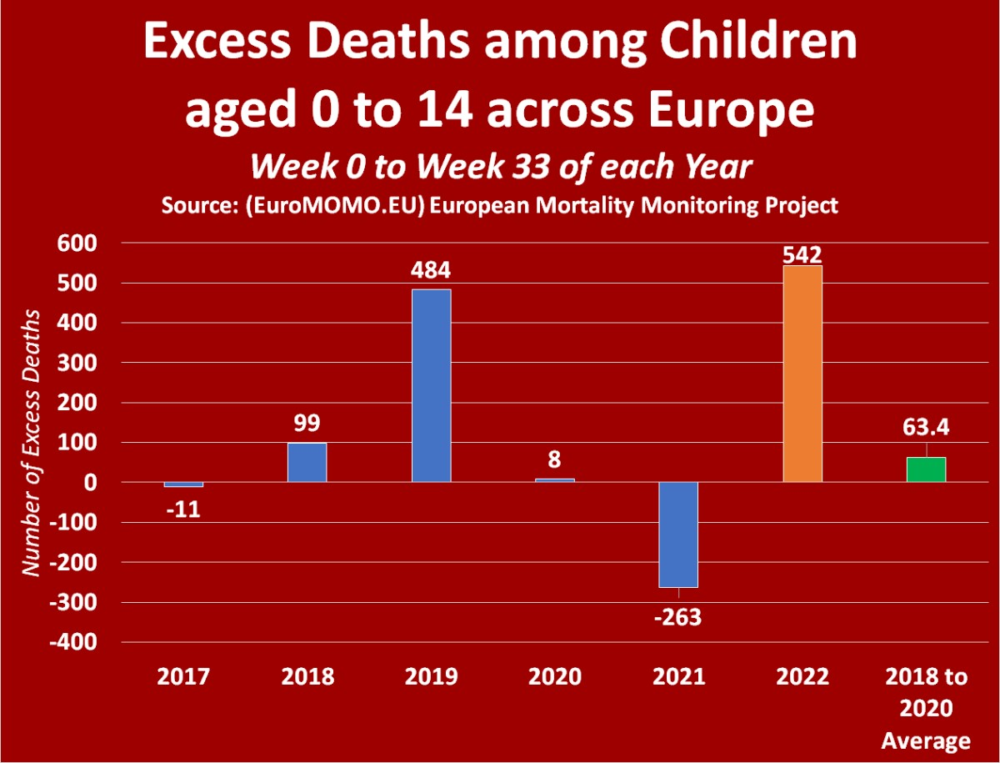
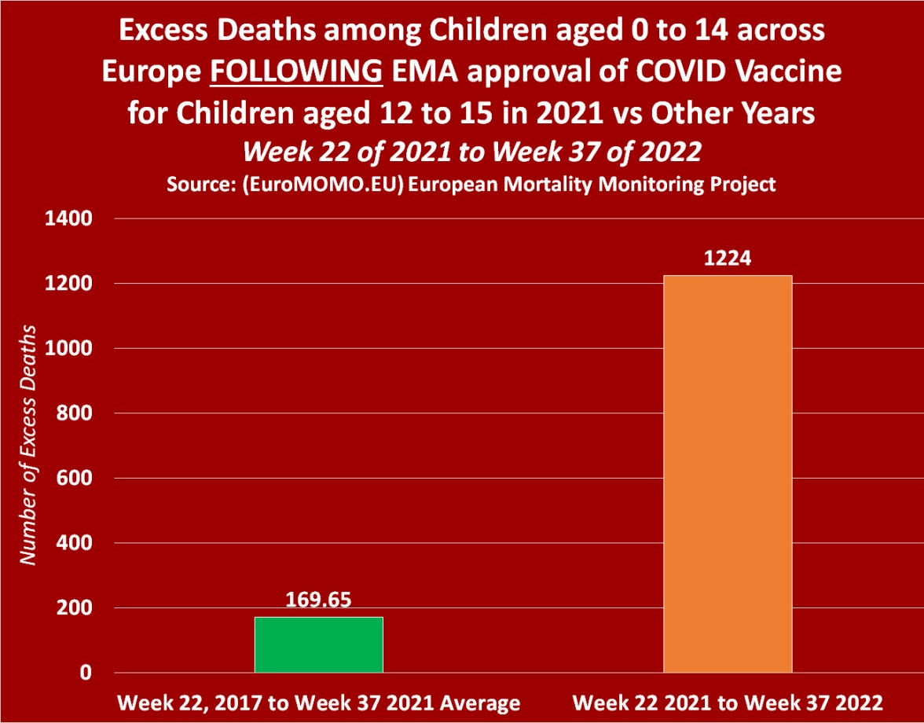
Sources: Euromomo https://www.euromomo.eu/graphs-and-maps
This is shocking and deeply disturbing. This is of the utmost seriousness to the Irish people and nation and should not continue to be ignored by the government and health authorities.

I also refer the court to Exhibit 30a which are charts from Euromomo which show a big rise in excess mortality for all age groups in the European Union from mid 2021 to the present in 2023 which correspond to mass covid19 vaccinations. And in the second chart and third chart the rise in Excess Mortality for children aged 0 to 14 years old was negative until mid 2021, and begins to rise after that when covid19 vaccinations for children began and continues to rise and rise as more children get vaccinated and this excess mortality has continued for all of 2022 and into 2023. Excess morality for children has corresponded to mass covid19 vaccinations for children in Europe.
Source: https://www.euromomo.eu/
6a. I further say that In Ireland, Britain and Europe the Pfizer covid19 vaccine has been and is being offered to children. I further say that in respect of Exhibit 4c referenced in the last affidavit filed in the High Court in December 2022 provided statistical charts of data from the Office for National Statistics in Britain which showed that covid19 vaccinated children are dying at far higher rates than unvaccinated children. We need to quantify this and look at All Cause Mortality for the vaccinated and unvaccinated.
- For those who get their two does of the covid19 vaccine they are dying at over 15 times the rate of unvaccinated children. This is all cause mortality.
- For those who are triple vaccinated they are dying at over 45 times the rate of unvaccinated children. This is all cause mortality. And they are 120 times more likely to die of covid19.
Other Data from the Office for National Statistics in Britain up to march 31st 2022, shows that fully covid vaccinated children are dying at 80 times the rate of unvaccinated children. This is all cause mortality. And they are 300 times more likely to die of covid19. The same Pfizer covid19 vaccine is being used in Ireland and Britain for children. These statistics are presented in Exhibit 66 for the court.
Source:https://web.archive.org/web/20220524192354/https://www.ons.gov.uk/peoplepopulationandcommunity/birthsdeathsandmarriages/deaths/datasets/deathsbyvaccinationstatusengland
andhttps://www.ons.gov.uk/file?uri=%2fpeoplepopulationandcommunity%2fbirthsdeathsandmarriages%2fdeaths%2fdatasets%2fdeathsbyvaccinationstatusengland%2fdeathsoccurringbetween1january2021and31march2022/referencetable20220516accessible.xlsx
and some statistical analysis of the data on
https://expose-news.com/2022/05/20/kids-death-risk-increases-8100percent-covid-vaccination/
This is mass killing of children. This is illegal, unlawful, unethical and unConstitutional both in Britain and in Ireland. Parents and guardians should have been told about this but were not told. This is not full and valid informed consent. This is the illegal gaining of informed consent through fraud and deception. I ask the High Court to act immediately and decisively on this.

6b. I further say that the following statistical graph from CDC data in the USA provides great insight into the role of covid19 vaccinations. There is a large rise in excess mortality for children and young adults between the ages of 0 to 44 from mid 2021 when mass covid19 vaccinations began. This continued into 2022.
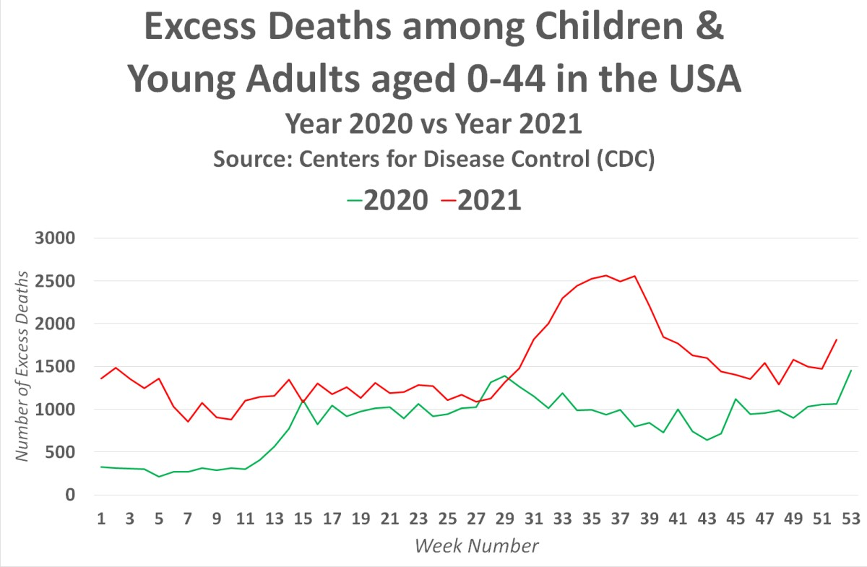
6c. I further say that more and more evidence is coming in worldwide of children developing myocarditis or pericarditis or heart abnormalities after getting the covid19 vaccinations and this is accompanied by more news of sudden deaths of young children shortly after receiving this vaccination. The following news article from Canada process this point.
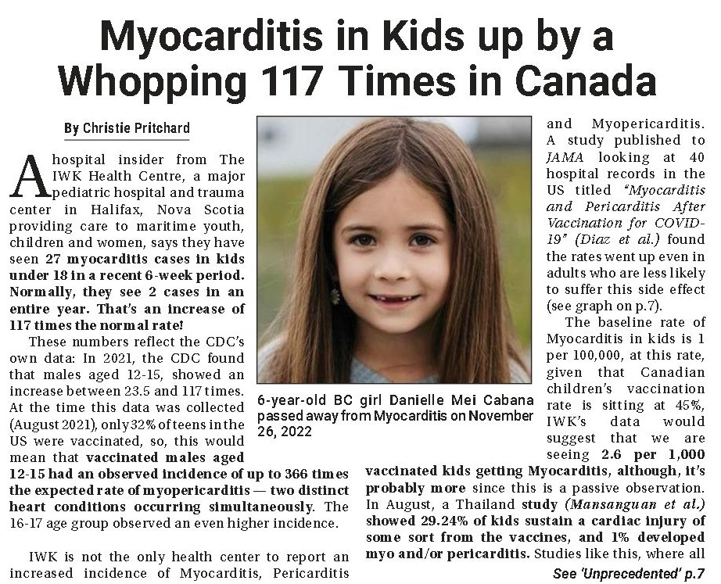
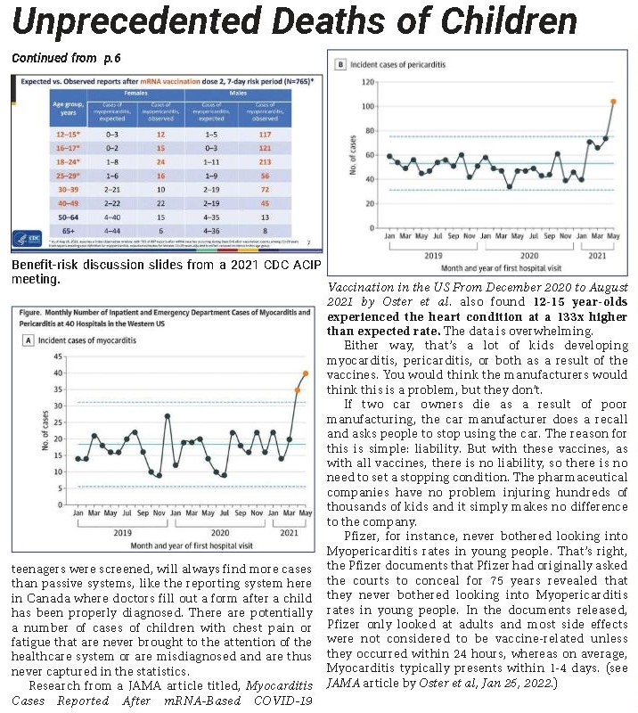
Source: Druthers newspaper, https://druthers.net/wp-content/uploads/2023/01/druthers-january-2023-resized.pdf
Myocarditis was very rare in children. The big rise in myocarditis in children occurred shortly after mass covid19 vaccinations of children in late 2021 and 2022. The news article states a 117 times increase in myocarditis in children in 2022. And myocarditis can kill and can greatly reduce life expectancy, which is something of great relevance to children.
7. I say that Excess Mortality statistics for Britain show a sudden and large rise in Excess Mortality in children aged 0 to 14 years old from Quarter 3 2021 into 2022. This correlates to mass covid19 vaccinations of children from Quarter 3 2021 and into 2022. The statistics show that there was negative excess mortality for this age group up until Quarter 3 2021 and then suddenly there was a large increase in excess mortality after this and the rising covid19 vaccinations line correlates with this rise in excess mortality. These statistics are from the Office for National Statistics and UKHSA in Britain and were compiled by Ed Dowd a data analyst in the USA. The statistics and charts are provided online at http://phinancetechnologies.com/HumanityProjects/Projects.htm#Nav_ExcessDeaths
I present Exhibit 40 to the court.
I present Exhibit 41 to the court showing excess mortality across different age groups for years 2020 to 2022 which show children and young adults have experienced a sudden rise in excess mortality after mass covid19 vaccinations began in Quarter 3 2021.

I present to the High Court the statistical evidence from 16 European countries which show a sudden large rise in excess mortality for children aged 0 to 14 in 2021 and 2022 and in young adults under 30 years old during this period which correlate to mass covid19 vaccinations in those countries. I present similar statistics for the USA, Britain and Australia which confirm this. These statistics are from official government, health and statistical bodies in several countries and have been compiled by Ed Dowd’s statistics team in the USA and are presented in a series of statistical charts available for viewing online at the following web addresses:
16 European countries - http://phinancetechnologies.com/HumanityProjects/yearly%20Excess%20Death%20Rate%20Analysis%20-%20Eurostat.htm
USA - http://phinancetechnologies.com/HumanityProjects/yearly%20Excess%20Death%20Rate%20Analysis%20-%20US.htm
Britain - http://phinancetechnologies.com/HumanityProjects/yearly%20Excess%20Death%20Rate%20Analysis%20-%20UK.htm
Australia - http://phinancetechnologies.com/HumanityProjects/yearly%20Excess%20Death%20Rate%20Analysis%20-%20AU.htm
This is Exhibit 42 for the court.
In Australia, in 2022 144,650 deaths occurred by 30 September (and were registered by 30 November), which is 19,986, 16.0%, more than the historical average (2015-2019). This 16% increase in excess mortality in Australia is significant and shows that something was killing large numbers of people in 2022, and this is causing great concern for the general public and government in Australia.
Source: https://www.abs.gov.au/statistics/health/causes-death/provisional-mortality-statistics/latest-release
Official government statistics from Japan show that mortality and excess mortality were normal for the years prior to 2020 and were very low in 2020 during the covid19 pandemic but there was a massive increase in mortality and excess mortality after covid19 boosters were given to the Japanese in December 2021. Over 80% of the Japanese got the booster. The rise excess mortality in 2022 in Japan is the highest in over 50 years. Something killed large numbers of Japanese people in 2022.
I present Exhibit 61 to the court showing this massive rise in excess deaths and the high rate of covid19 boosters taken by the Japanese in 2022
News reports at
https://dailysceptic.org/2023/01/13/japans-experts-baffled-by-high-covid-deaths-from-heart-problems-despite-high-vaccination-rate/
In the week ending 23 December 2022, in England, there were 2,272 excess deaths which represents a 20.2% increase above the five-year average. In Wales, the statistics were even worse with a 27.3% increase. This continues a trend since April 2022 which saw excess mortality of 1,000 or more every week.
Source: https://www.ons.gov.uk/peoplepopulationandcommunity/birthsdeathsandmarriages/deaths/bulletins/deathsregisteredweeklyinenglandandwalesprovisional/weekending23december2022

In England and Wales, week ending 30 December 2022 (Week 52)
9,517 deaths were registered in England and Wales
(393 mentioned "novel coronavirus, COVID-19)
The number of deaths was above the five-year average
Private homes, 36.9% above average, (684 excess deaths)
Hospitals, 14.8% above average, (537 excess deaths)
Care homes 20.4% above average, (371 excess deaths)
Other settings 0.2% above average, (1 excess death)
Total excess deaths, week 52 = 1,593
Percentage change compared to 5-year average (2016 to 2019 and 2021) for week 52 - 20.1% increase
This 20% increase in excess mortality in England and Wales is very significant and shows that something was killing large numbers of people in 2022, and this is causing great concern for the general public and government in England and Wales.
Source: ONS in England https://www.ons.gov.uk/peoplepopulationandcommunity/birthsdeathsandmarriages/deaths/bulletins/deathsregisteredweeklyinenglandandwalesprovisional/latest
Rise in Excess mortality in England Wales continuing into 2023
The number of deaths registered in the UK in the week ending 6 January 2023 (Week 1) was 16,948, which was 13.4% above the five-year average (2,004 excess deaths).
Source: https://www.ons.gov.uk/peoplepopulationandcommunity/birthsdeathsandmarriages/deaths/bulletins/deathsregisteredweeklyinenglandandwalesprovisional/weekending6january2023
The number of deaths registered in the UK in the week ending 13 January 2023 (Week 2) was 19,916, which was 20.4% above the five-year average (3,377 excess deaths); of these deaths, 1,059 involved COVID-19. More people are “dying suddenly” at home. The number of deaths was above the five-year average in private homes (31.5% above, 1,082 excess deaths), hospitals (11.1% above, 794 excess deaths), care homes (27.6% above; 855 excess deaths) and other settings (12.0% above, 106 excess deaths) in Week 2 of 2023 in England and Wales.
Source: https://www.ons.gov.uk/peoplepopulationandcommunity/birthsdeathsandmarriages/deaths/bulletins/deathsregisteredweeklyinenglandandwalesprovisional/weekending13january2023
29% rise in Excess Mortality in Scotland in 2023
The provisional total number of all deaths registered in Scotland in week 02 of 2023 (9th to 15th January) was 2,020, which amounts to 450 or 29% above the 5-year average.
Source: https://www.nrscotland.gov.uk/statistics-and-data/statistics/statistics-by-theme/vital-events/general-publications/weekly-and-monthly-data-on-births-and-deaths/deaths-involving-coronavirus-covid-19-in-scotland
There is a striking difference in how mortality rates in 2022 compare to 2019 at different
7.8% higher for ages 20-44. This is very significant as this age group is among the healthiest age group with very low mortality risk.
Sources: https://actuaries.org.uk/news-and-media-releases/news-articles/2023/jan/17-january-23-cmi-says-2022-had-the-worst-second-half-for-mortality-since-2010/
The mainstream presss and media in Britain are reporting on this national disaster. A national disaster which is happening in many other countries also including Ireland.

Massive spike in excess deaths sparks calls for an 'urgent investigation': NHS crisis is blamed for nearly 3,000 more Brits than usual dying each week
The Daily Mail January 26 2023
https://www.dailymail.co.uk/health/article-11671587/Massive-spike-excess-deaths-sparks-calls-urgent-investigation.html

New official data from Britain in 2023 shows one highly unusual and abnormal finding – a sudden big increase in excess mortality for children and young people aged 0 to 24 years old for 2021 and 2022. Something is killing large numbers of children and young people. See chart below.

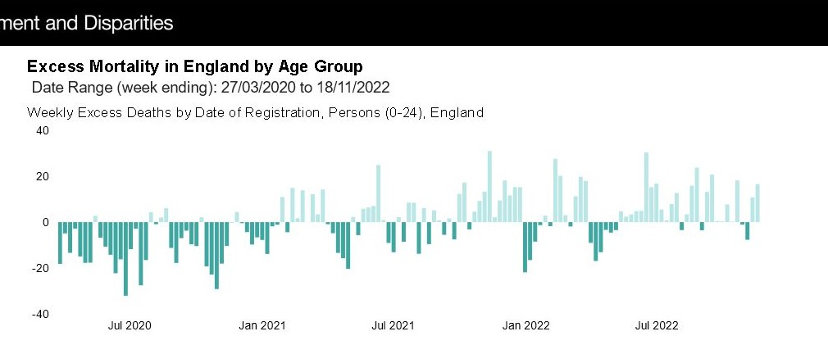

In the Netherland it’s the same story of a big rise in excess mortality in 2022 and into 2023
https://www.cbs.nl/en-gb/figures/detail/70895ENG

Germany
Official statistics from Germany show a massive 37% increase in excess mortality in December 2022
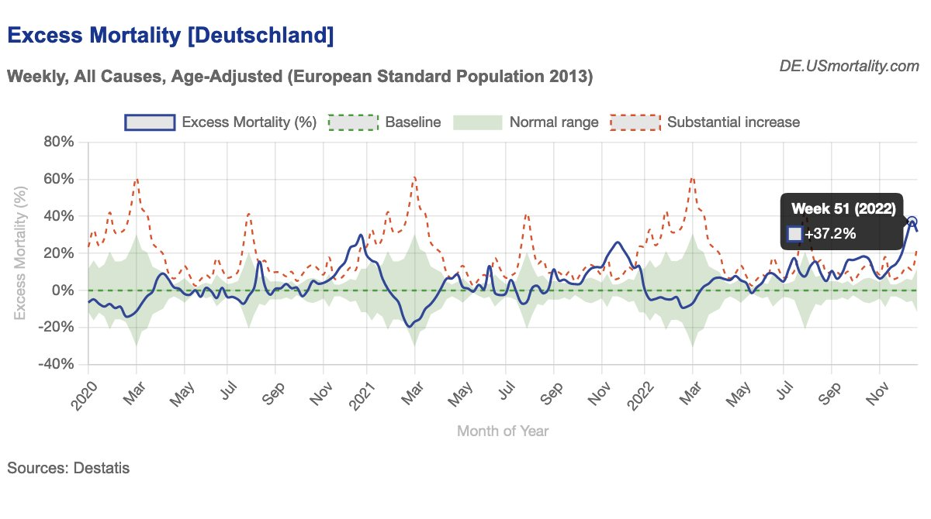
Source: Destatis, Germany
That is 27,436 Deaths, which is 7,240 Excess Deaths in a single week
There is a lot of killing of people going on around the world and they all have one factor in common - mass covid19 vaccinations and boosters ! This mass killing of people is a matter of the highest priority for the High Court and Supreme Court and Dail Eireann and the people of Ireland as defined in the Constitution.
7a. I further say that OECD statistics confirm a big rise in Excess Mortality in highly covid19 vaccinated countries in 2022. This is of the utmost seriousness to the Irish people and nation and should not continue to be ignored by the government and health authorities.
In 2022, Excess Mortality rises for following countries
Australia: high of 36% with most weeks over 19% by week 34
USA: high of 45% with most weeks over 13% by week 40. Latest week is 13%
UK: high of 25% with most weeks over 10%. Latest week is 17%.
Austria: high of 25% with most weeks over 10%. Latest week is 23%
Germany: high of 22% with most weeks over 10%. Latest week is 22%
New Zealand: high of 33% followed by 32% with most weeks over 12%. Latest week is 8%.
Greece: high of 41% followed by 31% with most weeks over 11%
Spain: high of 43% with most weeks over 11%. Latest week is 11%.
Israel: high of 48% followed by 41% with most weeks over 14%. Latest week is 16%.
Portugal: high of 48% followed by 42% with most weeks above 10%. Latest week is 11%.
Iceland: high of 78% followed by 62% and 51% with most weeks above 13%. Latest week is 17%.
Chile: high of 76% followed by 73% and 74% with most weeks over 17%. Latest week is 14%.
Source: https://stats.oecd.org/index.aspx?queryid=104676

Data provided by Euromomo, the OECD and the government statistical bodies in many countries show the following excess mortality for Europe
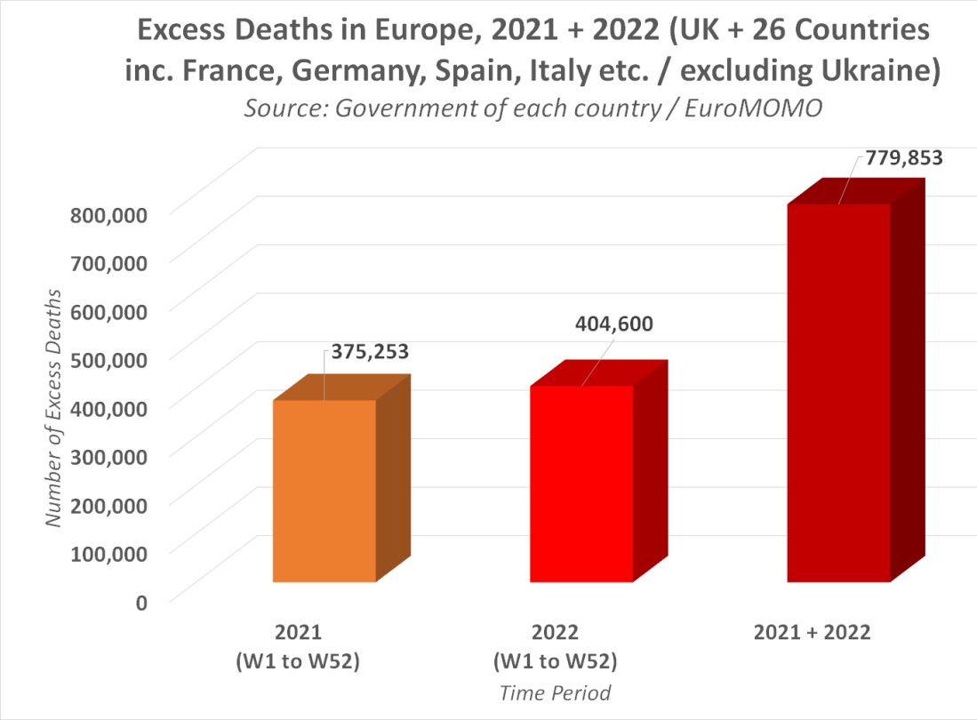
Sources: Euromomo https://www.euromomo.eu and
OECD https://stats.oecd.org/index.aspx?queryid=104676 and Government statistical bodies
Data provided by Euromomo, the OECD and the government statistical bodies in many countries show the following excess mortality for many countries around the world

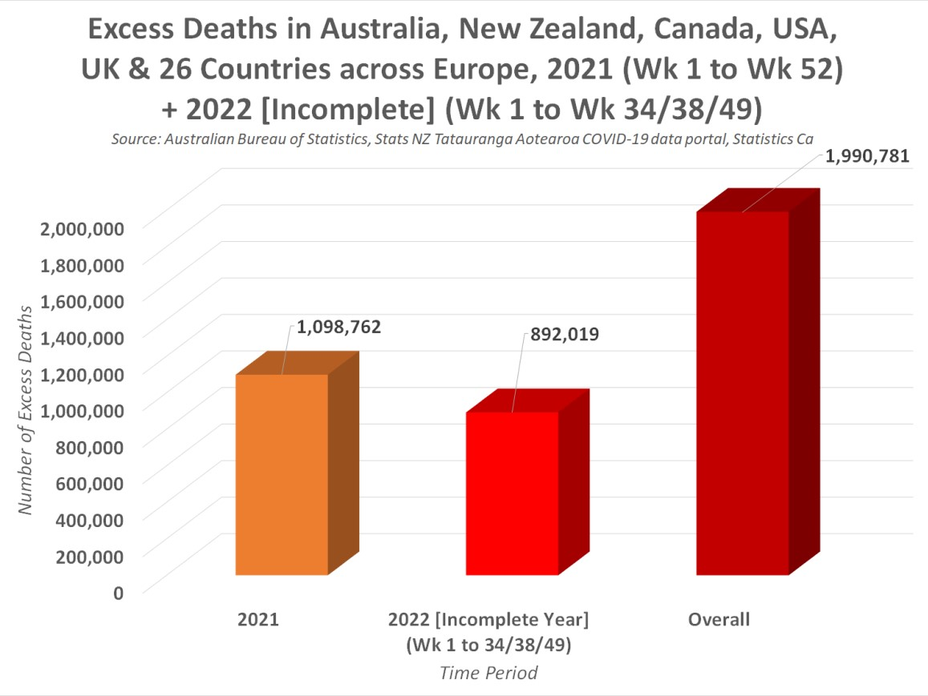
Sources: Euromomo https://www.euromomo.eu and
OECD https://stats.oecd.org/index.aspx?queryid=104676 and Government statistical bodies
The U.S. data has been provided by the Centers for Disease Control. The UK data has been provided by the Office for National Statistics. And Australia’s data has been provided by the Australian Bureau of Statistics, and Stats New Zealand for New Zealand.

There is a lot of killing of people going on around the world !
and they all have one factor in common - mass covid19 vaccinations and boosters ! This mass killing of people is a matter of the highest priority for the High Court and Supreme Court and Dail Eireann and the people of Ireland as defined in the Irish Constitution.
7b. I say that official government statistics show that Norway has experienced a massive rise in excess mortality after mass covid19 vaccinations were introduced there in mid 2021. And that New Zealand suffered a massive rise in excess mortality after mass covid19 vaccinations in 2021 and 2022. But it had negative excess mortality during the covid19 pandemic which was supposed to be killing people.
I cite a news report providing these official Norwegian government statistics at
https://principia-scientific.com/something-is-very-wrong-in-norway/
I present official statistics graph for New Zealand below:
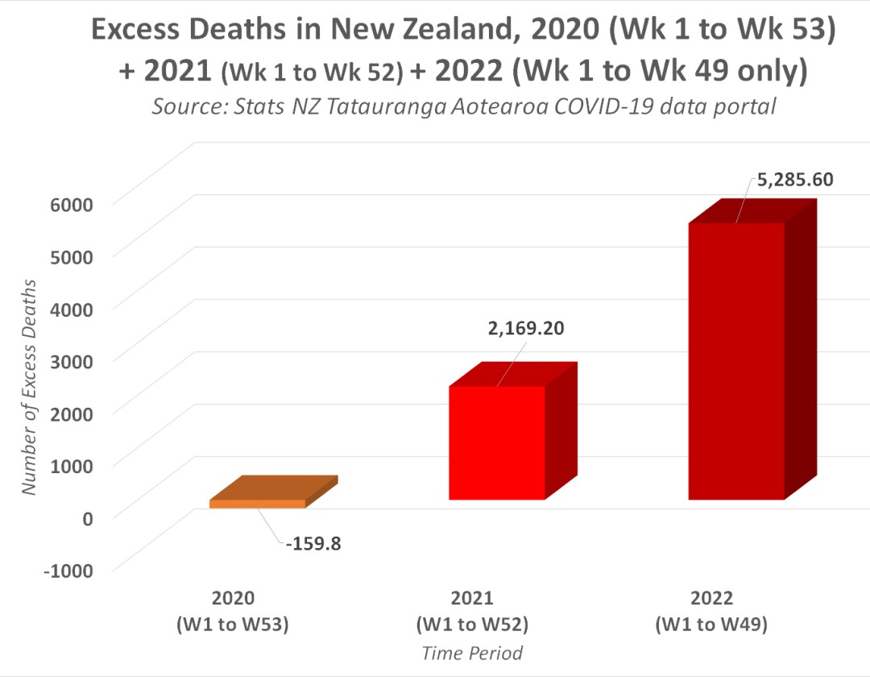
7c. I further say that I present Exhibit 25b to the court which are statistics from the CSO in Ireland and they compare mortality by total and by age group in the first quarter and second quarter of 2022 to the first quarter and second quarter of 2020, the year of the pandemic. The CSO figures show that mortality is much higher in 2022 and is higher for all age groups. This is also true for the 0 to 14 age group bracket.
Q1 of 2022 was 861 higher than Q1 of 2020 which was the start of the pandemic of 2020. Q1 of 2022 was 10% higher
Q2 of 2022 was 744 higher than Q1 of 2020 which was the middle of the pandemic of 2020. Q2 of 2022 was 8.6% higher
In Exhibit 64, the following statistics from the General Register Office in Ireland was published on its web site https://deathevents.gov.ie
Q4 of 2022 was 1,517 higher than Q4 of 2021. This was an increase in deaths of 17.5%
Q4 of 2022 was 2,745 higher than Q4 of 2020. This was an increase in deaths of 37%.
Q4 of 2021 was 1,228 higher than Q4 of 2020. This was an increase in deaths of 16.5%

This big increase in deaths in Ireland occurred after mass covid19 vaccinations from mid 2021 onwards and into 2022 and is continuing into 2023. The 37% increase in deaths for Q4 of 2022 shows we have a ‘Pandemic of vaccine deaths’ in Ireland.

The London Times reported about the big rise in excess mortality in Ireland. The article was published on January 15th 2023. The title of the article was ‘Ireland’s excess deaths rate rivals worst of Covid pandemic’ and is viewable online at
https://www.thetimes.co.uk/article/irelands-excess-deaths-rate-rivals-worst-of-covid-pandemic-mgr7fzw9m
The mainstream Irish press and media have refused to publish articles about this and there is evidence of continuing illegal censorship of the Irish press and media.
The evidence presented above and throughout this affidavit clearly shows that we have a Pandemic of Vaccine Deaths ! This is of the utmost seriousness to the Irish people and nation and should not continue to be ignored by the government and health authorities.
The defendants and their experts in this court case in their affidavits claimed that covid19 was a ‘national public health emergency’, yet they do not mention that the massive rise in excess mortality in late 2021 and into 2022 and into 2023 in Ireland and many other countries is also a ‘national public health emergency’. More people have died from mid 2021 onwards than died in the covid19 pandemic. These excess deaths are a ‘national public health emergency’. In fact, the defendants and their experts are completely ignoring it. None of them have mentioned it and none will mention it out of fear of repercussions from their political masters. This excess mortality and the massive rise in illnesses and disabilities and the over-crowded hospitals which experienced their worst crisis ever have mostly resulted from the actions of the Defendants and their political masters. This is one of the key factors in this court case.
7d. I state that according to official German Government data, by week 49 of 2022, the country had suffered over 102,000 excess deaths, a staggering increase from the 27,291.6 excess deaths reported by week 49 of 2020, the year of the covid19 pandemic.
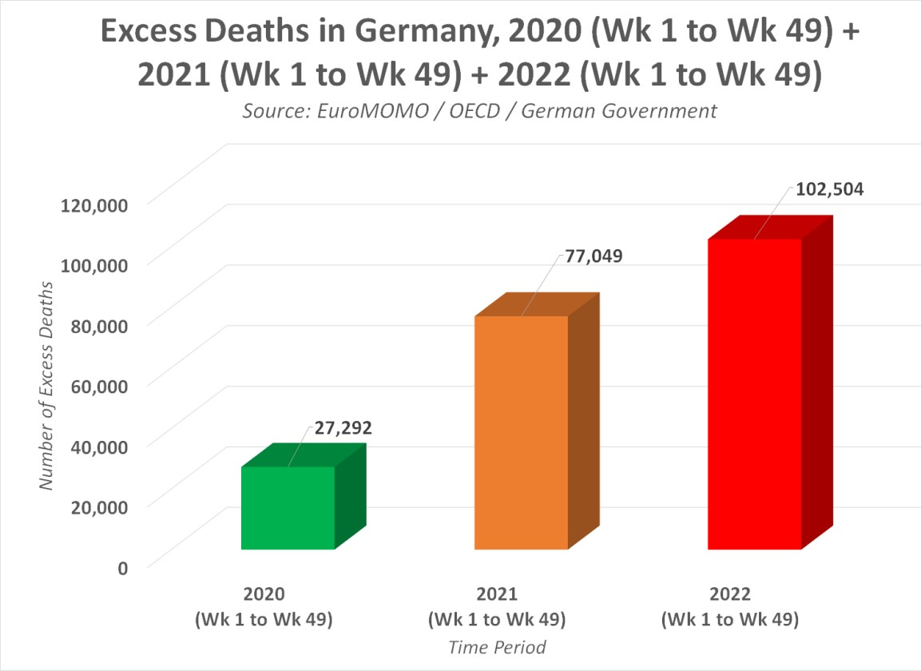
Sources: Euromomo, OECD and German government
This is a 300% increase in excess deaths in 2022, despite the roll-out of a vaccine that was supposed to lower deaths due to the Covid-19 pandemic. This 300% increase in excess mortality is very significant and corroborates all of the other evidence in this affidavit and our prior affidavits and books of evidence.
7e. I further say that official Statistics from the OECD, Euromomo and the government statistics bodies of many countries show a big rise in excess mortality in 2021 and 2022. I present Exhibit 62 to the court showing excess mortality for highly vaccinated Europe, USA, Canada, Australia and New Zealand of over 1.8 million. This is very significant. Comparisons of deaths between covidi19 vaccinated and unvaccinated in Britain during this time clearly show the vaccinated are dying in higher numbers. This is in our books of evidence and exhibits and also in a news report from Britain which analysed official statistics from the Office for National Statistics and the UKHSA showing deaths rates per hundred thousands were higher in the vaccinated - https://expose-news.com/2023/01/05/pfizergate-disaster-excess-deaths-mortality-rates/ This is of the utmost seriousness to the Irish people and nation and should not continue to be ignored by the government and health authorities.
7f. I say statistics from the Office for National Statistics in the UK show an excess mortality of 1,000 per week over 2022 and this was the subject of a news report and interview by Nigel Farage on GB news in January 2023. They are calling for a public inquiry into the link between covid19 vaccine injuries and deaths and the big rise in excess mortality. See https://www.youtube.com/watch?v=_JUdwZAJ-7k
Office for National Statistics data at
https://www.ons.gov.uk/peoplepopulationandcommunity/birthsdeathsandmarriages/deaths/datasets/weeklyprovisionalfiguresondeathsregisteredinenglandandwales and
https://www.ons.gov.uk/file?uri=/peoplepopulationandcommunity/birthsdeathsandmarriages/deaths/datasets/weeklyprovisionalfiguresondeathsregisteredinenglandandwales/2022/publicationfileweek492022.xlsx
Deaths registered in England and Wales were a massive 20.7% above the five-year average in the week ending December 23rd, according to the latest data from the ONS. There were a total of 14,530 deaths that week, which is 2,493 above the five-year average.
Source:https://www.ons.gov.uk/peoplepopulationandcommunity/birthsdeathsandmarriages/deaths/bulletins/deathsregisteredweeklyinenglandandwalesprovisional/weekending23december2022

The BBC in Britain reported in January 2023 that 2022 had the highest excess mortality in over 50 years
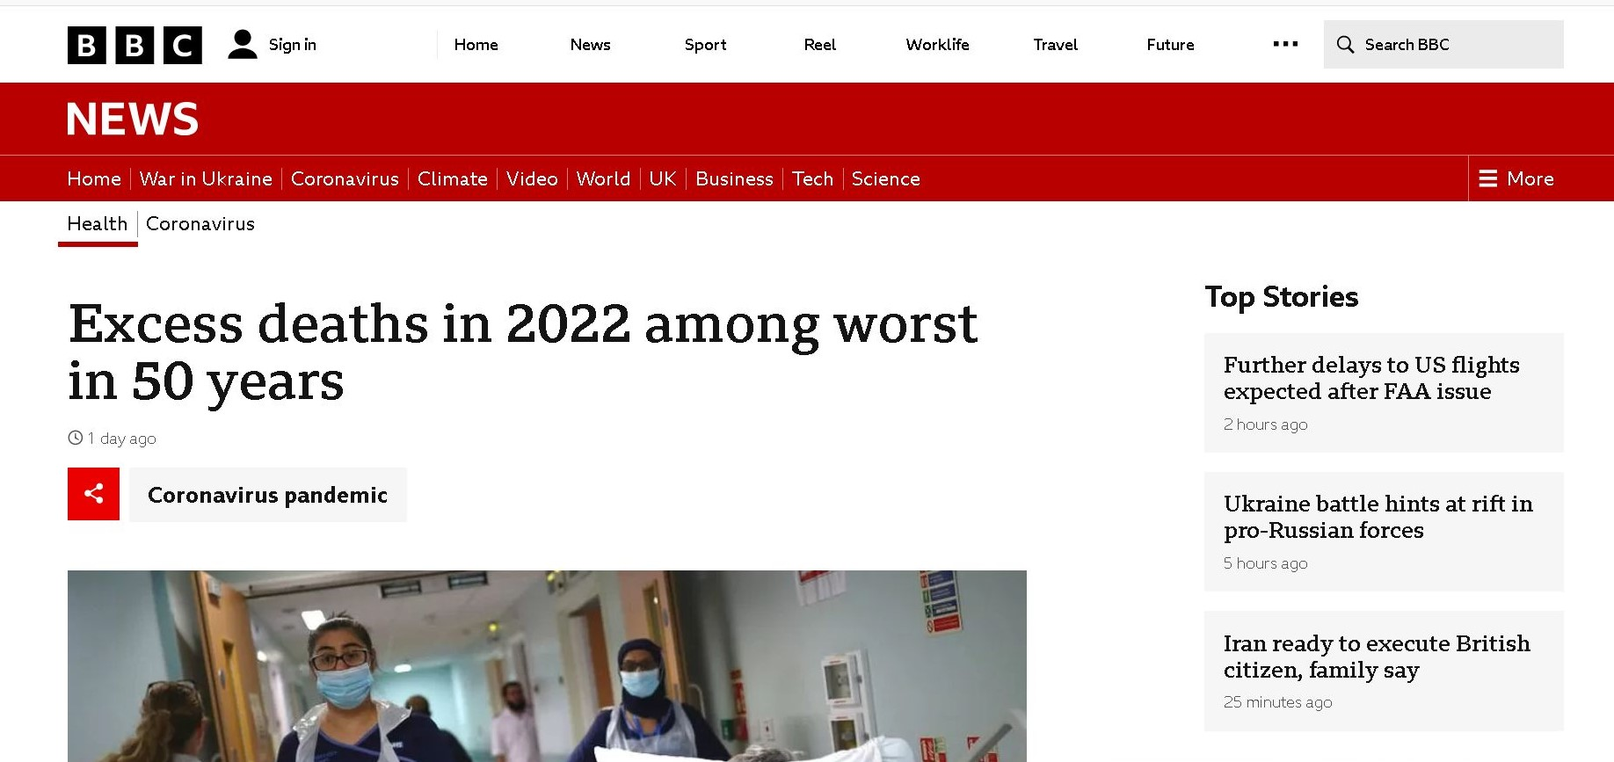

The Economist, one of the world’s leading news journals, published a big article on January 19th 2023 about Excess Mortality in 2022 and into 2023 and the fact that hospitals and healthcare systems in many countries cannot cope with this and are in crisis.
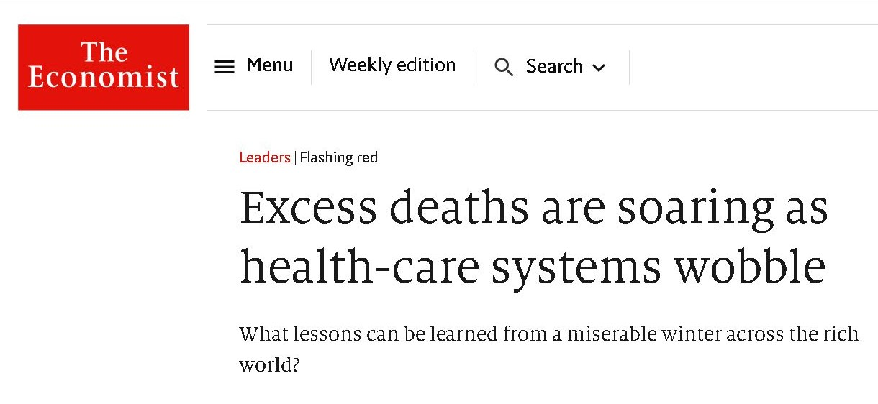
Important BBC interview about Excess deaths in 2022 and into 2023
On 13th January 2023 Dr. Aseem Malhotra a top Cardiologist in Britain gave an interview to the BBC about the big rise in heart diseases and excess deaths in 2021 and 2022 and he stated that covid19 vaccines especially those containing mRNA were implicated in the rise in excess deaths and the big rise in cardiovascular deaths and illnesses in Britain. This sent shockwaves through Britain in January 2023, opening the eyes of many people to the cause of this excess mortality in Britain and other countries. The video interview got over 20 million views online.
Link to video: https://www.youtube.com/watch?v=SrfEWsKMWfU and screenshot below.
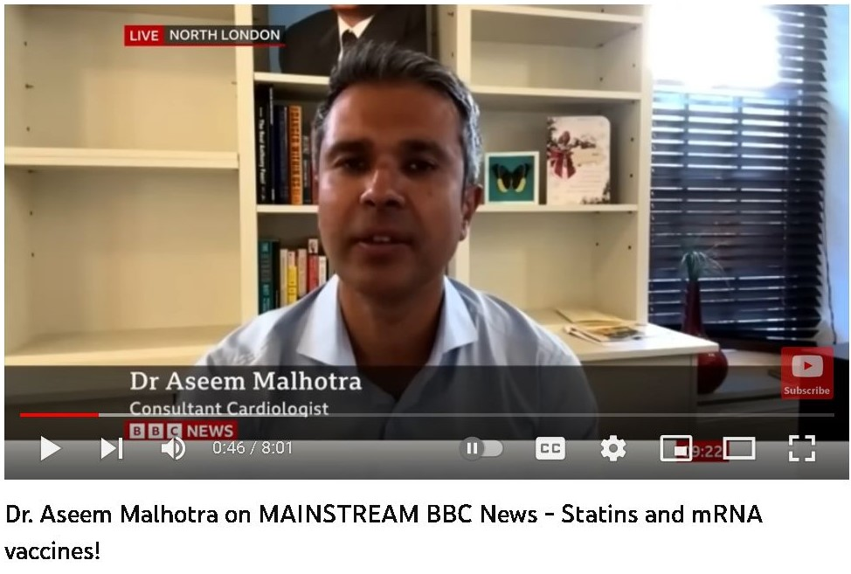
I further say that Dr. Professor Abdullah A. Alabdulgader from Saudi Arabia has publicly called for ending covid19 vaccinations due to safety concerns including higher risk of myocarditis.
Dr. Abdulgader is a Cardiologist and Professor of Congenital Cardiology/Electrophysiology and also General Directorate of Health and co-founder and General Director in Prince Sultan Cardiac Centre, General Director of King Fahad Hospital, Saudi Arabia. He is a scientific board member and editorial board member of many international organizations and journals in the USA, UK, Germany, Switzerland, China, India and other countries.
Source: https://www.youtube.com/watch?v=VfIN8hPBLZ4 or
https://twitter.com/i/status/1614916595650039808

7g. I further say that Professor Dr. Norman Fenton in England has found evidence that the Office for National Statistics in Britain has misclassified many covid19 vaccinated deaths as unvaccinated deaths. People dying shortly after getting the first covid19 vaccine were misclassified as unvaccinated. This means that deaths, including all cause mortality, for covid19 vaccinated people are much higher, and all cause mortality is even higher for covid19 vaccinated compared to unvaccinated people in Britain. The Office for National Statistics in Britain agreed with Professor Dr. Norman Fenton on this point in January 2023. This amounts to a serious error which needs to be corrected or amounts to fraud. This has great relevance to our High Court case.
Sources: https://wherearethenumbers.substack.com
and https://www.youtube.com/@NormanFenton81
and https://www.youtube.com/watch?v=6SAh0bJN6hs
8. I say that Expert Testimony by medical doctors and scientists to the US Senate stating that covid19 vaccines are very dangerous for children and young adults needs to be taken seriously by Irish government and health authorities and the Irish courts.
U.S. Senator Ron Johnson led a roundtable discussion of ‘COVID-19 Vaccines: What They Are, How They Work, and Possible Causes of Injuries’ in Washington DC in December 2022. Several Expert Witnesses, including medical doctors, Hospital Consultants, a Cardiologist and Scientists testified about the injuries, illnesses, disabilities and deaths caused by the covid19 vaccines.
Dr. Kirk Milhoan a medical doctor, Paediatrician and Cardiologist stated the following about the effects of covid19 vaccinations on children to the US Senate
"They Saw That In 151 Kids Who Had A [Cardiac] MRI, At 90 Days 81 Of Them Still Had Damage To Their Heart And The Damage Was Of Late Gadolinium Enhancement Which Is Associated With Sudden Cardiac Death"
Source: https://www.brighteon.com/fd9b2943-ebc1-41e4-be7d-f698ea45e90d
and https://www.redvoicemedia.com/2022/12/pediatric-cardiologists-emotional-testimony-on-sudden-death-vax-damage-to-young-hearts/

The scientific study Dr. Milhoan was referring to was

Recovery from mRNA COVID-19 vaccine-related myocarditis
Ammirati et al. 2022. Lancet
https://www.thelancet.com/journals/lanchi/article/PIIS2352-4642(22)00272-3/fulltext

This corroborates the evidence and statements we have here in this affidavit testimony before the High Court. This US Senate hearing can be viewed online at https://www.bitchute.com/video/REcpJ0b6kY7E/
or at https://www.bitchute.com/video/L9EkfZtg21CS/
This is of the utmost seriousness to the Irish people and nation and should not continue to be ignored by the government and health authorities.
9. I say that in December 2022, the Office for National Statistics in Britain corrected an error it made and which we cited in our previous affidavit. The accurate total number of disabled people increased by 363,000 between 2020 and 2022 and now stands at 2.5 million people in the UK. This was a very significant rise in long term illness and disability in the UK and corroborates what we stated in previous affidavits, exhibits, and our books of evidence, and provides more evidence of the harms, illnesses and disabilities caused by mass covid19 vaccinations.
The sudden and massive rise in long term illnesses and disabilities in Britain from late 2020 to 2022 is presented in a chart provided by the Office for National Statistics in Britain in Exhibit 27.
Sources: https://www.ons.gov.uk/employmentandlabourmarket/peoplenotinwork/economicinactivity/articles/halfamillionmorepeopleareoutofthelabourforcebecauseoflongtermsickness/2022-11-10
Comparing Quarter 2 (April to June) in both 2019 and 2022, the number of people inactive because of long-term sickness who reported their main health condition as “other health problems or disabilities” rose by 97,000 (41%), the largest of any category.

Those aged 25 to 34 years saw the largest relative increase in long-term sickness between 2019 and 2022. This is presented in Exhibit 27a.

A new report from the UK Institute for Fiscal Studies (IFS), which specialises in UK taxation and public policy, finds that sickness benefit claims have tripled among the young in the last year (2022). The number of new disability benefit claimants has doubled in a year (2022). This is coupled with a “significant rise” in non-COVID deaths.
Source: https://ifs.org.uk/sites/default/files/2022-12/The-number-of-new-disability-claimants-has-doubled-in-a-year-IFS-report-R233.pdf
“the rise in awards is very widespread, with at least a doubling at almost every age. There are particularly large proportional changes for teenagers, where new claims have tripled in the space of a year”

This happened shortly after mass covid19 vaccinations in Britain from mid 2021 onwards and boosters from Spring 2022 onwards. The same situation is occurring in many other highly covid vaccinated countries.

10. I say that there has been more corroboration of official statistics showing a big rise in disabilities in the USA in 2021 and 2022 which corresponded to mass covid19 vaccinations.
These statistics are from the Bureau of Labor Statistics in the USA which is an official government body and have been compiled by Ed Dowd’s statistics team in the USA and are presented in a series of statistical charts in Exhibit 43 which I present to the court.

Ed Dowd’s statistical team made the following analysis of these disability statistics in the USA.
‘ When looking at disabilities in the overall population aged 16 to 64, we observe that the long-term average disability rate is about 7.5%. However, from 2017 to 2019 the disability rate fell to about 7.3%.
We observe a sharp drop in disabilities in 2020, in similarity to in older individuals, which was likely due to:
- Less economic activity with lockdown reducing the risk of injury-related disability.
- Under-diagnosis of disabilities acquired during these months, due to reduced access to healthcare services.
- Working-age population less motivated to seek diagnosis and declare disability for the sake of disability benefits, if their employment/pay was already protected by pandemic-related social security measures.

Disabilities in 16-64 recovered to pre-pandemic values in early 2021. From 5/2021 we observe a large rise in disabilities from 7.3% to 8.1% in September 2022, corresponding to a 11.0% increase.
- For the 16-64 workforce also observe a very noticeable rise in disabilities starting around 5/2021 for both Men and Women. However, as we can clearly the rise in disabilities is much larger in Women than Men.
- For Women, the rise in disabilities went from a long-term average of about 3.3% in 4/2021 to 4.5% in 9/2022, corresponding to a 36.4% rise.
- For Men, the rise in disabilities went from a long-term average of about 3.3% in 4/2021 to 3.8% in 9/2022, corresponding to a 15% rise.
- For the workforce aged 16 and over or 16 to 64 years, we do not observe a noticeable drop in disabilities in 2020 which we observed in the overall population. Why was there no noticeable effect of the reduction in exposure to risky activities in the workforce? No effect of lockdowns or less mobility?
- We also observe a very noticeable rise in disabilities starting around 5/2021. For the 16-64 workforce this corresponded to a rise from 3.4% in 4/2021 to 4.2% in 9/2022, corresponding to a 23.5% rise. ‘

The chart below is from their web site. This sums up most of their statistical findings from the US Bureau of Labor Statistics in the USA

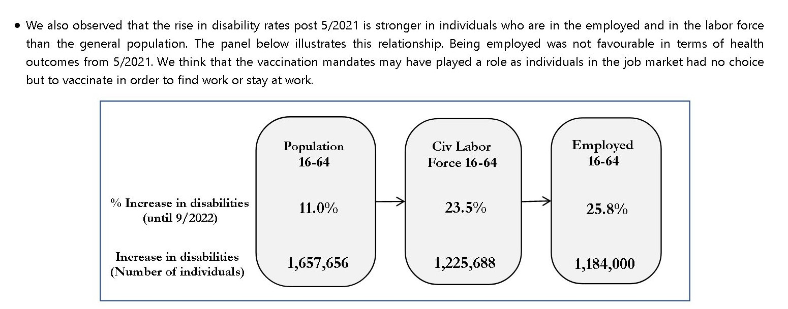

Source: http://phinancetechnologies.com/HumanityProjects/US%20Disabilities.htm
11. I say the evidence clearly shows a National Disaster in Ireland.
I say that the massive increase in covid19 vaccine caused injuries, illnesses and disabilities and premature deaths and lockdown caused illnesses have placed enormous pressures on Irish hospitals in November and December 2022 and January 2023 and this has led and is leading to loss of many lives. The NHS in Britain is under similar pressures during this time. And that this reflects international trends in highly covid vaccinated countries. Data from the Irish hospitals and HSE show that there is record number of people in Irish hospitals and waiting in trolleys in hospitals in December 2022 and January 2023. Ireland has witnessed a sudden and massive increase in seriously ill and newly disabled people in 2022. Hospital overcrowding has now broken an annual record with 118,622 people on trolleys so far in 2022 in Ireland. Speaking about the wider situation, INMO General Secretary Phil Ní Sheaghdha said there is “no sign of pressure easing” when compared with previous December periods. “We have reached an overcrowding milestone today in that 2022 is officially the worst year for hospital overcrowding on record. This is not something to be celebrated.” This is a disaster for Ireland and the Irish people and the role of covid19 vaccines must be acknowledged as they are playing a significant role in this crisis.

Top 5 most overcrowded hospitals January 4 - December 21, 2022
1. University Hospital Limerick – 17, 640
2. Cork University Hospital – 12,133
3. Galway University Hospital – 10,012
4. Sligo University Hospital – 7,977
5. St. Vincent’s University Hospital – 7,406
Source: Irish Independent newspaper, December 23rd 2022.
https://www.independent.ie/irish-news/news/teenage-girl-who-died-from-meningitis-left-on-hospital-trolley-for-up-to-16-hours-42239768.html

This got much worse for Irish hospitals in January 2023. The Irish Independent newspaper reported on this on January 3rd 2023, see below
Revealed: Ireland’s most overcrowded hospitals as number of patients on trolleys hits record high
Irish Independent newspaper, January 3rd 2023
https://www.independent.ie/irish-news/health/revealed-irelands-most-overcrowded-hospitals-as-number-of-patients-on-trolleys-hits-record-high-42259174.html
“The Irish Nurses and Midwives Organisation (INMO) said this is the largest number of patients left without a hospital bed since the union started counting trolley figures in 2006.
It is 171 cases higher than the previous record of overcrowding on December 19 last.”

I further say that Point 43. of this affidavit is very important in the sense that it presents scientific evidence of severe weakening of the immune systems of vaccinated people making them more vulnerable to viral and bacterial infections, some fatal, and cancers and cancers coming out of remission. And that this is in addition to many other illnesses and disabilities being caused by the vaccine / boosters. All of this has resulted in increased hospital admissions for the vaccinated in 2022 and into 2023. And that this has had very serious implications for hospitals and healthcare systems in 2022 and into 2023, creating the worst crisis in many decades.

This is strong evidence that something in 2022 has created a big spike in hospital admissions. That something according to international scientific studies and a mountain of scientific and statistical evidence points to the effects of mass covid19 vaccinations. This is leading to loss of lives in Ireland which does not bother Irish politicians and the government. The Irish politicians and political parties do NOT care about this. They have neglected the hospital overcrowding and lack of funding and resources problem for over 20 years. It’s not a priority for them. They have wasted many billions of euros giving tax breaks to speculators to create massive speculative bubbles in the early 2000’s and then wasted many more billions of euros bailing out these speculators and their bankers and bondholders after the crash in 2008, and then implementing vicious cutbacks in hospitals and healthcare spending. They have neglected the Irish hospitals and healthcare system for over two decades. They have created the neglected, under- funded, low capacity, bankrupt and failing Irish hospitals and healthcare system which cannot cope now in a real crisis.
And the Irish government pushed unsafe and dangerous covid19 vaccines which injured many people and created more illnesses and disabilities for Irish people and put the under-funded Irish hospitals and healthcare into serious crisis in 2022 and into 2023. They did what their foreign masters demanded off them. One senior Irish politician, an elected TD and Minister, recently admitted that Irish national sovereignty does not exist. He rejected the Irish Constitution of 1937 and rejected the Irish nation as an independent entity. This is the low quality of person who presumes to represent the Irish people and their interests. The damage to the Irish people and nation caused by these politicians and health officials is horrendous and shocking, and amounts to them “stepping over the dead bodies and disabled bodies of many Irish people” and is truly criminal, and will need to be rectified in court cases and tribunals.
The Economist, one of the world’s leading news journals, published a big article on January 19th 2023 about Excess Mortality in 2022 and into 2023 and the fact that hospitals and healthcare systems in many countries cannot cope with this and are in crisis.

11a. I further say that the evidence shows a comparison between vaccinated and unvaccinated people clearly shows that the vaccinated are being hospitalized at far higher rates and that this is vaccine dose dependent. This is a good indication of causality. These increased hospital admissions for the vaccinated have put more pressure on hospitals in Ireland, Britain, Germany, EU countries, Canada, the USA, and Australia, in 2022 and into 2023 pushing them into the worst crisis ever.
I present Exhibit 65 to the court showing the covid vaccinated are over represented in hospital admissions and ICU’s in Australia and that the hospital crisis there is linked to the injuries and illnesses caused by covid19 vaccinations.

Comparisons between the vaccinated and unvaccinated show higher death rates and hospitalization rates for the vaccinated in late 2021 and into 2022. This was particularly true in Winter 2022 and into 2023 and has caused one of the worst hospital crisis ever in Ireland, Britain, Germany, Canada, the USA and Australia.
11b. I further say that the failure of the HSE, the Department of Health and the CSO to gather and provide accurate, timely and up to date statistics of deaths, illnesses and disabilities and hospitalizations for the covid19 vaccinated and the unvaccinated to the general public and on their web sites so that vaccine safety and effectiveness can be independently assessed and verified by the general public including parents and guardians means that the HSE and the Department of Health and government are totally discredited, not fit for purpose and their claims about vaccine safety and effectiveness are unproven, false, misleading and fraudulent. And this fraud has caused losses to the general public in terms of deprivation of full and valid informed consent for the vaccinations, and of vaccine injuries, illnesses, disabilities and premature deaths and loss of jobs, careers, homes, families and considerable financial losses.
The attitude and policies of the HSE, NPHET, the Minister for Health and Department of Health and the government is to totally ignore the big increase in excess mortality in Ireland since mid 2021 and 2022 and into 2023, and ignore its relationship to the vaccine deaths, injuries, illnesses and disabilities which are placing additional burdens and pressures on the over-burdened healthcare system, leading to more over-crowded hospitals in 2022 and 2023 and covid19 ; the worst in history. They falsely claim that this crisis is mild, temporary, coincidental, a random event, doesn’t really matter, is due to “lack of resources” while resources in the form of many billions of euros were wasted on ineffective covid19 measures and on unsafe and ineffective covid19 vaccines while they blocked and banned cheap, safe and effective medicines for covid19 in 2020 and 2021. They hope that the problem they created will “go away”. But excess deaths are not going away and over-crowded hospitals are not going away and vaccine injuries, illnesses, disabilities and deaths are not going away.
Their Disclosure in this court case in terms of folders and documents proves this to be the case. Courts and governments have a legal duty of care to the Irish people and Nation and they should not ignore and dismiss the big increase in excess mortality in Ireland and other highly covid vaccinated countries which is related to covid19 vaccine deaths, injuries, illnesses and disabilities which are placing massive, new, additional burdens and pressures on the over-burdened healthcare system leading to more and more over-crowded hospitals in 2022 and 2023 ; the worst health crisis in history. Their breaching of informed consent during mass covid19 vaccinations is having devastating effects on Ireland and created a national crisis. Here again, we see the central role played by deprivation of informed consent which is the subject of this High Court case

12. I say that have been more failures by the Irish government and health authorities to provide proper, up to date and accurate disability statistics. This hides the real number of ill and disabled people in Ireland and deprives the government and health authorities, the general public and the courts from assessing all of the damage caused by the covid19 vaccines to the Irish people and nation.
The HSE and CSO and other state bodies and Irish government have a lot of highly qualified so called “experts” but no adequate healthcare system and statistics system and no resource monitoring and management system to provide basic health services to the general public. Vast amounts of Irish taxpayers money is being wasted and misappropriated to provide a failed system and national disasters which profits a tiny few. This needs to be exposed, remedied, and ended.
The CSO has disability statistics up to 2016 and nothing for the period 2020 to 2022. This is a major failing of the CSO and Irish government as it is important to know the disability figures from 2020 to 2022 in order to assess the impact of covid19 infections and lockdowns and the impact of covid19 vaccines in terms of the injuries, illnesses and disabilities the vaccines cause. The only disability statistics we have are the 2016 statistics which are many years out of date.
The Disability Federation of Ireland was given tabulated statistics for 2016 from the CSO. These statistics are in Exhibit 26. They show the following:
Population
13.5% of the population of Ireland, or 643,131 people have at least one disability.
Age
Their age profile is:
0-14 59,086
15 – 24 53,465
25 – 44 123,638
45 – 64 182,554
65+ 224,388

We need these figures to 2020 to 2022 in order to assess the impact of covid19 infections and the impact of covid19 vaccines in terms of the injuries, illnesses and disabilities the vaccines cause. But, the CSO and other Irish government bodies do not have these figures. This is a major failure of state bodies and the Irish government.
13. I say the MHRA data operated by the British government and health authorities in Britain has relevance to Ireland as the MHRA has better data collection capabilities, better statistics, data and data analysis, more transparency and more accountability than it’s Irish counterparts. The VAERS data from CDC in the USA also has relevance to Ireland as VAERS has better data collection capabilities, better statistics, data and data analysis, more transparency and more accountability than it’s Irish counterpart.
MHRA data from Britain. September 2022
Yellow Card Adverse Event Reports – 177,925 (Pfizer) + 246,866 (AZ) + 47,045 (Moderna) + 52 (Novavax = N) + 2,130 (Unknown) = 474,018 people impacted including bivalent vaccines (increase of 3,995 in 4 weeks)
Overall 1 in 114 people injected experiences a Yellow Card Adverse Event, which may be less than 10 per cent of actual figures according to MHRA.
Fatalities – 857 (Pfizer) + 1,334 (AZ) + 111 (Moderna) + 60 (Unknown) = 2,362
Children & Young People Special Report
Suspected side effects reported in individuals under 18 years old
Pfizer – 4,200,000 children (1st doses) + 2,900,000 (2nd doses) + 400,000 (mono) / 52,500 (bivalent) boosters resulting in 4,205 Yellow Cards
AZ – 11,400 children (1st doses) + 8,500 (2nd doses) + ‘extremely limited boosters’ resulting in 267 Yellow Cards (reporting rate 1 in 43)
Moderna – 2,100 children (1st doses) + 2,000 (2nd doses) + 32,400 (mono) / 1,000 (bivalent) boosters resulting in 39 Yellow cards
Brand unspecified – 37 Yellow Cards
Total = 4,213,700 children injected (under 18s)
Total doses (1st, 2nd & boosters) = 7,609,900
Total Yellow Cards Under 18s = 4,548
Source: MHRA in Britain
https://www.gov.uk/government/publications/coronavirus-covid-19-vaccine-adverse-reactions
I present Exhibit 28 to the court, detailing the types of injuries, illnesses, disabilities caused to people by the covid19 vaccines and total number of deaths.
13a. Dr. Richard Ennos, a retired Professor of Evolutionary Biology at Edinburgh University in Scotland, has undertaken a thorough analysis of this MHRA data and found it indicates “unequivocal safety signals” for adverse reactions caused by the Pfizer and Moderna vaccines affecting the blood, the heart and female reproduction. He concludes that: “There can be no question that the mRNA vaccines should be withdrawn with immediate effect.”
Dr. Richard Ennos wrote a brilliant scientific analysis of this MHRA data and the fact that adverse events including injuries, illnesses and disabilities caused by covid19 vaccines are far greater than for other vaccines at https://dailysceptic.org/2023/01/18/unequivocal-safety-signals-for-heart-blood-and-reproduction-found-in-yellow-card-vaccine-data-says-top-scientist-withdraw-them-immediately/
14. I say that the MHRA have admitted that only 10% of injuries, illnesses and deaths caused by the covid19 vaccine and medical drugs are reported to them. So one can multiply the high figures above by 10 to get more accurate figures for covid19 vaccine injuries, illnesses, disabilities and deaths.
I present Exhibit 36 to the court showing that the MHRA in Britain has admitted on its web site that only 10% of injuries, illnesses and deaths caused by the covid19 vaccine and medical drugs are reported to them.

15. I further say that the VAERS of the CDC in the USA has reported the following statistics for covid19 vaccine injured, ill disabled and dead for year end 2022. This is presented to the court in Exhibit 58.
This includes 1.4 million reports of adverse events, 33,000 deaths, 186,000 hospitalizations, 15,000 heart attacks, 36,000 cases of myocarditis / pericarditis, 200,000 visits to doctors, 61,000 permanently disabled. This is the highest in history for any vaccine and more than all other vaccines combined together.
Exhibit 58a shows the death and damage done to children by these vaccines. 60,00 reports of adverse events, 173 children dead, 552 permanently disabled, 1,700 cases of myocarditis, 285 with encephalitis, 4,500 hospitalized, and over 10,000 not recovered from injuries and illnesses caused.
The evidence shows that the covid19 vaccines are not safe.
Scientific studies and statistical analysis cited in the previous affidavit and in the books of evidence show that only 1% of adverse events are reported and less than 10% of serious illnesses and deaths are reported. The under reporting factor may be range from 10 to 100.
There are accusations that VAERS Are Deliberately Hiding Childrens Deaths From Covid Injections. The link to see VAERS hidden reports is https://www.vaersaware.com/kids-unk-age-deaths
There are reportedly lots more and many have been permanently deleted.
UNSPECIFIED AGE is also how they hide the child deaths in EudraVigilance reports and Yellow card reports. This is obviously highly concerning and hiding or obfuscation of such reports to administrators or recipients of covid vaccines is not conducive to obtaining voluntary informed consent.

15a. I further say that the CDC in the USA released the following data for covid19 vaccines in January 2023 and that this corroborates our evidence and further supports our statements to the High Court and our case for an Injunction.
The analyses cover VAERS reports for mRNA COVID-19 vaccines from the period from the vaccine rollout on Dec. 14, 2020, through to the end of July 2022.
- Centers for Disease Control and Prevention’s (CDC) Vaccine Adverse Event Reporting System (VAERS) safety signal analysis based on reports from Dec. 14, 2020 – July 29, 2022, for mRNA COVID-19 vaccines shows clear safety signals for death and a range of highly concerning thrombo-embolic, cardiac, neurological, hemorrhagic, hematological, immune-system and menstrual adverse events (AEs) among U.S. adults.
- There were 770 different types of adverse events that showed safety signals in ages 18+, of which more than 500 (or 2/3) had a larger safety signal than myocarditis/pericarditis.
- The CDC analysis shows that the number of serious adverse events reported in less than two years for mRNA COVID-19 vaccines is 5.5 times greater than all serious reports for vaccines given to adults in the U.S. since 2009 (~73,000 vs. ~13,000).
- Twice as many mRNA COVID-19 vaccine reports were classified as serious compared to all other vaccines given to adults (11% vs. 5.5%). This meets the CDC definition of a safety signal.
- There are 96 safety signals for 12-17 year-olds, which include: myocarditis, pericarditis, Bell’s Palsy, genital ulcerations, high blood pressure and heart rate, menstrual irregularities, cardiac valve incompetencies, pulmonary embolism, cardiac arrhythmias, thromboses, pericardial and pleural effusion, appendicitis and perforated appendix, immune thrombocytopenia, chest pain, increased troponin levels, being in intensive care and having anticoagulant therapy.
- There are 66 safety signals for 5-11 year-olds, which include: myocarditis, pericarditis, ventricular dysfunction and cardiac valve incompetencies, pericardial and pleural effusion, chest pain, appendicitis and appendectomies, Kawasaki’s disease, menstrual irregularities, vitiligo and vaccine breakthrough infection.
The safety signals cannot be dismissed as due to “stimulated,” exaggerated, fraudulent or otherwise artificially inflated reporting, nor can they be dismissed due to the huge number of COVID-19 vaccines administered.
There are several reasons why, but the simplest one is this: the safety signal analysis does not depend on the number of reports, but whether or not some AEs are reported at a higher rate for these vaccines than for other non-COVID vaccines. Other reasons are discussed in the full post below.
- In August 2022, the CDC told The Epoch Times that the results of their safety signal analysis “were generally consistent with EB [Empirical Bayesian] data mining [conducted by the U.S. Food and Drug Administration (FDA)], revealing no additional unexpected safety signals.”
So either the FDA’s data mining was consistent with the CDC’s method — meaning they “generally” found the same large number of highly alarming safety signals — or the signals they did find were expected. Or they were lying. We may never know because the FDA has refused to release their data mining results.
For children the most common adverse events were
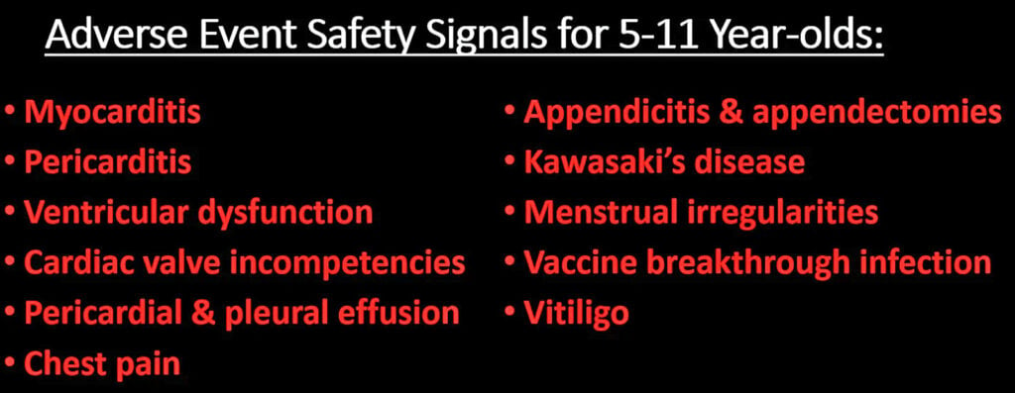
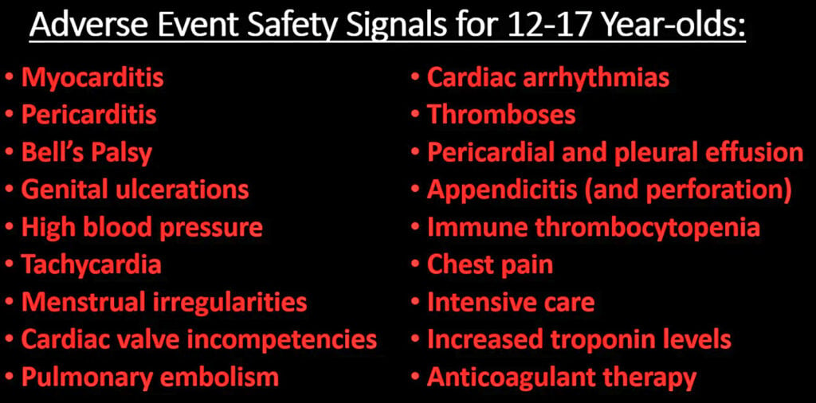
Sources: https://www.theepochtimes.com/health/exclusive-cdc-finds-hundreds-of-safety-signals-for-pfizer-and-moderna-covid-19-vaccines_4956733.html
and
https://childrenshealthdefense.org/defender/cdc-vaers-covid-vaccines-serious-injuries/
This information was deliberately withheld and hidden from the general public, and was released only because of pressure from organizations to launch FOI requests for this data in the USA. And none of this data was communicated to the general public and to vaccine recipients and to parents and guardians prior to vaccinations. There was no full and valid informed consent given for these vaccines.
16. I say that the gap between Excess Mortality figures and vaccine deaths is linked to the under reporting factor for covid19 vaccine deaths which ranges from 10 to 100 according to published scientific studies and statements from official government bodies.
The VAERS data in the CDC in the USA is under reported by a factor of 10 to 100 according to scientific and statistical studies
These numbers are high but the reality is that they are an underestimate, the real figures are much higher due to under-reporting and people not identifying the sudden development of a new illness or sudden death with the vaccine. The VAERS system is a US Government vaccine monitoring system which tracks vaccine deaths and injuries in the USA. This system identifies 10% of vaccine deaths and 1% of vaccine caused injuries, side effects, disabilities and new illnesses according to a Harvard Medical School study in 2010. I cite the scientific paper below.
Electronic Support for Public Health - Vaccine Adverse Event Reporting System (ESP:VAERS) - Final Report.
by Lazarus et al. and Harvard Pilgrim Health Care, 2010
https://digital.ahrq.gov/sites/default/files/docs/publication/r18hs017045-lazarus-final-report-2011.pdf
I quote from this ' Adverse events from drugs and vaccines are common, but underreported. Although 25% of ambulatory patients experience an adverse drug event, less than 0.3% of all adverse drug events and 1 - 13% of serious events are reported to the Food and Drug Administration (FDA). Likewise, fewer than 1% of vaccine adverse events are reported. Low reporting rates preclude or slow the identification of “problem” drugs and vaccines that endanger public health. New surveillance methods for drug and vaccine adverse effects are needed.'
This scientific research by Harvard University Medical School means adverse events to VAERS will need to be multiplied by 100 and that deaths and serious injuries / disabilities / new illnesses multiplied by 10 to get accurate statistics for injuries and deaths caused by covid19 vaccines in the USA.
A recent scientific study on the covid19 vaccines found anaphylaxis occurred at a rate of 2.47 per 10, 000 vaccinations which is 247 per million and is 10 times higher than officially reported.
Source: https://jamanetwork.com/journals/jama/fullarticle/2777417
A scientific study by scientists and statisticians Dr. Jessica Rose and Mathew Crawford and Steve Kirsch in the USA found in 2021 that there is under-reporting to VAERS and the most credible estimate for deaths and illnesses is 41 times the rate reported to VAERS. This means the real figures are 41 times higher. This gives over 7.2 million hospitalisations, 1.2 million deaths, 2.3 million permanently disabilities and 2.1 million cases of myocarditis by October 2022. Underreporting factor of 41 is scientifically presented on https://www.skirsch.com/covid/Deaths.pdf
Links to scientific studies at https://expose-news.com/2021/09/20/covid-19-vaccines-have-killed-at-least-150000-people-in-the-usa/
Official and reported vaccine deaths may need to be multiplied by 10 to 100 times to give an accurate measure of vaccine deaths in the USA and other western countries. This would explain the massive rise in excess mortality in 2021 and 2022. In Ireland, the under reporting factor is similar to that in the USA. Many doctors in Ireland have not reported covid19 vaccine injuries, illnesses, disabilities and deaths out of fear of repercussions for them. This includes repercussions form injured patients, the family and relations of dead patients, and the Irish Medical Council which has clamped down on all criticism of the covid19 vaccines and threatened doctors with suspension or loss of medical license. And Coroners Inquests into dead vaccinated people have been banned and blocked by the state. There has been a big rise in excess mortality in Ireland since mass covid19 vaccinations began and this is continuing into 2023.
There is a big gap between official figures for covid vaccine deaths and the excess mortality figures ; this gap is explained by the under reporting factor for covid19 vaccines, which ranges from a factor of 10 to 100. Some of the deaths also relate to the effects of lockdowns and the refusal of hospitals, clinics and doctors to diagnose cancers, heart attacks and other diseases during the lockdowns of 2022 to 2022, which was orchestrated by the Irish government and health authorities. The combination of covid19 vaccines and lockdowns supported and enforced by the Irish government and health authorities have caused a big increase in excess mortality in Ireland, a mass killing of Irish people. The failures of the HPRA and the Department of Health in Ireland to gather accurate statistics about vaccine injuries, illnesses and deaths are detailed in the next point, 17 below.

16a. I further say that the disturbing findings from VAERS and CDC are now being felt in the airline industry and among pilots. On October 24, 2022, the FAA quietly, without any announcement at all, widened the EKG requirements necessary for pilots to be able to fly. The PR (a measure of heart function) used to be in the range of .12 to .2. It is now: .12 to .3 and potentially even higher. This is a very wide range; it accommodates people who have cardiac injury. The FAA is acknowledging that many pilots now have abnormal EKG’s and the evidence points to the effects of the covid19 vaccines. It is scientifically proven that the covid19 vaccines adversely affect the heart and cause various heart injuries, abnormalities and illnesses.
News Reports: Fox News broadcast https://twitter.com/i/status/1615533566737420290
and https://stevekirsch.substack.com/p/the-faa-has-very-quietly-tacitly
In a Harvard study that extended over a 30- to 40-year period, it was found that individuals with PR intervals greater than 0.2 seconds had twice the risk of atrial fibrillation, three times the risk of needing a pacemaker (meaning the presence of advanced degrees of heart block), and nearly a one and a half times increase in all-cause mortality. Furthermore, greater degrees of PR interval prolongation led to an even greater risk.
Source: Cheng S, Keyes M, Larson M et al. (2009) Long-term outcomes in individuals with prolonged PR interval or first-degree atrioventricular block. JAMA 301:2571-2577. PMID: 19549974

These cardiac injuries and abnormal EKG’s in pilots present a higher risk to the general public in Ireland and other countries, especially those people who fly a lot. It further corroborates our evidence for this case.

17. I say that there is more corroborating evidence to show that there is no robust and effective monitoring system for vaccine injuries, illnesses, disabilities and deaths in Ireland, and this has led to an under-estimate of such deaths and illnesses. This is due to
(i) there is NO legal compulsion or mandate for medical doctors, nurses and medical professionals to report all vaccine injuries, illness, disabilities and deaths especially those occurring within 90 days of vaccination. Most cases are not reported and many are covered up. This has led to false and misleading figures in Ireland.
(ii) the HPRA is totally ineffective. They do not have the information gathering, data analysis, and reporting capabilities of the MHRA in Britain and the VAERS and V-Safe system in the USA. Also the HPRA is not transparent and not accountable.
This massive under-estimate of covid19 vaccine deaths explains the gap between high excess mortality figures after mass covid19 vaccinations in 2021 and 2022 and official figures for vaccine induced deaths which are a massive under-estimate. The HPRA was contacted and warned about covid19 dangers by an Irish Pharmacist in 2021 and 2022 but ignored this. The HPRA ignored and fobbed off medical professionals and ignored the many dangers and risks of the covid19 vaccines. Covid19 deaths are registered automatically within 28 days of a positive PCR test and this includes cases where covid19 is obviously not a factor, yet deaths from covid19 vaccination are being dismissed as coincidental or natural causes. The HPRA is not fit for purpose.
Exhibits 29 and 29a contain emails sent by an Irish Pharmacist to the HPRA informing them and warning them about the dangers of the covid19 vaccines and asking them to take appropriate action to protect and safeguard the Irish public. And an email sent by an Irish Pharmacist to Insurance Ireland regarding insurance and indemnity and liability risks of all medical professionals in relation to covid19 vaccinations.
17a. I say that the big rise in excess mortality in Ireland and other countries after mass covid19 vaccinations from mid 2021 to the present in 2023 means that Coroners Inquests and autopsies should have been carried out to establish what role the covid19 vaccines and spike proteins had in these deaths. This is standard procedure for Coroners and autopsies in Ireland and other countries. In light of the massive rise in excess mortality they should have been mandatory in Ireland. Coroners in Ireland continue to refuse to investigate deaths caused or suspected to be caused by covid19 vaccines in 2021, 2022 and 2023. We believe and it is widely believed in Ireland that the state is blocking or banning such Coroners Inquests and autopsies. We detailed this in the last affidavit filed in the High Court in December 2022. And that two of the Plaintiffs in this court case are eye witnesses to this fact. This in addition to under-reporting and non reporting by the HPRA has led to a massive under-estimate of deaths caused by the covid19 vaccines in Ireland. This amounts to an illegal and unConstitutional cover up which has placed and is placing the lives of the Irish people and nation in danger, and breaching and destroying Democracy and the Irish Constitution. In these circumstances of high excess mortality, there is a legal and Constitutional duty to make it mandatory for Coroners Inquests and autopsies to be performed on all sudden deaths of previously healthy people and on all deaths of those people under 50 years old so as to establish the basis for the big rise in excess mortality in Ireland. And for the German pathology findings cited in this affidavit and previous affidavits filed with the High Court to be used in Coroners Inquests and autopsies to establish the role of spike proteins in these deaths.
Full and valid informed consent for a vaccine and boosters cannot be given if important Coroner and autopsy evidence is covered up, and the public have no access to this information and data.
17b. I further say that a Coroner in Britain has found a definite link between a covid19 vaccination and death caused by that vaccination. I cite the news report of this below which involved a young man, 29 years old, who died suddenly from the effects of a covid19 vaccine, Astrazeneca’s version in this case.
Jack Last: Coroner rules blood clot death was 'direct result' of AstraZeneca Covid vaccine
ITV News, 13 December 2022
https://www.itv.com/news/anglia/2022-12-13/coroner-rules-blood-clot-death-was-direct-result-of-astrazeneca-jab
There have been many similar deaths of covid19 vaccinated people in Ireland. All of the covid19 vaccines have one thing in common, they cause spike proteins to be created in the body and these spike proteins have been found to accumulate in most of the body’s organs and blood vessels and this can continue indefinitely for months and years. Germany autopsy findings mentioned in the last 2 affidavits filed with the High Court in November and December 2022 confirms that these spike proteins are implicated in the deaths of covid19 vaccinated people. The Pathologists cited spike protein accumulation in the heart as a major factor in death. These are typically called ‘sudden deaths’ or ‘heart related deaths’. The spike proteins are also implicated in abnormal and excessive blood clotting and in hemorrhaging including brain bleeds. This is happening all over Ireland in 2021 and 2022 and into 2023. These have also been termed “sudden deaths”. This is very serious and requires action by Coroners all over Ireland.
17c. I say that in 2022 and into 2023, one brave Coroner Mr. Pat O’Connor based in Mayo, Ireland is investigating the sudden and unexpected death of a healthy 14 year old boy named Joseph McGinty shortly after he got a covid19 vaccination. The Coroner, Mr. O’Connor is demanding that Pfizer supply him with information about their covid19 vaccine including vaccine trial data so that he can determine the cause of death. The Coroner described the death as an issue is of ‘significant public concern’ at the opening of the inquest last November.
I cite news reports of this Coroners Inquest
Irish Mirror - https://www.irishmirror.ie/news/irish-news/irish-boy-14-dying-three-28550646
and https://louiseroseingrave.substack.com/p/coroner-seeks-vaccine-trial-data
and Connaught Telegraph - https://www.con-telegraph.ie/2022/12/21/pfizer-seek-all-medical-records-relating-to-mayo-teenagers-death/
and https://www.google.com/search?q=Coroner+Pat+O’Connor+joseph+mcginty

17d. I further say that accurate statistics to measure the safety and effectiveness of the covid19 vaccines have not been provided in Ireland due to failures of the CSO, the HPRA, the HSE and Department of Health to gather and store accurate statistics of deaths, illnesses and disabilities for vaccinated and unvaccinated persons from Quarter 1 2021 onwards. And gather accurate Coroner and Autopsy data for dead vaccinated and unvaccinated people as outlined Points 17a and 17b above. And provide these statistics to the general public on the Internet. This has made it impossible to assess the safety and effectiveness of the covid19 vaccines and all claims made by them stating the vaccines are safe and effective are unproven and fraudulent. And completely undermined informed consent for those persons who received the vaccines and boosters.

18. I say that Science and scientists knew about the dangers and risk to life of vaccines for sars-cov viruses since 2012 when a scientific trial in 2012 proved this. This has been completely ignored in the rushed development of a vaccine for sars-cov2 or covid19 in 2020 and the lack of safety tests for this vaccine to assess medium to long term side effects and this has resulted in a dangerous vaccine and loss of many lives and high numbers of illnesses and disabilities caused by the covid19 vaccine.
I cite the scientific study from 2012 below:
Immunization with SARS coronavirus vaccines leads to pulmonary immunopathology on challenge with the SARS virus
Tseng et al. 2012. PLoS One
https://pubmed.ncbi.nlm.nih.gov/22536382/
.Conclusions: These SARS-CoV vaccines all induced antibody and protection against infection with SARS-CoV. However, challenge of mice given any of the vaccines led to occurrence of Th2-type immunopathology suggesting hypersensitivity to SARS-CoV components was induced. Caution in proceeding to application of a SARS-CoV vaccine in humans is indicated.

19. I further say that the Pfizer internal documents released under Federal Court order in the USA in 2022 corroborate the evidence we have given in sworn affidavits and books of evidence to the High Court in this court case. The following has recently been revealed in these Pfizer documents :
• 300 reports of stroke within 41 days of covid19 vaccination
• 50% of strokes occurred in the first 48 hours
• All 300 reports were classified as "serious"
• One in five (61 of the 300) strokes was fatal, 32% did not resolve, 28% had an “unknown” outcome, and three suffered very rare deep brain clots (cerebral venous sinus thrombosis).
And what was Pfizer’s conclusion? “This cumulative case review does not raise new safety issues.”
Pfizer Ignored this horrific Stroke Safety Signal 90 Days After Vaccine Rollout in 2021. Both Pfizer and the FDA ignored this. And the EMA in Europe and Irish regulator who had access to these FDA documents and data also ignored these dangers and refused to inform the general public. This has been uncovered by s special team of investigators who are trawling through the Pfizer documents on a site online at
https://campaigns.dailyclout.io/campaign/brand/cc3b3e5a-6536-4738-8ed6-5ee368c67240
and
https://dailyclout.io/groundbreaking-new-book-sends-shockwaves-through-pfizers-criminal-enterprise/
The HPRA and NIAC in Ireland ignored these important facts while spouting “the vaccines are safe and effective” to the general public. They have proven themselves not interested in the scientific, medical and statistical facts and evidence and informing the general public. These covid19 vaccines are highly profitable for those people in positions of power and of dominance over others and this and conflicts of interest may be the deciding factor here.
19a. Pfizer Internal documents support our legal claims and evidence in the High Court
I further state that the Pfizer internal documents which were supposed to be covered up and not released to the general public for 75 years but were released under federal court order in the USA in 2022 have been analysed by experts and put into a new book. The Pfizer internal documents reveal that the covid19 vaccine is very dangerous to human health and can cause many types of serious illness or disability and premature deaths and this has serious implications for the USA, Ireland, Britain and many other highly vaccinated countries. And these Pfizer documents were filed with and known to the FDA in the USA and the EMA in Europe and the regulatory authorities in Ireland in 2020 and 2021 but they refused to inform the general public and refused to protect the general public. This completely undermined informed decision making and informed consent.
This book is titled ‘Pfizer Documents Analysis Reports’ and is Exhibit 67 for this High Court case and there is a link to the book here at
https://dailyclout.io/product/war-room-dailyclout-pfizer-documents-analysis-volunteers-reports/
19b. I further say that more corroborating evidence exists from the founders of BioNTech who produced the covid19 vaccine for Pfizer, CEO Ugur Sahin and CMO Özlem Türeci, in their new book ‘The Vaccine: Inside the Race to Conquer the COVID-19 Pandemic’ who say they skipped important categories of preclinical testing, i.e. testing on animals, in order to move on to the clinical, i.e. human, trials. They skipped full safety tests for the vaccine which normally take a few years and they waived major categories of safety testing for their product which regulators normally require. This book is an auto-hagiographical account of their efforts to develop a covid-19 vaccine that they co-authored with the journalist Joe Miller.
BioNTech launched its own project to develop a covid-19 vaccine, dubbed “Project Lightspeed,” already in late January 2020 – less than a month after the first Covid-19 cases had been reported in Wuhan and before the outbreak had even been designated a pandemic by the WHO. Somehow, it had prior knowledge of the global need for such vaccines long before everybody else.
Sasha Latypova, a former executive of a pharmaceutical Contract Research Organisation, reviewed Pfizer vaccine trial documents released under FOI to Judicial Watch for a second time this year and agreed that proper safety tests had not been carried out on this vaccine. In submissions to FDA, several categories of preclinical testing were simply omitted altogether. These include so-called safety pharmacology studies, which, per 2005 WHO guidelines, are intended to investigate the effects of a candidate vaccine on “physiological functions (e.g. central nervous system, respiratory, cardiovascular and renal functions) other than those of the immune system.” The same guidelines are also cited by the European Medicines Agency in its February 2021 Comirnaty assessment report, where it notes that “No safety pharmacology studies were conducted with BNT162b2.
I quote Sasha:
‘ Finding 1: Pfizer’s program did not include a comprehensive end-to-end test of all components as well as the final chemical entity of the mRNA product. The studies included in the FDA approval package were for a variety of versions of the product with no comparability assessments, thus no comprehensive assessment of the product safety can be made.
Finding 2: The toxicity/safety pharmacology of the Covid 19 vaccine’s active ingredient (mRNA BNT162b2) was never evaluated!
Finding 3: Pfizer claimed absence of potential for “vaccine-elicited disease enhancement” based on studies of an animals that did not get sick from Sars-Cov-2.
Finding 4: CDC, FDA and Pfizer lied about “vaccine staying in the injection site” - the injected substance is carried by the LNPs all over the body and into all organs.
Finding 5: Pfizer waived major categories of safety testing for their product altogether using self-serving interpretation of WHO recommendations from 2005.
Finding 6: Both FDA and Pfizer knew about major toxicities associated with gene therapy class of medicines, and therefore cannot claim lack of anticipatory knowledge of these risks. ’
‘ The cursory nature of the entire preclinical program for mRNA injections conducted by Pfizer can be briefly summarized as “we did not find any safety signals because we did not look for them”. The omissions of standard safety studies and glaring scientific dishonesty in the studies that were performed are so obvious that they cannot be attributed to the incompetence of the manufacturers and regulators. Rather, the questions of fraud and willful negligence should be raised.’
Source: https://sashalatypova.substack.com/p/did-pfizer-perform-safety-testing
Documents: https://www.judicialwatch.org/documents/jw-v-hhs-fda-pfizer-biontech-vaccine-prod-3-02418/
The Pfizer covid19 vaccines could not and cannot be deemed to be “safe” as safety was never fully established in the trials. Those people and state bodies who publicly claimed these vaccines were “safe” deliberately misled the general public and are guilty of fraud.
19c. I state that the safety problems identified by Pfizer and in VAERS and other government databases worldwide are corroborated by the views of the general public who are suffering the dire consequences of these covid19 vaccines. And that a recent Rasmussen report confirms this fact and has revealed that the American public are waking up the dangers of the covid19 vaccines and boosters
A Rasmussen Reports survey of 1,000 American Adults was conducted in the last week of December 2022. It found 71% say they have received a covid vaccination, while 26% have not. Among the vaccinated, many of whom pushed the covid injections on family members or in the workplace, now 38% consider unexplained deaths from the vaccine at least somewhat likely. While 45% of the unvaccinated think someone they know personally might have died from vaccine side effects, only 22% of vaccinated adults know of a vaccine death making the population average a stunning 28%. This is occurring despite relentless propaganda in the press and media and on social media online and by the Biden regime promoting the vaccines and repeating the mantra “the vaccines were safe and effective”. The Americans people are waking up to the scientific and medical facts showing that the vaccines are unsafe and ineffective.
Source: https://www.rasmussenreports.com/public_content/politics/public_surveys/died_suddenly_more_than_1_in_4_think_someone_they_know_died_from_covid_19_vaccines
and analysis by a medical doctor ar
https://petermcculloughmd.substack.com/p/national-survey-finds-finds-28-personally
I further say that another recent Rasmussen Reports poll found that of the nearly 7 in 10 American adults who say they’ve received the COVID-19 vaccine, 34% said they experienced minor side effects while an astounding 7% reported major side effects from the jab.
“Seven percent of vaccinated people said they have a major side effect and this amounts to 12 million people,” calculated Rasmussen’s head pollster, Mark Mitchell, in a podcast discussion with Emerald Robinson. This is a very high number of Americans made seriously ill or disabled by the vaccine.
Source: Rasmussen Reports, https://www.rasmussenreports.com/public_content/lifestyle/covid_19/concerns_about_covid_19_vaccines_remain_high
19d. I further say that other studies corroborate the findings of the Rasmussen reports in Point 19c above. A peer-reviewed study published on 24 January 2023 estimates 278,000 Americans died in 2021, alone, due to covid injections. 243 million Americans had received Covid injections by the end of Dec 2021. So, the study’s estimate suggests that 1 out of 874 vaccinees is killed by the injections. I cite it below:
The role of social circle COVID-19 illness and vaccination experiences in COVID-19 vaccination decisions: an online survey of the United States population
Skidmore. 2023. BMC Infectious Diseases
https://bmcinfectdis.biomedcentral.com/articles/10.1186/s12879-023-07998-3
In mid December 2021 Steve Kirsch estimated 388,000 Americans had been killed by covid injections based on VAERS data from the CDC.
https://stevekirsch.substack.com/p/latest-vaers-estimate-388000-americans
A detailed statistical analysis of official German government statistics and data carried out by Fabian Spieker estimated 1 death for every 1,642 doses given in Germany. Assuming that by the end of 2021, 1.8 doses per vaccinated person were given, as some had only one dose. This would yield, in the USA, 266,400 dead from covid injections.
https://vigilance.pervaers.com/p/german-excess-mortality-part-3
19e. I say that a recently published scientific article listing and discussing scientific studies about the ingredients of the covid19 vaccines corroborates information about this in our previous affidavits and books of evidence. And this has relevance to this court case. I cite the article below:
What is in the so-called COVID-19 “Vaccines”? Part 1: Evidence of a Global Crime Against Humanity
David Hughes. 2022
https://ijvtpr.com/index.php/IJVTPR/article/view/52
All of the vaccine ingredients have been deliberately withheld from the general public and vaccine recipients. This undermined and blocked full and valid informed consent.
20. I further say that vaccines were stopped in the past for less injuries, illnesses and deaths caused by the vaccine than for covid19 vaccines
I wish to add further to Point 11 of the previous sworn affidavit filed on December 12th 2022. In the published peer reviewed scientific paper of Fraiman et al. 2022, titled ‘Serious adverse events of special interest following mRNA COVID-19 vaccination in randomized trials in adults’ published in the journal ‘Vaccine’, the authors found that 1 in 800 covid vaccinated suffered serious adverse effects. This is 1,250 per million. This figure is very high for covid19 vaccines and is further proof that these vaccines are NOT safe.
- The swine flu in 1976 was stopped due to 1 serious adverse effect per 100,000 vaccinees.
- The Rotavirus vaccine named ‘Rotashield’, in 1999 was stopped due to 1 to 2 serious adverse effect per 10,000 vaccinees.
Yet the covid19 vaccine has 1 serious adverse effect per 800 vaccinees and it is still being offered to the public. This is highly unusual and unprecedented and goes against science and represents a threat to public health.
Increased risk of serious adverse events of special interest
Pfizer 10.1 per 10,000 vaccinated over placebo baseline of 17.6
Moderna 15.1 per 10,000 vaccinated over placebo baseline of 42.2
Combined were associated with an absolute risk increase of serious adverse events of special interest of 12.5 per 10,000
Pfizer: 36% higher risk of serious adverse events in vaccine group
Moderna: 6% higher risk of serious adverse events in vaccine group
Dr. John Campbell provided an excellent scientific lecture about these findings at https://www.youtube.com/watch?v=JYR1wz-Cf_M
No harm-benefit analysis was carried out for these vaccines by the Irish government and health authorities. They are too fixated on the repeating the mantra “safe and effective” to the general public.
20a. I further say that while on the subject of banning covid19 vaccinations for safety reasons, then why has Britain banned the covid19 vaccines for children aged under 12 years old while Ireland continues to give covid19 vaccines to children aged 5 to 11 and for children below 5 years old ? are Irish children different to British children ? is it more acceptable to kill, injure, make ill and disable Irish children instead of doing this to British children ? is it more acceptable to disable Irish children who will become disabled adults than do this to British children ? are the experts in Britain more qualified or more experienced or more honest or more ethical than the experts in Ireland ? have conflicts of interest determined the views of experts in Ireland and government policies about this in Ireland ? and if so, then it is the duty of the civil courts and criminal courts to address this issue of conflicts of interest which place the lives of Irish children in considerable danger.
20b. I say that the Netherlands has stopped promoting covid19 vaccinations for children aged 5 to 11 years old due to concerns about safety. The choice is left to parents.
Source: https://www.government.nl/topics/coronavirus-covid-19/dutch-vaccination-programme/vaccination-of-children-aged-5-to-11
The Nordic countries in Europe stopped covid19 vaccinations of children in 2022. A growing number of countries worldwide are stopping covid19 vaccinations for children based on the scientific and medical evidence showing that these vaccines are dangerous for children. And that covid19 is not a significant danger to children.
20c. I say that the Irish government and health authorities have enthusiastically approved the covid19 vaccines for children under 5 years old in 2023 and that this is dangerous for the children involved due to the many dangers outlined throughout this affidavit and in prior affidavits and in our books of evidence. It should be pointed out that these vaccinations will increase the profits of big vaccine companies and the grants and other financial incentives for experts, government advisors, senior civil servants, scientists, academics and others involved in promoting these vaccinations in Ireland.
The FDA in the USA has made the following discoveries about covid19 vaccinations of children under 5 years old.
FDA DOCUMENTS: Severe Adverse Events From Moderna mRNA Vaccine Seen In 6-23 Month Old Babies After Dose 1 or 2:
- There was a 400% increase in severe adverse events in babies who received 1 or 2 doses of Moderna’s COVID-19 vaccine VS those who received a placebo.
- Regrettably, 23% of babies vaccinated with either 1 or 2 doses of Moderna required medical attendance because their side effects were so severe.
- Considering the 1,761 individuals in the vaccinated cohort, 21 experienced severe adverse events. That boils down to every 1 in every 83 children suffering.
- Of the 1,761 vaccinated babies, 1 in every 1,200 experienced a serious adverse event.
Source: https://fda.gov/media/159157/download
21. I say that there is more corroborating evidence of mass killing in 2021 and 2022.
On 12th December, 2022, the AFD party in Germany hosted a press conference to unveil the data on 72 million patients (the 90% of Germans with statutory health insurance) they had obtained from the Association of Statutory Health Insurance Physicians (KBV), the association which represents all physicians who receive insurance in Germany. German parliamentarian Martin Sichert and data analyst Tom Lausen forced this data to be released via an FOI. This data summarises the number of times all ICD-10 (an international standard) diagnostic codes were used by German healthcare providers for these patients (outside of hospitals) from the first quarter of 2016 to the first quarter of 2022. The years 2021 and 2022 show a massive increase in sudden deaths and deaths within 24 hours of symptoms. This increase is far greater than previous years. The number of sudden deaths more than doubled since the vaccine was introduced at the end of 2020, jumping from about 6,000 per quarter to 14,000 currently. The difference, 8,000, means more than 80 people each day are dying suddenly and mysteriously, The German Press Conference about this can be viewed at https://www.youtube.com/watch?v=qfB6ZFUgIEk
and the data findings were analyzed and confirmed by a top German Data Analyst Tom Lausen at https://www.youtube.com/watch?v=5L4dM44UP4s
German data findings on https://afdbundestag.de/datenauswertung-von-impffolgen/
and at https://www.corih.de/
and also at https://amidwesterndoctor.substack.com/api/v1/file/725732a1-a2b0-4d09-90f2-9a2dc25ef840.pdf and https://amidwesterndoctor.substack.com/api/v1/file/bc65f665-c685-468a-9fe1-65ad8f507ece.xlsx and https://amidwesterndoctor.substack.com/api/v1/file/e90b4fe7-47f4-4b70-be06-a4923faf6887.xlsx
News report below
https://dailysceptic.org/2022/12/13/sudden-deaths-explode-in-germany-after-vaccine-rollout-new-insurance-data-show/
I present Exhibit 34 to the court which is a statistics chart of the data on 72 million patients (the 90% of Germans with statutory health insurance) in Germany the AFD party obtained from KBV, the association which represents all physicians who receive insurance in Germany. The second chart on page 2 shows that most of these increased deaths are cardiovascular related.
I present Exhibit 35 to the court which is a statistics chart from the aforementioned dataset from Germany above which shows that there was a large increase in sudden cardiac deaths in 2021 and 2022 in Germany.
In the conclusion of his presentation to the German public, Tom Lausen calls for the immediate suspension of the COVID jabs until correlation between the shots and death can be conclusively ruled out. He also calls for:
- Autopsies on all who died suddenly to determine what the massive increase is due to
- Mandatory recording of the COVID jab status of all deceased individuals, and the brand used, and regular publication of these data
- Immediate evaluation of the KBV data by German health authorities
- Informing all doctors and the population at large about the increase in diseases being reported post-jab
- Regular publication of KB e V data linked with COVID jab data held by the Paul Ehrlich Institute and the Robert Koch Institute (Germany’s public health institute)
An independent and outside scientific team which looked at this data concluded approximately 5% of vaccine recipients subsequently required medical care, which is in line with the 7.7% discovered in V-Safe’s data and required a court order to be released as the CDC understandably did not wish to disclose this information. The data points to 5 - 8% of covid vaccine recipients requiring medical care or hospitalization after getting the vaccine. This is serious and points to the vaccine being unsafe. These figures will rise as more data becomes available in 2023 and subsequent years.
Source: https://howbadismybatch.com/healthinsurance.pdf
Probability Analysis
Deaths are the most serious outcome of these vaccines. A medical doctor based in the mid-west in the USA has carried out a probability analysis on this German data above and he found the following:
‘Additionally, one way that individuals have analyzed the unusual changes in health following the vaccination campaigns has been to assess how far they fall outside of the expected range of variation (this was also done for the final spreadsheet). I did a quick calculation for the above graph and found that 2021’s increase from 2016-2020 was 37.7σ, while 2022’s was 41.0σ. This is quite a big deal (the rarity of an event happening by chance increases exponentially as the σ increases). For context, a 7σ event has a 1/390,632,286,180 chance of spontaneously occurring (it is thought to occur once in a billion years), a 10σ event happens spontaneously once every 5.249e+020 years, and a 25σ event happens by chance every 1.309e+135 years (I was not able to find a reference on the probabilities for the even higher σ events observed here).’
Source: https://amidwesterndoctor.substack.com/p/the-most-important-dataset-of-the
The probability of this large rise in sudden deaths occurring in such a short period time in Germany by chance or random or coincidence is many trillions to one. In other words it is zero. Something big happened from Quarter 1 2021 onwards and the evidence points to mass covid19 vaccinations.
The Actuaries Institute in Australia have publicly stated that excess mortality in Australia is 13% in 2022 which is very high and a record in Australia. This has created great difficulties for the insurance industry there. Official news report about this titled
‘Excess deaths in 2022 ‘incredibly high’ at 13 per cent’
Frank Chung.
News.com.au December 8th 2022
https://www.news.com.au/lifestyle/health/health-problems/excess-deaths-in-2022-incredibly-high-at-13-per-cent/news-story/
The Australian Bureau of Statistics (ABS) found that the excess mortality was as high as 17% in 2022.
- In 2022, there were 128,797 deaths that occurred by 31 August and were registered by 31 October, which is 18,671 (17.0%) more than the historical average.
- In August there were 17,419 deaths, 1,926 (12.4%) above the historical average.
Source: https://www.abs.gov.au/statistics/health/causes-death/provisional-mortality-statistics/latest-release
This massive rise in excess mortality in Australia coincided with mass covid19 vaccinations and boosters from mid 2021 and into 2022. It corroborates our evidence in previous affidavits and in our books of evidence.
The rise in Excess Mortality continues in Britain according to Office for National Statistics and Public Health Scotland. From week 16 to week 49 in 2022, Excess Mortality has been high, significantly higher than previous years. These two exceptions, weeks 22 and 38 coincide with the late Queen’s Platinum Jubilee and funeral, which would have caused delays in death registrations due to the bank holidays. The increased deaths have occurred in England, Wales and Scotland, with excess mortality being over 47,000 in 2022. This is very significant. Something is killing large numbers of British people.
Statistics from the Office for National Statistics and Public Health Scotland in Britain confirm this. See Exhibit 59.
22. I say the German findings in the Point above are corroborated by other official German data showing the covid19 vaccines have many more side effects than the flu vaccines
In Germany in 2019, it was estimated that 39% of those 65 and older received an influenza vaccination. However, unlike previous vaccines, the introduction of the COVID-19 vaccine caused far more people to require medical care for side effects. Chart below shows this.
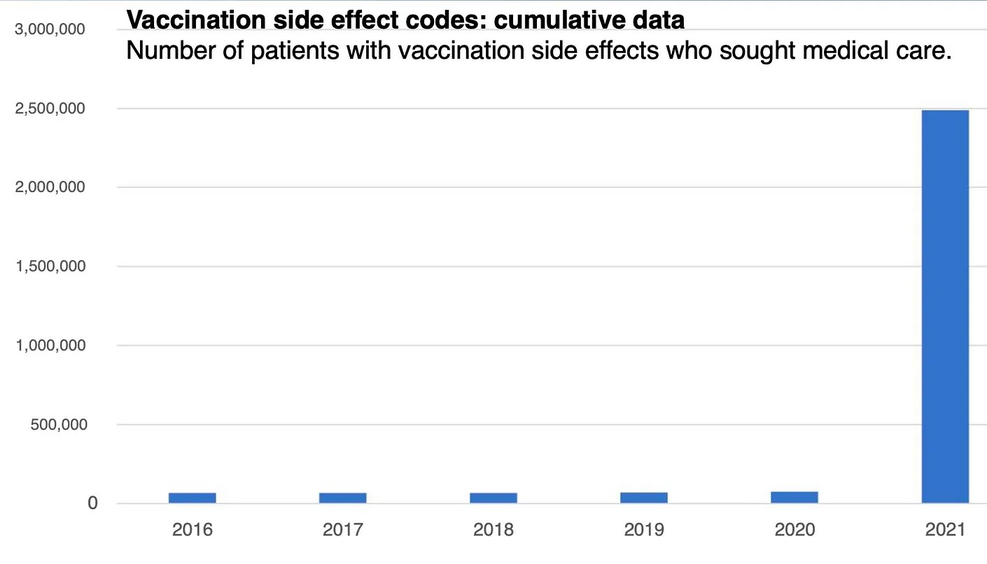
https://www.destatis.de/EN/Themes/Countries-Regions/International-Statistics/Data-Topic/Population-Labour-Social-Issues/Health/Influenza-2.html
23. I say that on the subject of mass killings, more evidence has emerged to corroborate this in relation to large numbers of children and young adults dying suddenly in 2021 and 2022
CDC and OECD data shows a large rise in excess mortality for 0 to 44 year olds in 2021 and 2022 in the USA. The statistics show a big increase from week 31 in 2021 onwards when mass covid19 vaccinations of young people and children started in the USA.
I present Exhibit 37 which are statistics charts using CDC and OECD data confirming this.
24. I say that Research of Multiple Scientific studies shows that myocarditis, pericarditis and heart inflammation are common adverse effects for the mRNA vaccines and this has serious repercussions for children and young adults who face premature death from this or a lifetime of serious disabilities.
Cardiac complications following mRNA COVID-19 vaccines: A systematic review of case reports and case series
Safiri et al. 2022
https://pubmed.ncbi.nlm.nih.gov/34921468/
In consideration of the scientific facts from this particular scientific study, do the HSE, Irish doctors and Irish hospitals check for the following in covid19 vaccinated children and adults after vaccinations ?
(i) CK-MB, troponin, and NT-proBNP which were elevated in 100%, 99.5% and 78.3% of subjects, respectively.
(ii) ST-segment abnormality which was the most common electrocardiogram feature.
(iii) Cardiac magnetic resonance imaging, which is the gold-standard approach for diagnosing myocarditis, and was abnormal in all patients in the scientific study above.
(iv) Vascular ultrasound is a noninvasive test healthcare providers use to determine how blood flows in arteries and veins in your arms, neck and legs. This will identify dangerous blood clots.
(v) d-dimer tests for abnormal blood clotting and tests for blood oxygen levels for evidence of enhanced hypoxia. Massive blood clots have been removed by Pathologists and Embalmers from the bodies of dead covid19 vaccinated people.
(vi) sensitive tests and MRI, CAT and other scans for subclinical myocarditis, pericarditis and evidence of heart inflammation as found in scientific studies in Thailand and Switzerland referenced on pages 31-32 in our last sworn affidavit filed in the High Court on December 12th 2022.
(vii) C-reactive protein and TNF-a for evidence of enhanced inflammation. Evidence of severe inflammation has been found in the bodies of dead covid19 vaccinated people by Pathologists.
(viii) amyloid-beta and phosphorylated tau for evidence of increased predisposition to Alzheimer’s disease, and serum HMGB1, CXCL13, and Dickkopf-1 for evidence of an increased disposition to autoimmune disease.
The HSE and hospitals both public and private and Irish health authorities have not and are not routinely testing for these in covid19 vaccinated children and adults. And this failure is placing many lives at risk.
24a. I further say that some very important scientific studies have emerged in 2023 regarding the link between covid19 vaccination and the onset of myocarditis and other heart condition. The first is a report titled ‘Myocarditis: Once Rare, Now Common’ by Dr. Thomas Levy a medical doctor, cardiologist and lawyer presents the scientific and medical evidence showing how the spike proteins created by the vaccine in the body leads to myocarditis, pericarditis and other heart illnesses. And that these illnesses have suddenly become more common after mass covid19 vaccinations. And the second is a published scientific paper by Li et al.
They should be required reading for all medical doctors, cardiologists, and government advisors and elected politicians in all countries.

Myocarditis: Once Rare, Now Common
by Thomas E. Levy, MD, JD. January 2023
http://orthomolecular.org/resources/omns/v19n01.shtml

Clinical cardiovascular emergencies and the cellular basis of COVID-19 vaccination: from dream to reality?
Li et al. 2022
https://pubmed.ncbi.nlm.nih.gov/36075372/
These scientific papers are Exhibit 69 for the court.
25. I further say that there are more published peer reviewed scientific papers to further corroborate the link between covid19 vaccinations and Myocarditis and serious abnormalities and illnesses of the heart, and that this increases the risk of premature death. This applies to children and young adults. And I say there is more evidence to show that regulatory authorities in the USA, Europe and Ireland failed in their duties to regulate and to protect the general public.

100% Of Kids 14-16 With mRNA COVID Vaccine Induced Myocarditis Had Damaged Hearts At 3-6 Month Follow Up
Admission and follow-up cardiac magnetic resonance imaging findings in BNT162b2 Vaccine-Related myocarditis in adolescents
Ozen et al. 2022
https://www.tandfonline.com/doi/abs/10.1080/23744235.2022.2157478?role=tab&scroll=top&needAccess=true&journalCode=infd20
Seven (77.7%) patients had abnormal electrocardiography (ECG) findings, and the most prevalent finding was diffuse ST-segment elevation. Initial cardiac MRI results were abnormal in all patients, where 8 (88.8%) patients had late gadolinium enhancement, and 5 (55.5%) had myocardial edoema. Three patients showed local left ventricular wall-motion abnormalities. In their follow-up MRIs 3–6 months later, myocardial edoema was present in 2 (28.5%) patients, while late gadolinium enhancement was present in all patients (7/7, 100%, 2 patients did not have control MRI time).
- 100% late gadolinium enhancement present at 3-6 month follow up.
- 77.7% abnormal ECG findings (ST-elevation most common).
- late gadolinium enhancement on 88.8% of MRIs.
- 55.5% myocardial edoema (excess fluid). Use of mRNA COVID-19 Vaccine After Reports of Myocarditis Among Vaccine Recipients: Update from the Advisory Committee on Immunization Practices — United States, June 2021
Gargano et al. 2021
https://www.ncbi.nlm.nih.gov/pmc/articles/PMC8312754/
This initial report established the serious problem of myopericarditis in adolescents following mRNA inoculation was published in June 2021. June 2021 was one month AFTER the FDA received the priority review for EUA for 12 to 15-year-olds to receive the mRNA vaccine. This raises the question about what the FDA knew about myocarditis and when they knew it — because this paper would have been peer-reviewed some months before it was published. Thus, the findings of heart damage in teenagers would have been available to the FDA at the time when it granted EUA for the Pfizer injection. However, the Emergency Use Authorization itself in May 2021 did NOT mention any risk of myocarditis in adolescents. It wasn’t until August — after hundreds of thousands of 12 to 15-year-olds were injected — that the FDA finally disclosed to the general public the legitimate concerns of myocarditis in this age group. Due to the lack of disclosure by the FDA of the known harms, the parents who chose to have their teenagers vaccinated with mRNA vaccines, therefore, could not have made use of fully informed consent. As the European Medicines Agency had access to the same FDA data and decisions, and followed the FDA’s decisions, the European Medicines Agency is equally guilty. And the Irish health authorities obeyed the European Medicines Agency without question.
In March 2022, the dire consequences of this Non Disclosure and disaster were finally exposed when a scientific study found 35 cases of myocarditis in children within one week after receiving the second dose of the Pfizer mRNA injection.
Source: https://dailyclout.io/pfizer-vaccine-fda-fails-to-mention-risk-of-heart-damage-in-teens/

Scientific study of March 2022
Persistent Cardiac Magnetic Resonance Imaging Findings in a Cohort of Adolescents with Post-Coronavirus Disease 2019 mRNA Vaccine Myopericarditis
Schauer et al. March 2022
https://www.jpeds.com/article/S0022-3476(22)00282-7/fulltext
Changes of ECG parameters after BNT162b2 vaccine in the senior high school students
Wang et al. 2023
https://link.springer.com/article/10.1007/s00431-022-04786-0 or https://pubmed.ncbi.nlm.nih.gov/36602621/
The researchers conducted electrocardiograms (ECGs), which measure the heart rhythm, on 4,928 high schoolers in Taipei City, the capital of Taiwan, before and after their second Pfizer shot. Over 90 percent of the students were male. (High school is the same as secondary school in Ireland).

In total, 763 students (17.1%) had at least one cardiac symptom after the second vaccine dose, mostly chest pain and palpitations. They found 51 children (1%) had significant changes in their ECGs after the second Pfizer jab. And 1 in 1,000 had significant arrhythmias or myocarditis / pericarditis. Those included a student with premature ventricular contractions, which can raise the risk of sudden cardiac death. QRS duration and QT interval decreased significantly after the vaccine with increasing heart rate (mean increase of 2.6 beats per minute). “The arrhythmia triggering effect by BNT162b2 [Pfizer] vaccine needs further study to elucidate,” the scientists wrote. Should government and health authorities be subjecting children to these risks and dangers ?
The following video lecture by Dr. John Campbell in the UK provides the medical and scientific facts about this important scientific paper to the general public - https://www.youtube.com/watch?v=eYz-yelhkYE
COVID-19 vaccine induced myocarditis in young males: A systematic review
Prasad et al. 2022
https://onlinelibrary.wiley.com/doi/full/10.1111/eci.13947
This paper is important as it uses Age Stratification and reveals a very high risk for myocarditis for those aged 18 to 24 and those under 30 and those under 18 among the covid19 vaccinated.
One of the authors gave a lecture about this scientific paper online - https://www.youtube.com/watch?v=5tYcZq9bIYU
and at https://sensiblemed.substack.com/p/our-new-analysis-of-myocarditis-after

News report: 1 in 35 Experience Cardiac Injury After 3rd COVID Vaccine: Study
https://www.ntd.com/1-in-35-experience-cardiac-injury-after-3rd-covid-vaccine-study_880965.html

Clinically Suspected Myocarditis Temporally Related to COVID-19 Vaccination in Adolescents and Young Adults: Suspected Myocarditis After COVID-19 Vaccination
Truong et al. 2022
https://pubmed.ncbi.nlm.nih.gov/34865500/
And Dr. Peter McCullough has updated his analysis of scientific studies worldwide linking covid19 vaccines to Myocarditis and other heart conditions at
https://petermcculloughmd.substack.com/p/every-bit-of-heart-muscle-matters#_edn1
This corroborates the scientific evidence we have provided so far.
Incidence non négligeable des myocardites après 3ème dose de vaccin à ARN messager anti-COVID 19
(Significant incidence of myocarditis after 3rd dose of anti-COVID 19 messenger RNA vaccine)
Le Pessec et al. 2022
https://www.cardio-online.fr/Actualites/A-la-une/ESC-2022/Incidence-non-negligeable-myocardites-apres-3-dose-vaccin-ARN-messager-anti-COVID-19
SARS-CoV-2 Vaccination and Myocarditis in a Nordic Cohort Study of 23 Million Residents
Karlstad et al. 2022. JAMA Cardiology
https://jamanetwork.com/journals/jamacardiology/fullarticle/2791253
CONCLUSIONS AND RELEVANCE: Results of this large cohort study indicated that both first and second doses of mRNA vaccines were associated with increased risk of myocarditis and pericarditis. For individuals receiving 2 doses of the same vaccine, risk of myocarditis was highest among young males (aged 16-24 years) after the second dose. These findings are compatible with between 4 and 7 excess events in 28 days per 100 000 vaccinees afterBNT162b2, and between 9 and 28 excess events per 100 000 vaccinees after mRNA-1273.
In the above scientific study, for 16-24 year old males, post vaccination myocarditis rates were 6 (pfizer-pfizer) to 19 (moderna-moderna) to 28 (pfizer-moderna) times HIGHER than males aged 12-15. This is massive increase ein risk of myocarditis for children and young adults.
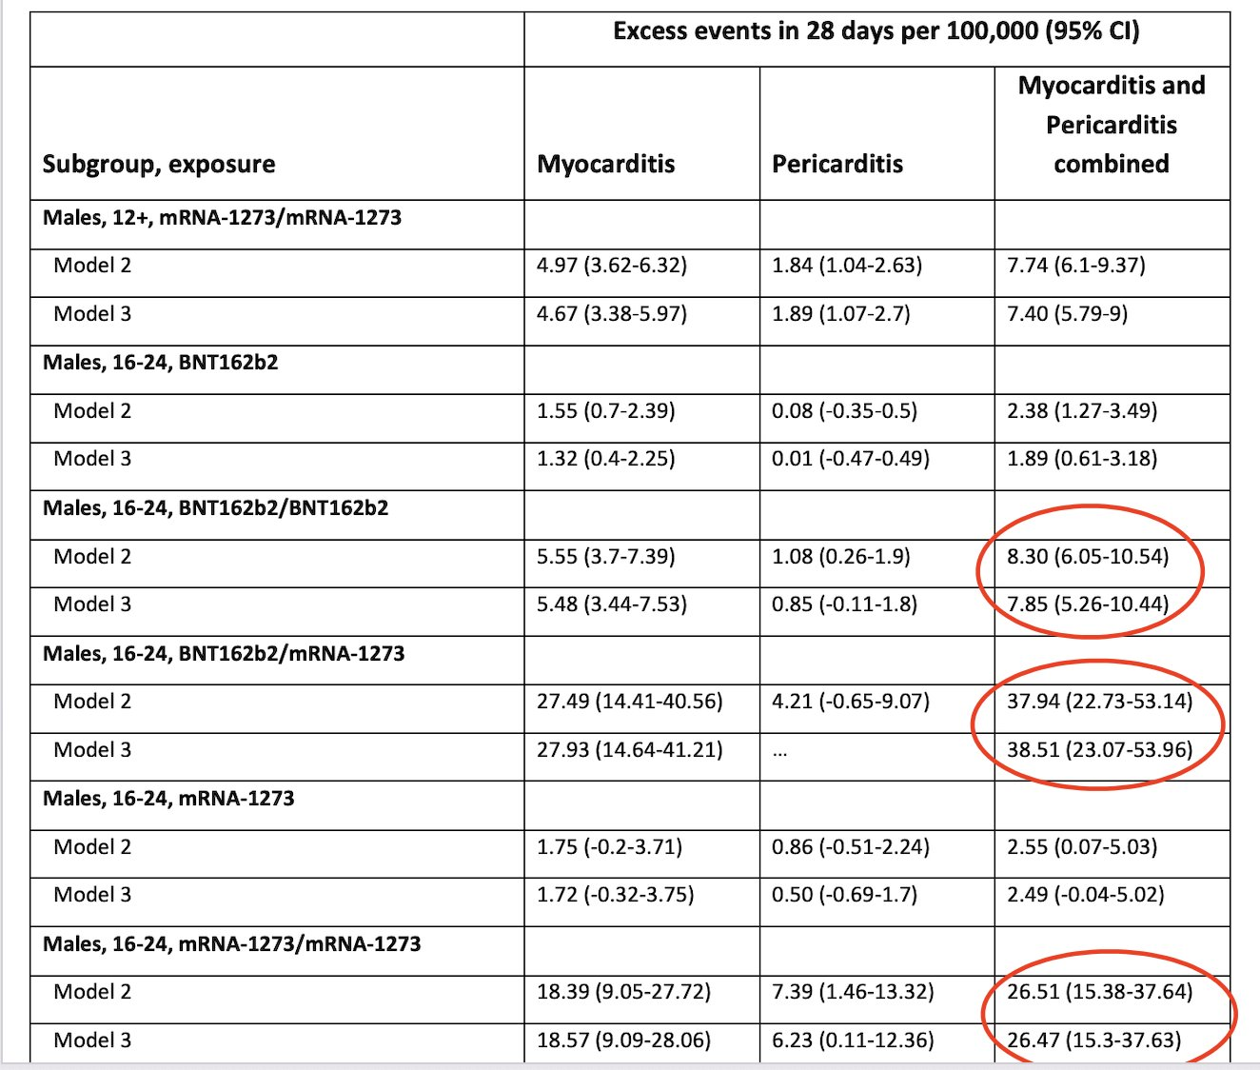
Sources: Dr. Tracey Hoeg, https://twitter.com/TracyBethHoeg/status/1583303306218127361
and https://jamanetwork.com/journals/jamacardiology/fullarticle/2791253

Booster Vaccination with SARS-CoV-2 mRNA Vaccines and Myocarditis Risk in Adolescents and Young Adults: A Nordic Cohort Study of 8.9 Million Residents
Hviid et al. 2022
https://www.medrxiv.org/content/10.1101/2022.12.16.22283603v1
A new Nordic study of 8.9 million found a nearly 9-times increased rate of myocarditis 28 days following a 3rd dose of Moderna's mRNA booster VS dose 2 (8.89, 95% CI: 2.26-35.03) in males 12-39 from Denmark, Finland, Noway, and Sweden.
Serial Changes in Troponin I in COVID-19 Vaccine-Associated Myocarditis
Jairo Aldana-Bitar et al. Cardiol Res. 2022 Aug; 13(4): 250–254.
https://www.ncbi.nlm.nih.gov/pmc/articles/PMC9451592/#!po=22.7273
Other important published scientific studies which corroborate this include:

Jan 2022, JAMA study found myocarditis risk increased in multiple age, sex groups after mRNA COVID-19 vaccination, highest in young men. https://jamanetwork.com/journals/jama/fullarticle/2788346
- Study of VAERS data between Jan-Jun 2021 found highest rate of myocarditis in young boys 12-15 after dose 2 of mRNA COVID-19 vaccination. https://onlinelibrary.wiley.com/doi/10.1111/eci.13759
- This slide presentation to the CDC and FDA on myocarditis should have rung some IMMEDIATE alarms bells - but they went on vaxxing the young people anyway. https://fda.gov/media/159007/download
- Study in Nature found increased risks of myocarditis and pericarditis in France after Covid-19 mRNA vaccines, particularly after 2nd dose and in age 18-24 yrs, both male and female were affected. https://www.nature.com/articles/s41467-022-31401-5
- CDC report 2022 found 14 cases of myocarditis or pericarditis among 102,091 males aged 16-17 who received Pfizer-BioNTech Covid-19 vaccine, significant departure from reported rates in 2021, showing concerns labeled as misinformation are real. https://thefederalist.com/2022/09/09/cdc-admits-post-vaccine-myocarditis-concerns-that-were-labeled-covid-misinformation-are-legit/
- Study found myocarditis/pericarditis as rare side effect of mRNA COVID-19 vaccines, disproportionately affects young male adolescents, commonly after 2nd dose of primary series and 1st booster. https://www.acpjournals.org/doi/10.7326/M22-2274
- Myopericarditis After COVID-19 Booster Dose Vaccination
Sharff et al. 2022
https://www.ncbi.nlm.nih.gov/pmc/articles/PMC8957365/
- The estimated MMRRs and SMR were about 4 times higher than the MMRRs and SMR. The study concludes that the SARS-CoV-2 vaccine is associated with a higher risk of myocarditis death in all age groups, including the elderly. The risk may be 4 times or higher than the apparent risk of myocarditis death. https://www.medrxiv.org/content/10.1101/2022.10.13.22281036v1.full.pdf
- Markedly elevated levels of full-length spike protein were detected in the plasma of individuals with post-vaccine myocarditis, whereas no free spike was detected in asymptomatic vaccinated control subjects. It suggests that the cause of myocarditis may be linked with spike antigen. https://www.ahajournals.org/doi/10.1161/CIRCULATIONAHA.122.061025
- The risk ratio for the mRNA vaccines combined is 1.43 which means that recipients are 43% more likely to have a serious adverse event. https://www.sciencedirect.com/science/article/pii/S0264410X22010283
- BNT162b2 Vaccine-Associated Myo/Pericarditis in Adolescents: A Stratified Risk-Benefit Analysis
Hoeg et al. 2022
https://onlinelibrary.wiley.com/doi/10.1111/eci.13759
- Age and sex-specific risks of myocarditis and pericarditis following Covid-19 messenger RNA vaccines
Le Vu et al. 2022
https://www.nature.com/articles/s41467-022-31401-5
- CDC Admits Post-Vaccine Myocarditis Concerns That Were Labeled Covid Misinformation Are Legit
https://thefederalist.com/2022/09/09/cdc-admits-post-vaccine-myocarditis-concerns-that-were-labeled-covid-misinformation-are-legit/
- COVID-19 vaccine boosters for young adults: a risk benefit assessment and ethical analysis of mandate policies at universities
Bardosh et al. 2022
https://jme.bmj.com/content/early/2022/12/05/jme-2022-108449
- Comparative Safety of the BNT162b2 Messenger RNA COVID-19 Vaccine vs Other Approved Vaccines in Children Younger Than 5 Years
Toepfner et al. 2022
https://jamanetwork.com/journals/jamanetworkopen/fullarticle/2797451
- You’re going to have to vaccinate 35,000 young adults to prevent one hospitalization and in doing so you’re going to send nearly 20 of these folks into a serious adverse reaction from the vaccine https://jme.bmj.com/content/early/2022/12/05/jme-2022-108449
The consequences of this on young people and children is very severe. As of mid-December 2022, Good Sciencing in USA has recorded 1,604 cardiac arrests and 1,105 of them dead since the start of the mass covid19 vaccination campaign in Spring 2021. This number of sudden deaths, mostly cardiovascular, in such a short period of time is unprecedented. Its far higher than previous years over the last 50 years.
News Report: https://goodsciencing.com/covid/athletes-suffer-cardiac-arrest-die-after-covid-shot/
Data from Public Health Scotland shows a sudden big increase in the number of cardiovascular cases for people aged 15-44 years old in Scotland after mass covid19 vaccinations in 2021.
I present exhibit 60 the court.
According to Australian government and health authorities more than 10,200 Australians died of ischemic heart disease in the first eight months of 2022 – that is about 17 per cent higher than would be expected in a normal year.

I further say that this has serious consequences for members of the public as a leading Cardiologist called for an end to mNRA booster shots - as teen, 18 years old, tells how her reaction to the jab saw her miss her Year 12 exams: 'I've had 60 to 70 in my practice who've had similar reactions'
Dail Mail newspaper, UK. 24 November 2022
https://www.dailymail.co.uk/news/article-11464097/Covid-Australia-2022-Teen-misses-HSC-pericarditis-jab-reaction-cardiologist-issues-warning.html
and at https://www.msn.com/en-au/news/australia/covid-australia-2022-teen-misses-hsc-after-pericarditis-jab-reaction-as-cardiologist-issues-warning/ar-AA14uClj?ocid=EMMX
25a. I say that Dr. Aseem Malhotra a top Cardiologist and medical doctor based in London, England gave an important scientific and medical analysis of the covid19 vaccines on the Fox News television station on December 2nd 2022. He also discussed the absence of informed consent by those people who got the covid19 vaccines. This is viewable online at https://www.youtube.com/watch?v=w3MPnBpfrRk. This is Exhibit 45.
Dr. Peter McCullough a top Cardiologist and published scientist based in the USA and Dr. Aseem Malhotra a top Cardiologist based in Britain attended an American Thought Leaders Program in the USA and gave an interview to a news station. This can be viewed and read at
https://www.theepochtimes.com/dr-peter-mccullough-and-dr-aseem-malhotra-how-the-covid-19-vaccines-impact-the-heart_4929815.html
I quote from this interview:
“10 million Americans did it. The CDC wanted to withhold it. They were forced under court order to release it to the NGO, ICAN, and the results are bombshell. 25 per cent of people who take the vaccine are incapacitated the next day. They can’t go to work or school the day after. 7 to 8 per cent are hospitalized or go to the ER. This is the most toxic vaccine by the CDC data that we’ve ever seen in clinical medicine.” Dr. Peter McCullough said.
And Dr. Peter McCullough has updated his analysis of scientific studies worldwide linking covid19 vaccines to Myocarditis and other heart conditions at
https://petermcculloughmd.substack.com/p/every-bit-of-heart-muscle-matters#_edn1
This corroborates the scientific evidence we have provided so far. These medical and scientific facts should not continue to be ignored by the Irish government and health authorities.
25b. I further say that government databases are finding increased Deaths of Children which is strongly linked to covid19 vaccinations
Data from the CDC shows covid19 vaccinated children dying of sudden and unexpected heart and cardiovascular conditions and abnormal clotting and bleeds shortly after getting the covid19 vaccines. Other vaccines did not cause these problems for children in the past. This is a strong signal that the covid19 vaccines are not safe for children.
CDC data: https://www.cdc.gov/mmwr/volumes/70/wr/mm7031e1.htm
Expert analysis of CDC data: https://stevekirsch.substack.com/p/why-cant-anyone-explain-how-these=
26. I further say that in previous affidavits and books of evidence that very long and dangerous blood clots are being found in living and dead covid19 vaccinated people and that this is highly significant in light of the fact that many vaccinated people including children are dying of cardiovascular events, which are often termed “sudden deaths”. And that this continues to be corroborated in new scientific studies.
The spike proteins being created by all the covid19 vaccines in the human body are the key factor in this. To corroborate our evidence in the books of evidence and my sworn affidavits filed in the High Court, I cite the following published scientific study
Thromboembolic events after Ad.26.COV2.S COVID-19 vaccine: Reports to the Vaccine Adverse Event Reporting System
Woo et al. 2022
https://pubmed.ncbi.nlm.nih.gov/36065046/
Woo et al from the FDA in a report has described thousands (N=3790, 11% fatal) of patients with blood clots and their description of what happens in the human body is truly shocking and very disturbing. Clots going from the ankle to the groin, shooting to both lungs, and killing the victim are occurring and seem like a description out of a horror movie yet in this report produced by the US government, the terrible facts are exposed to the public. I include a screenshot from the scientific study below:

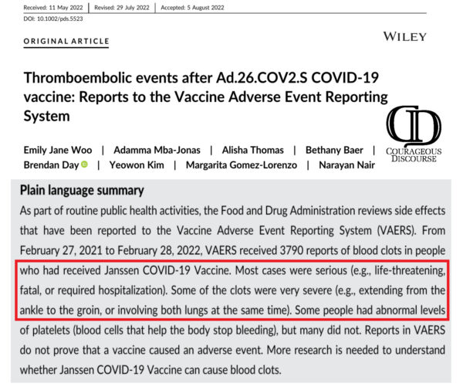
News report at https://www.theepochtimes.com/health/nih-reports-thrombi-are-long-require-hospitalization-and-are-life-threatening_4988487.html
26a. I say to corroborate prior findings showing a link between cancers and covid19 vaccinations, I will quote Dr. Ryan Cole, a Pathologist and medical doctor in Idaho in the USA, who has treated cancer and researched cancer there. Dr. Ryan Cole keeps meticulous records and noticed there was a tremendous increase in aggressive cancers after the Covid injection rollout. He also noticed that people who had well-controlled cancers were developing uncontrollable cancers and dying very quickly. Dr. Ryan Cole was interviewed online to provide his expert opinion on covid19 vaccine injuries, illnesses and deaths and his experience as a medical doctor, a Pathologist, and scientific researcher. He states that the spike protein is the main cause of these vaccine harms and deaths and that it was a big mistake or blunder for vaccine developers to use this new type of vaccine.
This is viewable at https://www.youtube.com/watch?v=2SLp6B_kkRI
I quote Dr. Ryan Cole: “The spike protein binds to a gene in our bodies that’s known as the guardian of the genome: the P53 tumour suppressor gene, Dr. Cole explained. “It also binds to a breast cancer gene and an ovarian cancer gene.” The spike protein binding to these receptors allows tumors to grow unimpeded.
“There’s an uptick of some unusual cancers that I’ve been seeing … This should at least open the door to other pathologists and universities to say ‘well, we should maybe go back and look at some of these unusual fast-spreading cancers in young patients that we normally don’t see’,” said Dr. Cole.
“There’s at least a dozen mechanisms that the spike can induce in those cancer pathways … One way is that micro clotting can cause the “choking off” of tissues [as] cancers like an oxygen-depleted environment.”
The web site of Dr. Ryan Cole is at https://www.colediagnostics.com/
27. I say that data from the VAERS database of the CDC in the USA shows Pulmonary Embolism is elevated by 500 to 1,000 times for covid19 vaccines compared to other vaccines
In the chart below, the query for ‘Pulmonary Embolism’ for covid19 on the VAERS database of the CDC is compared to all other vaccines. The figure of 13,608 for covid19 is 500 to 1,000 times higher than other vaccines and is higher than all other vaccines combined over the last 32 years. Pulmonary Embolism is the best signal for adverse effects of the covid19 vaccines. This has recently been acknowledged by both the FDA and CDC in the USA. Pulmonary Embolism is linked to the large clots pulled out of dead covid19 vaccinated people and the abnormal blood clotting found in living covid19 vaccinated people.
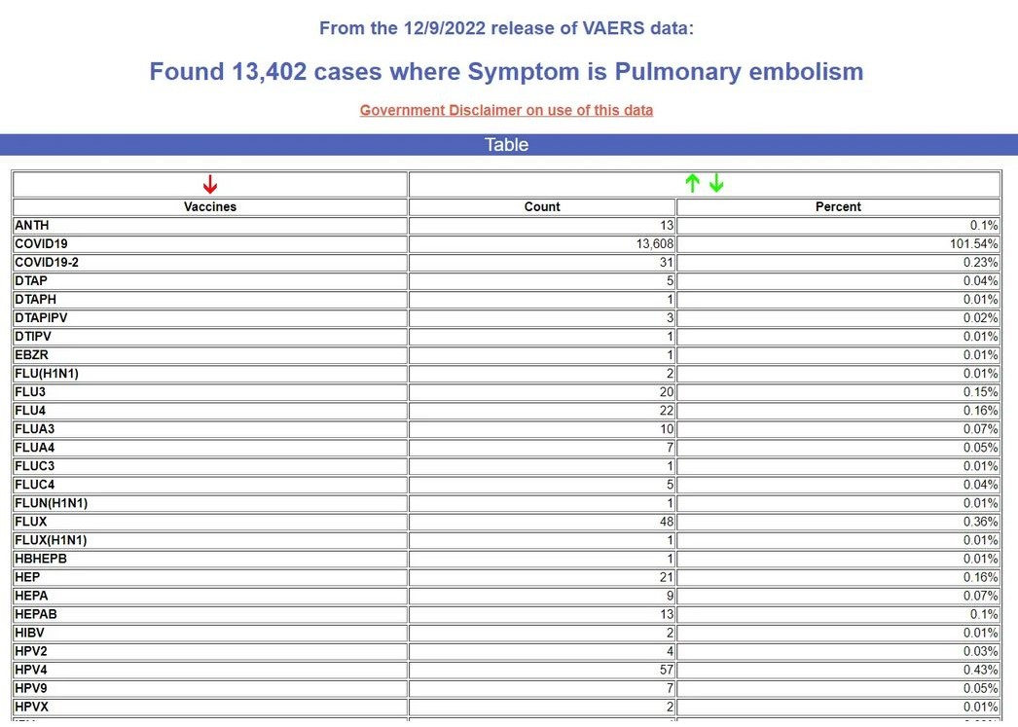
Steve Kirsh a data analyst and statistician based in the USA analysed these statistical results online at
https://stevekirsch.substack.com/p/fda-acknowledges-that-pulmonary-embolism?utm_medium=ios

A recent published scientific study shows that the spike protein can block or prevent the breakdown of blood clots. This is a major factor in the formation of massive blood clots inside covid19 vaccinated people. This has serious implications for covid19 vaccinated people including children.
SARS-CoV-2 spike protein S1 induces fibrin(ogen) resistant to fibrinolysis: implications for microclot formation in COVID-19
Grobelaar et al. 2021
https://www.ncbi.nlm.nih.gov/pmc/articles/PMC8380922/
The Irish health and government authorities should NOT be subjecting Irish children to the risk of Pulmonary Embolism which is fatal in many cases and can lead to life long health problems for survivors.
28. I further say that the Food and Drug Administration (FDA) has recently found that Pfizer’s COVID-19 vaccine has been linked to dangerous blood clotting in older individuals, and this confirms and corroborates our books of evidence and sworn affidavits. FDA researchers, crunching data from a database of elderly persons in the United States, found that pulmonary embolism—blood clotting in the lungs—met the initial threshold for a statistical signal and continued meeting the criteria after a more in-depth evaluation. The vaccine increases risk of lung blood clots by 50% and acute myocardial infarction by 41%. This is very serious.
Two other outcomes of interest — a lack of oxygen to the heart, a blood platelet disorder called immune thrombocytopenia, and another type of clotting called intravascular coagulation are also linked to the vaccine but require further research, researchers said. These are being investigated to establish how the Pfizer covid19 vaccine is causing these conditions, and the risk to public health. Scientific paper below.
Surveillance of COVID-19 vaccine safety among elderly persons aged 65 years and older
Anderson, FDA et al. December 2022. Vaccine
https://www.sciencedirect.com/science/article/pii/S0264410X22014931
Dr. Joseph Fraiman a hospital doctor in Louisiana in the USA and published scientist who has published papers about covid19 and covid19 vaccines tweeted the following about this
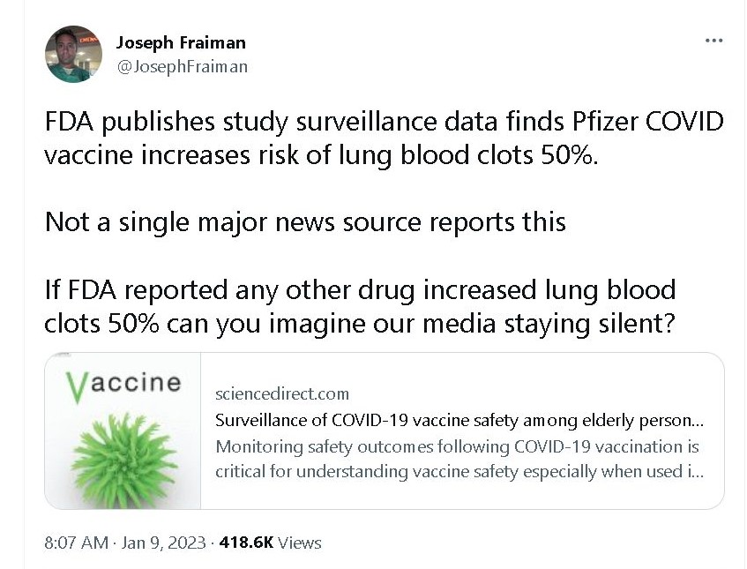
This was followed by a tweet from Dr. Aseem Malhotra one of the top cardiologists in Britain
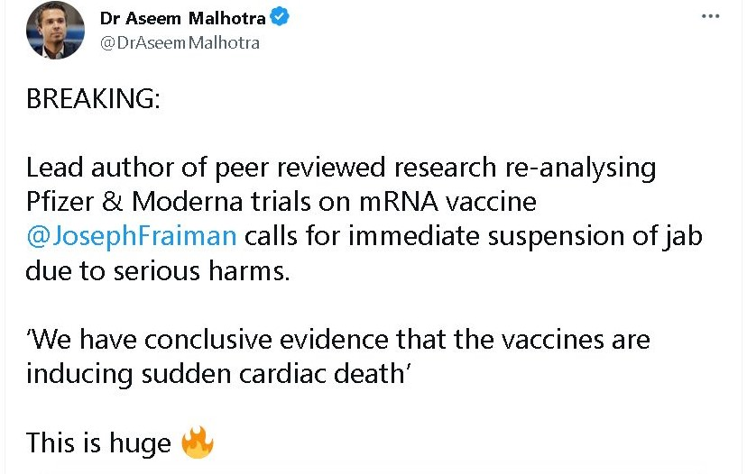
Dr. Joseph Fraiman gave a video interview about these new scientific findings at https://rumble.com/v24k8be-its-time-to-withdraw-the-mrna-vaccines.html
and scientific news report at https://www.theepochtimes.com/health/doctor-calls-for-withdrawal-of-pfizer-moderna-covid-19-vaccines-following-new-research_4975379.html
This important scientific news is not being reported in the mainstream press and media and this corroborates our other research showing continuing censorship of the press and media. This censorship has completely undermined informed consent for these vaccines.
29. I further state that Statistical analysis of data from the VAERS database of the CDC in the USA shows increased risk for several other fatal illnesses and life long disabilities from the covid19 vaccines compared to other vaccines
This statistical analysis was carried out by Steve Kirsch in the USA.
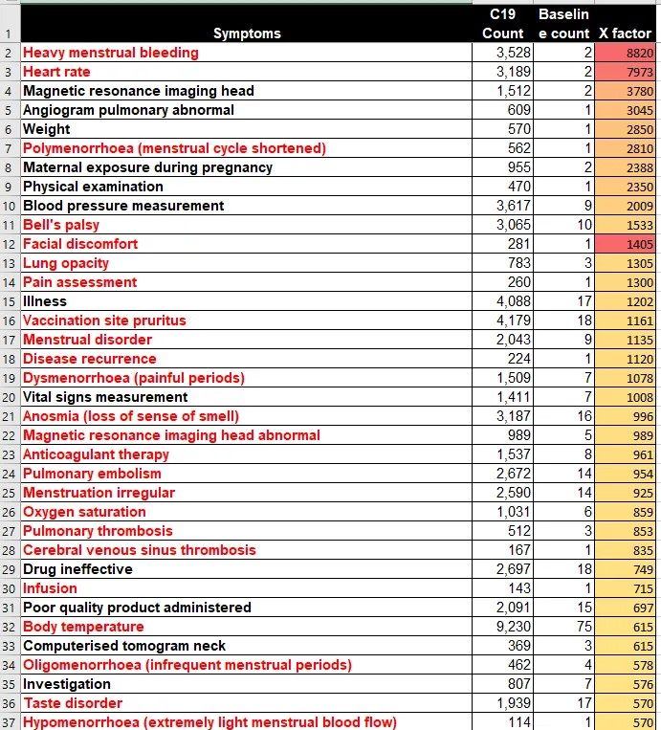
Source: VAERS database of CDC and
https://stevekirsch.substack.com/p/new-vaers-analysis-reveals-hundreds and
https://stevekirsch.substack.com/p/the-vaers-x-factor-analysis
The Irish health and government authorities should NOT be subjecting Irish children to the risk of Pulmonary Embolism which is fatal in many cases and can lead to life long health problems for survivors.
29a. I further say that viewing all of the serious illnesses and disabilities being caused by these covid19 vaccines as presented here in this affidavit and other affidavits and books of evidence that critically ill people including children will not benefit from covid19 vaccines and boosters which add additional illnesses and disabilities to their existing illness, and burden them even more. And these additional burdens could lead to premature death. I cite a scientific study by Dy. Yamamoto in Japan about this
Adverse effects of COVID-19 vaccines and measures to prevent them
Yamamoto. 2022
https://www.ncbi.nlm.nih.gov/pmc/articles/PMC9167431/
29b. I say that the serious adverse effects of these covid19 vaccines are dire even for small children. For example, a new entry on the VAERS data base shows that a healthy 2 year old child died shortly after getting her covid19 vaccination on December 15th 2022 in new Hampshire in the USA. She died of “sudden death” 24 hours after getting her covid19 vaccination on December 16th 2022.
News report at https://www.thegatewaypundit.com/2023/01/2-year-old-child-dies-suddenly-one-day-receiving-covid-vaccine-annual-flu-vaccine/
30. I further state a strong link between Cancers and the covid19 vaccinations. I further say that these cancers can occur in adults and children and that the immunological and biological changes induced by the covid19 vaccines make both adults and children more vulnerable to these cancers.
A video interview of Professor Dalgleish who is Professor of Oncology at St George’s University of London, a Fellow of the Royal College of Physicians of the UK and Australia, the Academy of Medical Sciences, and the Royal College of Pathologists. As an Oncologist, his main focus has been on diagnosing cancers, treating cancers, researching cancers, and developing immunotherapies to treat cancers. Professor Dalgleish confirms the findings of Dr. Ryan Cole in relation to the link between cancers and covid19 vaccines, especially boosters. The interview is viewable at https://rumble.com/v1yw7f8-are-covid-boosters-causing-cancer.html and at
http://www.drtesslawrie.substack.com/p/are-covid-boosters-causing-cancer?utm_source=substack&utm_medium=email#play
and Professor Dalgleish wrote an excellent article in a leading journal titled
‘Other cancer specialists agree with me about vaccine harm, but the authorities still won’t listen’
https://www.conservativewoman.co.uk/other-cancer-specialists-agree-with-me-about-vaccine-harm-but-the-authorities-still-wont-listen/
And he wrote a news article recently about his experiences. This is available at https://dailysceptic.org/2022/12/19/i-have-tried-sounding-the-alarm-about-the-vaccines-causing-cancer-relapse-but-the-mainstream-media-dont-want-to-know/
This corroborates the scientific and medical findings of Dr. Ryan Cole in the USA showing a link between certain cancers and new more aggressive cancers and covid19 vaccines. These vaccines are NOT serving the Common Good and the Public Interest in Ireland. Dr. Dalglish has stated “I believe vaccinating children with these vaccines is gross criminal incompetence and/or negligence.”
30a. I further say that more corroborating scientific research continues to show covid19 can cause a worsening of certain cancers. I further say that these cancers can occur in adults and children and that the immunological and biological changes induced by the covid19 vaccines make both adults and children more vulnerable to these cancers.
Rapid Progression of Angioimmunoblastic T Cell Lymphoma Following BNT162b2 mRNA Vaccine Booster Shot: A Case Report
Goldman et al. 2021
https://www.frontiersin.org/articles/10.3389/fmed.2021.798095/full
More corroborating evidence has been found which backs up the evidence in our books of evidence and previous sworn affidavits. More cancers have been linked to covid19 vaccines than all other vaccines in history. More cancers have been caused by covid19 vaccine than from the flu vaccine which has been given to greater numbers of people.
SARS–CoV–2 Spike Impairs DNA Damage Repair and Inhibits V(D)J Recombination In Vitro
Jiang et al. 2021
https://www.mdpi.com/1999-4915/13/10/2056
This adversely affects p53 which is involved in suppressing cancer. Its loss makes people vulnerable to cancers, including more aggressive cancers. This research shows SARS-CoV-2 spike protein obliterates 90% of the DNA repair mechanism in lymphocytes, a type of white blood cells that help your body fight infection and chronic disease, including cancer.
Scientific analysis of this is at
https://arkmedic.substack.com/p/welcome-to-gilead?utm_source=substack&utm_campaign=post_embed&utm_medium=web
A search of the CDC VAERS database on the number of cancer cases reported as adverse reactions to the Covid-19 injections since they were first rolled out in the USA, reveals that from December 2020 up to 5th August 2022, a total of 2,579 adverse events related to cancer were made in just 1 year and 8 months. These involve approximately 606 million doses.
See Exhibit 32
A search of the VAERS database on the number of cancer cases reported as adverse events to all other available vaccines between 2008 and 2020, a period of 13 years, reveals there were just 791 adverse events related to cancer. These involve over 1 billion vaccine doses.
See Exhibit 32
Comparison of the flu vaccine where 1.7 billion doses were given between 2008 and 2020 and the covid19 vaccine where 606 million doses were given in the USA between December 2020 and August 2022 provides an appropriate example. The first chart in Exhibit 33 shows the total number of flu vaccine doses administered in 13 full flu seasons all the way from the 2008/2009 flu season to the 2019-2020 flu season. The data has been extracted from the CDC’s VAERS database. This totals 1.7 billion doses.
In the second chart in Exhibit 33, according to ‘Our World in Data’, as of 9th August 2022, 606 million doses of the Covid-19 vaccines have been administered in the USA. This means there have been actually nearly 3 times as many flu vaccines administered between 2008-2020 as Covid-19 injections.
In the third chart in Exhibit 33 the CDC data confirms that between 2008 and 2020, a period of 13 years, there were just 64 events related to cancer reported as adverse reactions to the influenza vaccines.
In the fourth chart in Exhibit 33, the adverse events related to cancer for covid9 vaccines are compared against flu vaccines. 2,579 for covid19 vaccines and 64 for flu vaccines, even though 3 times more flu vaccines were given.
Seneff et al. from MIT in the USA has also carried out scientific research into the link between covid19 vaccines and cancers. They presented a chart of data from VAERS of the CDC, se below:
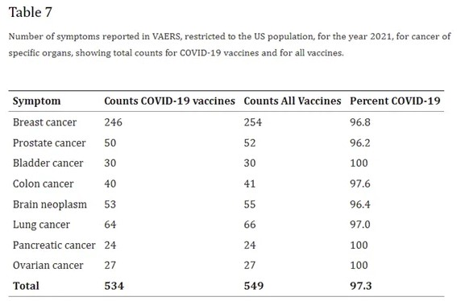
Source: Innate immune suppression by SARS-CoV-2 mRNA vaccinations: The role of G-quadruplexes, exosomes, and MicroRNAs. Seneff et al. 2022. https://www.ncbi.nlm.nih.gov/pmc/articles/PMC9012513/ “We identify potential profound disturbances in regulatory control of protein synthesis and cancer surveillance. These disturbances potentially have a causal link to neurodegenerative disease, myocarditis, immune thrombocytopenia, Bell’s palsy, liver disease, impaired adaptive immunity, impaired DNA damage response, and tumorigenesis.”
The VAERS database is a good indicator of the safety or lack of safety of a vaccine on an international level. Its findings have relevance to Ireland. Its certainly very important for Ireland as Ireland lacks such capability and has nothing comparable to VAERS and V-Safe in the USA.
Swedish pathologist, researcher and senior physician at Lund’s University in Sweden, Dr. Ute Kruger, has observed an explosion in rapidly advancing cancers in the wake of the COVID-19 vaccinations. For example, she’s noticed:
- Cancer patients are getting younger — The largest increase is among 30- to 50-year-olds.
- Tumor sizes are dramatically larger — Historically, 3-centimeter tumors were commonly found at the time of cancer diagnosis. Now, the tumors they’re finding are regularly 4 to 12 centimeters, which suggests they’re growing at a much faster rate than normal.
- Multiple tumors in multiple organs are becoming more common.
- Recurrence and metastasis are increasing — Kruger points out that many of the cancer patients she’s seeing have been in remission for years, only to suddenly be beset with uncontrollable cancer growth and metastasis shortly after their COVID-19 jab.
Source: https://doctors4covidethics.org/covid-vaccination-and-turbo-cancer-pathological-evidence/
and https://etana.substack.com/p/turbo-cancer
Dr. Joseph Marcela, a medical doctor in the USA has publicly stated
“Research shows that SARS-CoV-2 spike protein obliterates 90% of the DNA repair mechanism in lymphocytes, white blood cells that help your body fight infection and chronic disease, including cancer.”
and provided analysis of scientific studies about this on a scientific news article at https://childrenshealthdefense.org/defender/covid-boosters-increase-cancer-young-adults-cola/
This corroborates the scientific and medical findings of Dr. Ryan Cole in the USA showing a link between certain cancers and new more aggressive cancers and covid19 vaccines. These vaccines are NOT serving the Common Good and the Public Interest in Ireland.
30b. I further say that scientific studies show that the spike protein created by the vaccine in the body causes serious damage to mitochondria and that this has serious implications for vaccinated people. And that the evidence shows that it also damages the nervous system. These injuries, illnesses and disabilities resulting for this are serious and can be life long.
A study of mitochondrial effects showed that the spike protein, alone, increased microglia mitochondrial activity producing extremely high levels of reactive oxygen and reactive nitrogen species. This makes the microglia more destructive than they normally would be. The study found extensive changes in the chemicals of mitochondria exposed to spike proteins. They noticed an increase in chemokines and cytokines. The spike protein also increased the ACE2 receptor binding site by 50% on microglia which means a lot more of them would be affected by the spike protein. Overall, the study found, there was a 64% increase in the principal inflammatory component, inflammasome, in a cell. It also showed that the spike protein impaired the ability of the brain to tolerate inflammation and greatly enhanced the brain cytokine storm.
Scientific study: https://link.springer.com/article/10.1007/s11481-021-10015-6
Another study of the effects of the spike protein on mitochondria found the spike protein caused microglia to switch to glycolysis – this is what cancer does. Glycolysis increases inflammation and excitotoxicity.
Scientific study: https://pubs.acs.org/doi/10.1021/acschemneuro.1c00675
The spike protein has also been shown to enter endothelial cells and rapidly enter the nucleus. It also damages the mitochondria of endothelial cells. Both have the effect of reducing endothelial cell function, which is essential to blood vessel function. The endothelial cell is particularly important for the blood-brain barrier. Reduced endothelial cell function causes damage to arteries, arterioles and capillaries in the brain. Damage to these vessels can lead to stroke and aneurysms.
Scientific study: https://www.mdpi.com/1999-4915/13/10/2021
A study published in March 2022 injected a fragment of the spike protein, the S1 subunit, into the hippocampus of mice. The hippocampus is a region of the brain that is associated primarily with memory. “They found a profound cognitive deficit,” Dr. Blaylock , a retired neurosurgeon said. The study found neurons were remarkably decreased and an increase of 59%-63% in astrocyte activation in the two zones which relate to learning and memory, and affective brain function. The study authors determined that the death of the neurons was secondary to microglial activation caused by the spike protein. “So, just the S1 fragment alone can cause a severe cognitive deficit,” a Dr. Russell Blaylock stated.
“The brain has a special anti-inflammatory system built into it, which is called the alpha-7 nicotinic acetylcholine receptor, and what this does is it down-regulates all the inflammatory responses. It’s also responsible for memory and learning. And so, what they found, is after immunisation with the spike protein it develops these immune reactions to the spike protein, just of that fragment, and there was a loss in episodic memory in those animals. The second injection was even worse. Which demonstrates the priming effect that we discussed. The second injection is always worse.”
a Dr. Russell Blaylock a retired neurosurgeon further stated.
Scientific studies: https://www.nature.com/articles/s41598-022-09410-7
and https://www.sciencedirect.com/science/article/pii/S0006291X22009779
and https://www.frontiersin.org/articles/10.3389/fimmu.2021.656700/full

31. I say that the evidence shows a combination of covid19 government policies including unnecessary, illegal and unlawful lockdowns which blocked and stopped cancer screenings and covid19 vaccines have caused a massive rise in Cancers, and that the government and health authorities are responsible for this and are guilty of mismanagement, fraud and deception, malfeasance in public office and gross failure in their duty of care to the general public.
The Telegraph newspaper in Britain had the following headline
‘Deadly cancer timebomb’ as thousands more than expected killed by the illness since pandemic
15 December 2022. The Telegraph newspaper
https://www.telegraph.co.uk/news/2022/12/15/deadly-cancer-timebomb-thousands-expected-killed-illness-since/
32. I say that the CDC and FDA are going to investigate the link between covid19 vaccines and strokes, and that Reuters and the mainstream press and media are beginning to report on deaths caused by the covid19 vaccines and that the illegal censorship is beginning to diminish. I cite the following news report.
U.S. FDA, CDC see early signal of Pfizer bivalent COVID shot's link to stroke
Reuters, January 13 2023
https://www.reuters.com/business/healthcare-pharmaceuticals/us-says-pfizers-bivalent-covid-shot-may-be-linked-stroke-older-adults-2023-01-13/

33. I say that Causality has been proven by 21 Factors which conform to the Bradford Hill criteria. The other party, the defendants in this court case have claimed in their affidavits that ‘correlation does not prove causality’. We are using multiple correlations and going well beyond correlations to look at other criteria for Causality and the Bradford Hill criteria. We are using multiple types of corroboration. These many other criteria when taken as a whole prove Causality.
I further say that the following findings are being added to the Causality section stated in Point 22, pages 67 - 69, in the previous affidavit filed in the High Court on December 12th 2022. They are additions to points 1 – 8 in that affidavit. There is now a total of 21 Factors.
(9) Big rise in Excess Mortality statistics for highly covid vaccinated countries across the world shortly after mass covid19 vaccinations
Excess Mortality statistics for Britain show a sudden large rise in Excess Mortality in children aged 0 to 14 years old from Quarter 3 2021 into 2022. This correlates to mass covid19 vaccinations of children from Quarter 3 2021 and into 2022. The statistics show that there was negative excess mortality for this age group up until Quarter 3 2021 and then suddenly there was a large increase in excess mortality after this and the rising covid19 vaccinations line correlates with this rise in excess mortality. These statistics are from the Office for National Statistics and UKHSA in Britain and were compiled by Ed Dowd a data analyst in the USA. The statistics and charts are provided online at http://phinancetechnologies.com/HumanityProjects/Projects.htm#Nav_ExcessDeaths
I present Exhibit 40 to the court.
I present Exhibit 41 to the court showing excess mortality across different age groups for years 2020 to 2022 which show children and young adults have experienced a sudden rise in excess mortality after mass covid19 vaccinations began in Quarter 3 2021.
I present to the High Court the statistical evidence from 16 European countries which show a sudden large rise in excess mortality for children aged 0 to 14 in 2021 and 2022 and in young adults under 30 years old during this period which correlate to mass covid19 vaccinations in those countries. I present similar statistics for the USA, Britain and Australia which confirm this. These statistics are from official government, health and statistical bodies in several countries and have been compiled by Ed Dowd’s statistics team in the USA and are presented in a series of statistical charts available for viewing online at the following web addresses:
16 European countries - http://phinancetechnologies.com/HumanityProjects/yearly%20Excess%20Death%20Rate%20Analysis%20-%20Eurostat.htm
USA - http://phinancetechnologies.com/HumanityProjects/yearly%20Excess%20Death%20Rate%20Analysis%20-%20US.htm
Britain - http://phinancetechnologies.com/HumanityProjects/yearly%20Excess%20Death%20Rate%20Analysis%20-%20UK.htm
Australia - http://phinancetechnologies.com/HumanityProjects/yearly%20Excess%20Death%20Rate%20Analysis%20-%20AU.htm
This is Exhibit 42 for the court.
Official government statistics from Japan show that mortality and excess mortality were normal for the years prior to 2020 and were very low in 2020 during the covid19 pandemic but there was a massive increase in mortality and excess mortality after covid19 boosters were given to the Japanese in December 2021. Over 80% of the Japanese got the booster. The rise excess mortality in 2022 in Japan is the highest in over 50 years. Something killed large numbers of Japanese people in 2022.
I present Exhibit 61 to the court showing this massive rise in excess deaths and the high rate of covid19 boosters taken by the Japanese in 2022
Non-COVID excess deaths correlate very strongly with newly administered vaccine doses in all German federal states during the time between calendar week 8/2021 and calendar week 27/2021 (Pearson correlation coefficient on the national level: 0.980).

95.8% of the variance in weekly, nationwide non-COVID excess deaths is explained by the number of administered vaccine doses in Germany per week (Standard Error: 78.7 deaths per week).
The correlation is strong enough to suggest a causal link. The insights we have gained into the pharmacodynamics of the nucleotide-based COVID-19 vaccines throughout the past years support the notion of a causal link between non-COVID excess deaths and administered vaccine doses.

One excess death occurred for every 1642 administered vaccine doses (95% CI: 1477-1808 doses).

Between the time of their introduction to the market until the end of 2022 a total of 191,029,491 COVID-19 vaccine doses were administered in Germany according to RKI figures. This translates to 116,309 vaccinees who died as a direct consequence of receiving a dose of the nucleotide-based vaccines against COVID-19 in Germany (95% CI: 105,669 - 129,331).
Source: https://vigilance.pervaers.com/p/german-excess-mortality-part-3
(10) German Pathologists including Schwab et al. 2022, Prof. Dr. Arne Burkhardt and Prof. Dr. Walter Lang, and Dr. Peter Schirmacher and Dr. Ryan Cole in the USA have found the following in dead covid19 vaccinated people:
- Highly unusual tissue inflammation in those people who died after covid19 vaccination. Pathologists had not observed this phenomenon before the Covid-19 vaccines, and they suspected this inflammation is fatal.
- Demonstrated that the Covid spike protein could be found in the inflamed tissues and organs of those who died.
- Demonstrated that high amounts of spike proteins are being found in the clots which are killing people
- Demonstrated that another key part of the SARS-CoV-2 virus was not present, meaning that the only possible source of the spike protein was the vaccine.
- Demonstrated that the inflammation foci at the vaccination site on the arm are the same as those found in the heart muscle
(11) The following statistics show a sudden, unexpected and large rise in excess mortality for children aged 0 to 14 years old after covid19 vaccinations began for this group after week 21 in 2021. Excess Mortality goes from negative figures to positive figures and keeps rising after covid19 vaccinations of children. The High Court must address this point and the fact that this vitally important information has been concealed and hidden from the parents and guardians of children in Ireland and throughout the European Union. I attach charts from EuroMomo the official statistics body for the European Union and European bodies.

Prior to covid19 vaccinations of children
After covid19 vaccinations of children
Sources: Euromomo https://www.euromomo.eu/graphs-and-maps
I also refer the court to Exhibit 30a which are charts from Euromomo which show a big rise in excess mortality for all age groups in the European Union from mid 2021 to the present in 2023 which correspond to mass covid19 vaccinations. And in the second chart and third chart the rise in Excess Mortality for children aged 0 to 14 years old was negative until mid 2021, and begins to rise after that when covid19 vaccinations for children began and continues to rise and rise as more children get vaccinated and this excess mortality has continued for all of 2022 and into 2023. Excess morality for children has corresponded to mass covid19 vaccinations for children in Europe.
Source: https://www.euromomo.eu/
I further say that In Ireland, Britain and Europe the Pfizer covid19 vaccine has been and is being offered to children. I further say that in respect of Exhibit 4c referenced in the last affidavit filed in the High Court in December 2022 provided statistical charts of data from the Office for National Statistics in Britain which showed that covid19 vaccinated children are dying at far higher rates than unvaccinated children. We need to quantify this and look at All Cause Mortality for the vaccinated and unvaccinated.
- For those who get their two does of the covid19 vaccine they are dying at over 15 times the rate of unvaccinated children. This is all cause mortality.
- For those who are triple vaccinated they are dying at over 45 times the rate of unvaccinated children. This is all cause mortality. And they are 120 times more likely to die of covid19.
Other Data from the Office for National Statistics in Britain up to march 31st 2022, shows that fully covid vaccinated children are dying at 80 times the rate of unvaccinated children. This is all cause mortality. And they are 300 times more likely to die of covid19. The same Pfizer covid19 vaccine is being used in Ireland and Britain for children. These statistics are presented in Exhibit 66 for the court.
Source:https://web.archive.org/web/20220524192354/https://www.ons.gov.uk/peoplepopulationandcommunity/birthsdeathsandmarriages/deaths/datasets/deathsbyvaccinationstatusengland
andhttps://www.ons.gov.uk/file?uri=%2fpeoplepopulationandcommunity%2fbirthsdeathsandmarriages%2fdeaths%2fdatasets%2fdeathsbyvaccinationstatusengland%2fdeathsoccurringbetween1january2021and31march2022/referencetable20220516accessible.xlsx
and some statistical analysis of the data on
https://expose-news.com/2022/05/20/kids-death-risk-increases-8100percent-covid-vaccination/
This is mass killing of children. This is illegal, unlawful, unethical and unConstitutional both in Britain and in Ireland. Parents and guardians should have been told about this but were not told. This is not full and valid informed consent. This is the illegal gaining of informed consent through fraud and deception. I ask the High Court to act immediately and decisively on this.
I further say that the following statistical graph from CDC data in the USA provides great insight into the role of covid19 vaccinations. There is a large rise in excess mortality for children and young adults between the ages of 0 to 44 from mid 2021 when mass covid19 vaccinations began. This continued into 2022.
(12) the massive increase in sudden deaths in 2021 and 2022 in Germany as stated in Point 21 above, and Exhibits 34 and 35 above helps prove Causality along with the other factors mentioned in this section and the 8 other factors mentioned in the Causality section of the previous affidavit filed on December 12th 2022.
(13) Comparisons of deaths between covidi19 vaccinated and unvaccinated in Britain during this time clearly show the vaccinated are dying in higher numbers. This is in our books of evidence and exhibits and also in a news report from Britain which analysed official statistics from the Office for National Statistics and the UKHSA showing deaths rates per hundred thousands were higher in the vaccinated - https://expose-news.com/2023/01/05/pfizergate-disaster-excess-deaths-mortality-rates/
I further say that the evidence shows a comparison between vaccinated and unvaccinated people clearly shows that the vaccinated are being hospitalized at far higher rates and that this is vaccine dose dependent. This is a good indication of Causality. These increased hospital admissions for the vaccinated have put more pressure on hospitals in Ireland, Britain, Germany, EU countries, Canada, the USA, and Australia, in 2022 and into 2023 pushing them into the worst crisis ever.
I present Exhibit 65 to the court showing the covid vaccinated are over represented in hospital admissions and ICU’s in Australia and that the hospital crisis there is linked to the injuries and illnesses caused by covid19 vaccinations.
(14) Big Data analysis across many countries.
Worldwide Bayesian Causal Impact Analysis of Vaccine Administration on Deaths and Cases Associated with COVID-19: A Big Data Analysis of 145 Countries
Kyle Beattie 2021
https://www.researchgate.net/publication/356248984_Worldwide_Bayesian_Causal_Impact_Analysis_of_Vaccine_Administration_on_Deaths_and_Cases_Associated_with_COVID-19_A_BigData_Analysis_of_145_Countries

Increases in COVID-19 are unrelated to levels of vaccination across 68 countries and 2947 counties in the United States
Kumar et al. 2021
https://www.ncbi.nlm.nih.gov/pmc/articles/PMC8481107/
Analysis of these scientific studies
https://www.dailyveracity.com/2022/01/10/massive-study-of-145-countries-finds-huge-increase-in-death-following-vaccinations/
(15) A scientific study in New Zealand in 2022 found a close temporal relationship between covid19 vaccination of a certain age group and excess deaths in that age group in 2021. This supports Causality.
Relationship Between Covid-19 Vaccination and All Cause Mortality for the 60+ Cohort in New Zealand. Time Series Analysis
Hatchard. 2022
https://hatchardreport.com/documents/relationship-between-covid-19-vaccination-and-all-cause-mortality-in-nz-dec-2022.pdf
(16) More correlations across continents provide a global view of the dangers and ineffectiveness of these covid19 vaccines. I present Exhibit 54 to the court showing a correlation between high vaccination rates and high rates of death from covid19. Note the very low death rate and excess mortality in Africa which had the lowest covid19 vaccination rate in the world.
A statistical analysis, using official statistics, of big differences in excess mortality between highly covid vaccinated countries and lowly vaccinated countries by Berenson illustrates this point at https://alexberenson.substack.com/p/urgent-deaths-in-england-surge-again
(17) More doses or repeated exposure leads to a worsening of outcomes
In paragraph 22 and Point 3 on page 68 in the previous affidavit filed with the High Court in December 2022, it was stated that more doses of the covid19 vaccine including boosters lead to higher mortality and illness and disability. This is proven further in Point 6a above and in Exhibit 4c and Exhibit 66 showing that more doses of this vaccine led to higher all cause mortality in children. I quote from Point 6a above again
“ - For those who get their two does of the covid19 vaccine they are dying at over 15 times the rate of unvaccinated children. This is all cause mortality.
- For those who are triple vaccinated they are dying at over 45 times the rate of unvaccinated children. This is all cause mortality. And they are 120 times more likely to die of covid19.
Other Data from the Office for National Statistics in Britain up to march 31st 2022, shows that fully covid vaccinated children are dying at 80 times the rate of unvaccinated children. This is all cause mortality. And they are 300 times more likely to die of covid19. The same Pfizer covid19 vaccine is being used in Ireland and Britain for children. These statistics are presented in Exhibit 66 for the court.”
And an important new scientific study below also proves this and shows that more doses of a covid19 vaccine increases the risk of Myocarditis by 9 times.
Booster Vaccination with SARS-CoV-2 mRNA Vaccines and Myocarditis Risk in Adolescents and Young Adults: A Nordic Cohort Study of 8.9 Million Residents
Hviid et al. 2022
https://www.medrxiv.org/content/10.1101/2022.12.16.22283603v1
A new Nordic study of 8.9 million found a nearly 9 times increased rate of myocarditis 28 days following a 3rd dose of Moderna's mRNA booster VS dose 2 (8.89, 95% CI: 2.26-35.03) in males 12-39 from Denmark, Finland, Norway, and Sweden.
SARS-CoV-2 Vaccination and Myocarditis in a Nordic Cohort Study of 23 Million Residents
Karlstad et al. 2022. JAMA Cardiology
https://jamanetwork.com/journals/jamacardiology/fullarticle/2791253
CONCLUSIONS AND RELEVANCE: Results of this large cohort study indicated that both first and second doses of mRNA vaccines were associated with increased risk of myocarditis and pericarditis. For individuals receiving 2 doses of the same vaccine, risk of myocarditis was highest among young males (aged 16-24 years) after the second dose. These findings are compatible with between 4 and 7 excess events in 28 days per 100 000 vaccinees afterBNT162b2, and between 9 and 28 excess events per 100 000 vaccinees after mRNA-1273.
In the above scientific study, for 16-24 year old males, post vaccination myocarditis rates were 6 (pfizer-pfizer) to 19 (moderna-moderna) to 28 (pfizer-moderna) times HIGHER than males aged 12-15. This is massive increase in risk of myocarditis for children and young adults.
And Exhibit 65 shows a relationship between doses of vaccine received and increased hospitalizations in Australia in 2022. This has been replicated in Ireland, Britain, Germany, EU countries, Canada and the USA. This is a good indication of Causality.
The Bradford Hill criteria show that if repeated doses or more doses of a vaccine or drug or substance leads to a worsening of known outcomes then this is significant evidence of Causality.
(18) An analysis of sudden deaths of healthy young persons aged under 45 from mid 2021 to the present in 2023 in Ireland reveals a rising trend in this type of death among that age group. There was a big rise in the sudden deaths of healthy young people under 45 during the period of mass covid19 vaccinations. The web site www.rip.ie and statistics in the CSO and HSE which have not been released to the public yet confirm this trend. The same is happening in the USA and in the UK and many other countries during this time period. The period of mass covid19 vaccinations.
What is causing this high number of healthy young people under 45 to die suddenly in that period of time, which is the same period of time as mass coivd19 vaccinations ? and why is it occurring in many countries which are highly vaccinated during that period of time ? and why is not occurring in countries with very low covid19 vaccination rates ? the government and health authorities are unable or are refusing to answer that question. They have so called “experts” with many qualifications and much prestige but they are unable to answer this very important question. Could it be that they are too scared or too conflicted to mention the role of mass covid19 vaccinations in this ?
19) Extremely rare diseases suddenly becoming more common after mass covid19 vaccinations. And this happening across many countries and continents during the same time period. Myocarditis and pericarditis and heart inflammation and heart attacks are extremely rare in children but these have suddenly become more common after mass covid19 vaccinations of children from mid 2021 onwards. Also one finds a relationship between more doses of this vaccine and a higher risk of developing these heart abnormalities or worsening of them and dying. Also CJD is very rare and is typically seen at a rate of 1 or 0.5 in a million. The protein misfolding being attributed to the effects of the spike protein in covid19 vaccines has led to a big rise in CJD type diseases in 2021 and 2022. Data from Germany shows a massive and sudden increase in CJD in 2021 after mass covid19 vaccinations. It goes completely against the trend of previous years.
I present Exhibit 55 to the court showing official German government data
The fact that CJD is very rare and now suddenly it is becoming more common after mass covid19 vaccinations in 2021 and 2022 points to the role of this vaccine.
A search on VAERS of the CDC (search for “Creutzfeldt”) discovered from 1990-2020, a total of 12 cases of CJD had been reported, most of which did not have causation asserted by the reporter, whereas in 2021, 33 cases were reported, and 40 have thus far been reported in 2022 (December 4th). Of these 73 cases, most noted a temporal correlation suggesting CJD resulted from the vaccine, and 72 were listed as being from a COVID-19 vaccine, while one was listed as unknown.
Source: https://www.openvaers.com/ and VAERS of CDC
A query of the VAERS database reveals 75 covid vaccinated people got CJD since mass covid vaccinations began in 2021. This is higher than all other vaccines combined over the last 30 years. I present exhibit 57 to the court.
Scientific analysis by a medical doctor based in the mid west in the USA is at https://amidwesterndoctor.substack.com/p/critical-thinking-in-the-age-of-censorship
Published scientific papers by scientists confirm this link
Towards the emergence of a new form of the neurodegenerative Creutzfeldt-Jakob disease: Twenty six cases of CJD declared a few days after a COVID-19 “vaccine” Jab
Perez et al. 2021
https://canadahealthalliance.org/wp-content/uploads/2022/06/V2CJDPerezMoretMontagnierRIP2022REFERENCEARTICLE.pdf
Dr. Luc Montagnier, the Nobel Prize winner, was part of this scientific research team. Montagnier’s findings include the following:
“In a few weeks, more 50 cases of almost spontaneous emergence of Creutzfeldt-Jakob disease have appeared in France and Europe very soon after the injection of the first or second dose of Pfizer, Moderna or AstraZeneka vaccines. To summarize, of the 26 cases analyzed, the first symptoms of CJD appeared on average 11.38 days after the injection of the COVID-19 "vaccine". Of these 26 cases [I could only identify 3 that were also reported to VAERS], 20 had died at the time of writing this article while 6 were still alive. The 20 deaths occurred only 4.76 months after the injection. Among them, 8 of them lead to a sudden death (2.5 months). All this confirms the radically different nature of this new form of CJD, whereas the classic form requires several decades.”
Creutzfeldt-Jakob Disease After the COVID-19 Vaccination
Kuvandık et al. 2021
https://cms.galenos.com.tr/Uploads/Article_50671/TYBD-0-0.pdf
Prion-like Domains in Spike Protein of SARS-CoV-2 Differ across Its Variants and Enable Changes in Affinity to ACE2
Tetz et al. 2022
https://www.mdpi.com/2076-2607/10/2/280/htm

This link between covid19 vaccines and CJD cases has been detailed in our books of evidence.
A U.S. case report in March 2022 highlighted 64-year-old Cheryl Cohen’s battle with CJD, which developed within days of her second dose of Pfizer’s COVID-19 vaccine.
The report stated: “Here, we highlight a case of a 64-year-old woman who presents with rapidly declining memory loss, behavior changes, headaches and gait disturbance approximately one week following administration of the second dose of the novel Pfizer-BioNTech messenger ribonucleic acid (mRNA) COVID-19 vaccine.” “After extensive investigation, conclusive evidence identified the fatal diagnosis of sporadic Creutzfeldt-Jakob disease.”
https://scholarlycommons.hcahealthcare.com/cgi/viewcontent.cgi?article=1307&context=internal-medicine
News reports of covid19 vaccinated people who got CJD from the vaccine
https://childrenshealthdefense.org/defender/covid-vaccines-incurable-fatal-degenerative-brain-disorder/
Similarly myocarditis is extremely rare in children, those under 18 and under 25, yet in 2021 and 2022 it has suddenly become more common in covid19 vaccinated children and young adults. I have presented statistics about this in the last affidavit and in this one and in the books of evidence. And similarly statistics show that super athletes rarely drop dead suddenly or develop serious heart illnesses, but there was a big increase in super athletes suddenly dropping dead suddenly or getting serious heart illnesses after getting the covid19 vaccines in 2021 and 2022.
(20) Pfizer internal documents relating to the covid19 vaccine and referenced in Points 19, 19a and 19b above clearly show Pfizer was aware that the covid19 vaccine was not safe and that it caused many serious illnesses and disabilities and premature deaths. The vaccine was in fact very unsafe and not suitable for the general public. Concealing and hiding these facts from the general public did not mean these facts did not exist. The general public has suffered the dire consequences of this as seen in the big rise in illnesses, disabilities, the over-crowded hospitals, and the big rise in excess mortality and “sudden deaths” in the period after mass covid19 vaccinations. Pfizer owns internal documents confirmed that serious illnesses, disabilities and deaths would result from these covid19 vaccines and this is what has happened and is happening. This is excellent proof of Causality.
For example, Pfizer’s own data and documents corroborate this. The Pfizer internal documents released under Federal Court order in the USA in 2022 has revealed the following:
• 300 reports of stroke within 41 days of covid19 vaccination
• 50% of strokes occurred in the first 48 hours
• All 300 reports were classified as "serious"
• 61 people died
Pfizer Ignored this horrific Stroke Safety Signal 90 Days After Vaccine Rollout in 2021. Both Pfizer and the FDA ignored this. This has been uncovered by s special team of investigators who are trawling through the Pfizer documents on a site online at
https://campaigns.dailyclout.io/campaign/brand/cc3b3e5a-6536-4738-8ed6-5ee368c67240
This shows a good temporal relationship between receipt of covid19 vaccines and the development of strokes and deaths.
The published scientific studies in this affidavit and previous affidavits and in the books of evidence showing a strong and continuing link between myocarsdtiits, pericarditis, heart inflammation, strokes and heart attacks and covid19 vaccinations is more evidence of Causality.
(21) Probability Analysis. A medical doctor based in the mid-west in the USA has carried out a probability analysis on the German data in factor (12) above and he found the following:
‘Additionally, one way that individuals have analyzed the unusual changes in health following the vaccination campaigns has been to assess how far they fall outside of the expected range of variation (this was also done for the final spreadsheet). I did a quick calculation for the above graph and found that 2021’s increase from 2016-2020 was 37.7σ, while 2022’s was 41.0σ. This is quite a big deal (the rarity of an event happening by chance increases exponentially as the σ increases). For context, a 7σ event has a 1/390,632,286,180 chance of spontaneously occurring (it is thought to occur once in a billion years), a 10σ event happens spontaneously once every 5.249e+020 years, and a 25σ event happens by chance every 1.309e+135 years (I was not able to find a reference on the probabilities for the even higher σ events observed here).’
Source: https://amidwesterndoctor.substack.com/p/the-most-important-dataset-of-the
The probability of this large rise in sudden deaths occurring in such a short period time in Germany by chance or random or coincidence is many trillions to one. In other words it is zero. Something big happened from Quarter 1 2021 onwards and the evidence points to mass covid19 vaccinations.
An addition to Factor 6 which is listed in the last affidavit filed in December 2022, is the comparison between covid19 vaccinated and unvaccinated blood carried out by Dr. Ryan Cole. This was done live on the Highwire show in the USA
https://rumble.com/v26p0o8-vaccine-under-the-microscope-blood-clots-confirmed.html
And the findings of the medical doctors and scientists listed on pages 28 and 29 in the previous affidavit filed in the High Court in December 2022 confirm this difference between covid19 vaccinated blood and unvaccinated blood. This is a very strong indication of Causality.
These 21 factors are consistent and coherent with each other, they corroborate each other, and all point to one causal agent. All of these 21 Factors when combined together satisfy the Bradford Hill criteria for Causality. The Bradford Hill criteria have been met as elucidated in the following points :
- multiple correlations using vast amounts of people and data all pointing to one factor across many countries and continents over the same time period. A large association between this one factor and certain adverse events or outcomes which did not exist at this high rate or high level prior to the introduction of this one factor. Very low P factors, below 0.05, which show that there are no coincidences or random events or errors taking place.
- the cause and effect being tightly linked together temporally in time and pointing to the same factor across many countries and continents. It can take from a few hours to a week to 6 months for effects to fully emerge or become known to the person. And effects here include “sudden death”. And these health effects did not exist in the person prior to being injected.
- the types of deaths and illnesses and disabilities caused by this one factor are consistent across many countries and continents
- the biological mechanisms between cause and effect in terms of deaths caused and illnesses and disabilities caused have been described in published peer reviewed scientific studies and autopsy evidence and embalmer evidence and is the subject of ongoing scientific research and autopsy research worldwide.
- the autopsy findings for this one factor are specific and well described and are consistent across countries and continents. And the autopsy findings correlate to the aforementioned biological mechanisms between cause and effect.
- this same factor has been identified in embalming and forensic examinations and forensic evidence and examination of inflamed tissues from dead people. Also the same type of inflammation has been found at the injection site on the arm as in the heart. There was no forensic evidence of this type prior to this one factor being introduced or injected into the general population.
- the damage caused by this one factor fulfills Koch’s Postulates. There is a high level of consistency internationally.
- the same factor is involved in blood tests and comparisons of vaccinated and unvaccinated blood
- Specificity is proven through comparisons of unvaccinated people with vaccinated people. The differences are significant and large.
- the same factor has been identified in over 1,200 published scientific studies detailing injuries, illnesses, disabilities and deaths caused by this one factor, and is consistent across many countries and continents
- studies of cause and effect can be replicated to prove causality and some are in the 1,200 published scientific studies cited above. The same applies for autopsy evidence. At present Coroners are being blocked or stopped from investigating deaths caused by the covid19 vaccines. This interference in Science is illegal, unlawful, unConstitutional and anti science.
- Pfizer internal documents prove that the covid19 vaccines cause these illnesses, disabilities and premature deaths. And this corroborates the published scientific studies and autopsy evidence. And the fact that they and the FDA tried to cover up this for 75 years, but were prevented from doing so by a federal court order in the USA in late 2021 provides more proof of Causality. Importantly this Pfizer evidence is corroborated by the 1,200 published scientific studies above and on government databases worldwide including VAERS, MHRA, Eudravigilance and others. This is called multiple corroboration of evidence and provides excellent proof of Causality.
- comparisons between the covid19 vaccines and other vaccines on similar population sizes which are referenced on government databases worldwide show that there are far more illnesses and disabilities and deaths associated with the covid19 vaccines compared to other vaccines. This is strong evidence that the covid19 vaccines are less safe than other vaccines and are in fact dangerous. This corroborates the other factors mentioned here.
- comparisons between the vaccinated and unvaccinated show higher death rates and hospitalization rates for the vaccinated in late 2021 and into 2022. This was particularly true in Winter 2022 and into 2023 and caused one of the worst hospital crisis ever in Ireland, Britain, Germany, Canada, the USA and Australia.
- a big rise in the numbers of healthy young people under 45 dying suddenly during the period of mass covid19 vaccinations
- extremely rare illnesses suddenly became more common after the introduction of this one factor. And scientific and medical findings can provide a biological explanation for this.
- repeated doses of or exposure to this one factor causes a worsening of outcomes or more deaths
- there is coherence between laboratory data and epidemiological data and statistical data. Mortality figures and excess mortality figures have risen by high and significant amounts after this one factor was administered to the general population and this has occurred in many countries
- all other causes including coincidences are ruled out by probabilities of many trillions to one
- conflicts of interest have served to deny, dismiss, cover up, and ignore this vast amount of scientific, medical, autopsy, forensic, and statistical evidence. People with conflicts of interest have blocked and stopped Coroner’s Inquests and autopsies into vaccine deaths, blocked and censored the reporting of vaccine injuries, illnesses, disabilities and deaths in the press and media and in scientific journals, ridiculed and dismissed the vaccine injured, and censored and threatened medical doctors, nurses, scientists and politicians. They have failed in their attempts to reduce all of these vaccine induced deaths, injuries, illnesses and disabilities down to “coincidences”, random events, after-effects of lockdowns, lack of statins, lack of ambulances or hospital beds, poor funding of healthcare, etc.. Lies and denials cannot hide scientific, medical, autopsy, and statistical facts and evidence and reality.
The Bradford Hill criteria are satisfied when the 20 factors above are taken as a whole, and this is sufficient to prove Causality for these covid19 vaccines. Causality relates here to excess mortality, and vaccine deaths, injuries, illnesses and disabilities which are having wide ranging negative effects on many countries including Ireland.
34. I say that important political debates in Parliaments and Government Buildings around the world about covid19 vaccine deaths, injuries, illnesses and disabilities are relevant to this court case. And that Dail Eireann should be debating this as it is supposed to represent the Irish people and nation not solely vested interests and powerful lobbies.
In December, 2022, Mr. Andrew Bridgen MP in the British Parliament in Westminster made a very important speech about the high number of injuries, illnesses, disabilities and deaths caused by the covid19 vaccines in Britain and that the covid19 vaccines are not safe and not effective. He urged the British government and health authorities to admit to this fact and to implement new laws and policies to address this national problem affecting hundreds of thousands of British people.
I present Exhibit 28a to the court which is a DVD video of Mr. Andrew Bridgen’s speech in the British Parliament in Westminster, link is at https://www.youtube.com/watch?v=-MSKzoI72eU
and also at https://www.bitchute.com/video/PZwnnzR88lDa/
and at https://www.bitchute.com/video/5MPEGS9dA2W0/
A famous Parliamentary speech in the Australian Parliament by Gerard Rennick, Senator for Queensland in Australia, and a member of the Liberal National Party on November 30th 2022 outlined the dangers and ineffectiveness of the covid19 vaccines. The “vaccine” injuries according to Senator Rennick now number around 140,000, which is “more than all the injuries reported from vaccines since 1971.” This brilliant speech has changed the direction of the Australian Parliament and country and opened their eyes to the dangers posed by the covid19 vaccines.
This is Exhibit 53 for the court and can be viewed at
https://www.bitchute.com/video/Lfpcap1V59zJ/
and
https://rumble.com/v1ytqx6-australian-senator-gerard-rennicks-amazing-vax-rant-leaves-opposition-parti.html
In December 2022, the Bundestag [German Parliament] Vice President, Wolfgang Kubicki, called for mandatory autopsies for those people who died shortly after receiving the covid vaccine. Kubicki thinks it is essential that every unexplained death that occurs within 14 days after a Covid vaccination is automatically registered as a suspected case with the Paul Ehrlich Institute (PEI). The Free Democratic Party (FDP) politician says investigating a “link between vaccination, myocarditis, and death is imperative.” In doing so, Kubicki referred to a recently published study by Peter Schirmacher, the chief pathologist at the Heidelberg University Clinic. Schirmacher and his team discovered that in 30 percent of the people they examined who died shortly after the Covid vaccination, that vaccination was the cause of death.
News report on German television is at
https://rairfoundation.com/breaking-german-parliament-vice-president-calls-for-investigation-into-covid-vaccine-deaths-and-damages-video/
In mid-December 2022, Florida Governor Ron DeSantis successfully petitioned the Florida Supreme Court for a grand jury investigation of crimes and wrongdoing committed in relation to the Covid-19 vaccinations. This was successful and now a Grand Jury is being set up to investigate and prosecute covid19 vaccine crimes and frauds in 2023. Governor DeSantis has also implemented autopsy surveillance of post-jab sudden deaths, and has established a Public Health Integrity Committee, an independent group of expert researchers “charged with assessing federal decisions, recommendations, and guidance related to public health and health care … to ensure that Florida’s public health policies are tailored for Florida’s communities and priorities”
Florida Surgeon General Dr. Joseph Ladapo publicly stated the following
“Healthcare professionals should always communicate the risks of a medical intervention to their patients in a manner that is clinically appropriate and meets standards of ethical practice. President Biden and Big Pharma have completely prevented that from happening — it is wrong. With these new actions, we will shed light on the forces that have obscured truthful communication about the Covid-19 vaccines.”
Source: https://www.flgov.com/2022/12/13/governor-ron-desantis-petitions-florida-supreme-court-for-statewide-grand-jury-on-covid-19-vaccines-and-announces-creation-of-the-public-health-integrity-committee/
This corroborates our legal argument that full and valid informed consent is not being given for these covid19 vaccines.
35. I state that there are more studies corroborate vaccine damage to human DNA and genome
SARS-CoV-2 Spike Impairs DNA Damage Repair and Inhibits V(D)J Recombination In Vitro
Jiang et al. 2021. Virues.
https://pubmed.ncbi.nlm.nih.gov/34696485/
Intracellular Reverse Transcription of Pfizer BioNTech COVID-19 mRNA Vaccine BNT162b2 In Vitro in Human Liver Cell Line
Aldén et al. 2022
https://www.mdpi.com/1467-3045/44/3/73
36. I say that Professor Dr. Shmuel Shapira – the former head of the Israel Institute for Biological Research and one of the top scientists in Israel has admitted that the covid19 vaccines were a failure and that they are unsafe and dangerous, and that he made a big mistake in receiving the covid19 vaccinations himself. He has been able to do this as he retired from government work. He has stated that he is exposing the vaccines scandal for the purpose of supporting the truth and science.
Many News Reports online at
https://www.haaretz.com/israel-news/2022-12-26/ty-article/.premium/israeli-made-covid-vaccine-failed-miserably-meet-the-delusional-mastermind-behind-it/00000185-4add-d7b9-a3ed-ceff2c850000/
and
https://yandex.com/search/?text=professor+shmuel+shapira+covid+vaccine
37. I further say that the vaccine contents, mRNA and spike proteins, accumulate in the Ovaries and have very serious consequences for women and girls
To corroborate scientific and statistical findings regarding loss of pregnancies, menstrual abnormalities and reproductive abnormalities in covid19 vaccinated women we presented to the High court in our books of evidence and previous sworn affidavits, there is further corroboration of this in a scientific study titled:
‘A Tissue Distribution Study of a [3H]-Labelled Lipid Nanoparticle-mRNAFormulation Containing ALC-0315 and ALC-0159 Following Intramuscular Administration in Wistar Han Rats’
referenced in Pfizer coivd19 vaccine trial documents and viewable on
https://phmpt.org/wp-content/uploads/2022/03/125742_S1_M4_4223_185350.pdf
which can also be found in the long list of confidential Pfizer documents that the FDA have been forced to publish via a court order here at
https://phmpt.org/pfizers-documents/
was carried out on Wistar Han rats, 21 of which were female and 21 of which were male. Each rat received a single intramuscular dose of the Pfizer Covid-19 injection and then the content and concentration of total radioactivity in blood, plasma and tissues were determined at pre-defined points following administration. In other words, the scientists conducting the study measured how much of the Covid-19 injection has spread to other parts of the body such as the skin, liver, spleen, heart etc.
But one of the most concerning findings from the study is the fact that the Pfizer injection accumulates in the ovaries over time. A chart of the findings is show below:
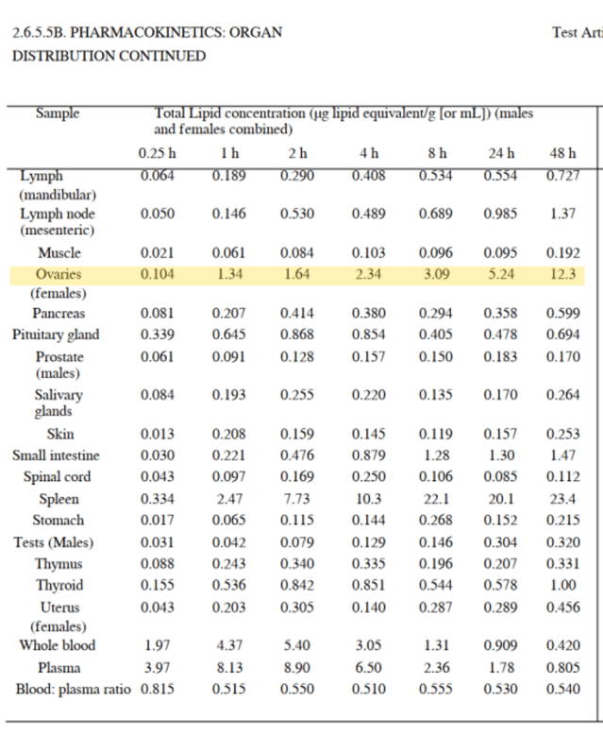
In the first 15 minutes following injection of the Pfizer jab, researchers found that the total lipid concentration in the ovaries measured 0.104ml. This then increased to 1.34ml after 1 hour, 2.34ml after 4 hours, and then 12.3ml after 48 hours.
The scientists, however, did not conduct any further research on the accumulation after a period of 48 hours, so we simply don’t know whether the concerning accumulation continued. The accumulation in the ovaries is very serious especially for women of child bearing age and the scientific and statistical findings in 2021 and 2022 confirm this.
The evidence produced in our books of evidence and my sworn affidavits have shown serious adverse effects of the covid19 vaccines on pregnant women and on their unborn babies. This evidence is being corroborated by more evidence from several countries showing a big decline in birth rates from mid 2021 onwards after mass coivd19 vaccinations. The data is visible in the statistics available from Germany and Hungary to name just two of the countries that appear to be affected.
Source: https://www.bib.bund.de/Publikation/2022/Fertility-declines-near-the-end-of-the-COVID-19-pandemic-Evidence-of-the-2022-birth-declines-in-Germany-and-Sweden.html?nn=1219558
and https://24.hu/belfold/2022/04/18/demografia-ujszulott-visszaeses-magyarorszag/
And unfortunately it is also visible in the statistics on births in the UKHSA Vaccine Surveillance Report in Britain. From a background rate of approximately 45,000 per month in summer 2021, births in England fell to a low of around 36,500 in February 2022 and have since recovered slightly to approximately 37,000-38,000 births per month. These data suggest that birth rates have fallen by approximately 15%, comparing the period prior to November 2021 and after February 2022. For other parts of of the U.K., preliminary births data from Scotland also appear to show a reduction in births by around 10% in recent months compared with the 2017-2019 average.
Source: https://www.nrscotland.gov.uk/statistics-and-data/statistics/statistics-by-theme/vital-events/general-publications/weekly-and-monthly-data-on-births-and-deaths/weekly-data-on-births-and-deaths
I present statistics chart from UKHSA in Britain below.
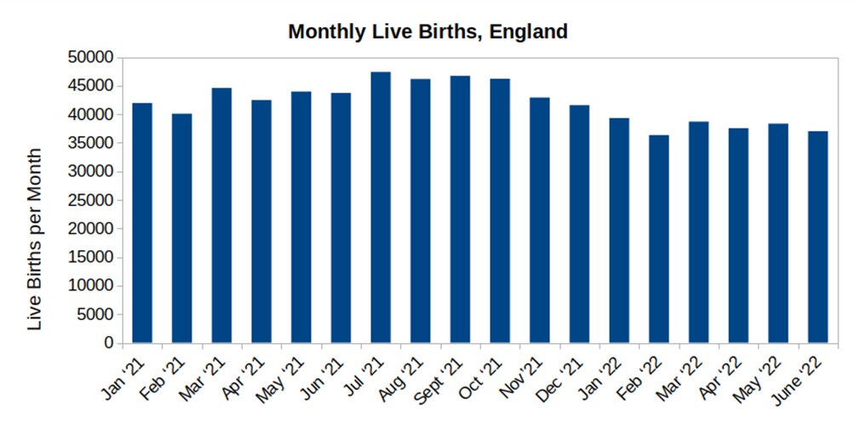
David Shuldman recently obtained data via FOIA request on neonatal deaths from the Israeli health insurance fund Maccabi, which covers about 25% of Israelis. Neonatal deaths are defined as deaths in the first four weeks of life, from the moment after birth until 28 days later. Recently, he obtained data on the quarterly number of neonatal deaths beginning Q1 2019). Here is what this looks like:
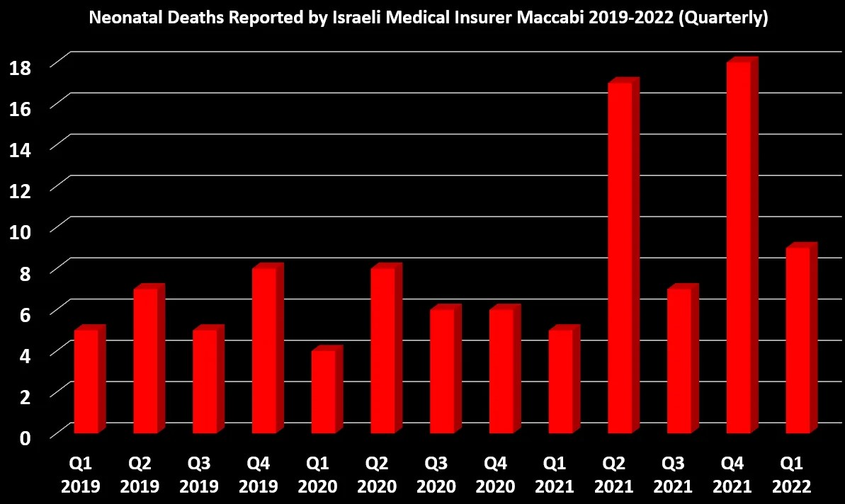
The massive rise in neo natal deaths corresponds to mass covid19 vaccinations in Israel. The spikes correspond to pregnant women being encouraged by the Israeli government and health authorities to get the covid19 vaccines and boosters and a high uptake by them. There is a lot of killing going on. This corroborates our evidence in our books of evidence and sworn affidavits.
Source: David Shuldman and his FOIA request on neonatal deaths from the Israeli health insurance fund Maccabi https://twitter.com/david_shuldman
Statistical analysis of this carried out by Josh Guetzkow at
https://jackanapes.substack.com/p/data-on-neonatal-deaths-from-major
and news report at https://dailyclout.io/infant-mortality-spiked-in-israel-following-mrna-rollout/
The Swedish birth rate has also collapsed in 2022 and this also corresponds to mass covid19 vaccinations in from mid 2021 into 2022 there. It’s the worst in Swedish history. These figures are official figures from the Swedish government.
I present Exhibit 46 to the court showing this.
Some statistical analysis of these findings -
https://boriquagato.substack.com/p/swedish-birthrate-data-october-is
Reports about this in Swedish newspapers such as Dagens Nyheter
https://www.dn.se/sverige/barnafodandet-fortsatter-att-minska-i-stockholm-fruktsamhetstalen-ar-pa-en-rekordlag-niva/
and in Germany at https://www.bib.bund.de/Publikation/2022/Fertility-declines-near-the-end-of-the-COVID-19-pandemic-Evidence-of-the-2022-birth-declines-in-Germany-and-Sweden.html?nn=1219558
The Pfizer internal documents released under federal court order in the USA in 2022 and the VAERS data and V-Safe data from the CDC and published scientific studies show dangers for pregnant women and their unborn babies from covid19 vaccines. And they also show a failure of the FDA in USA and EMA in Europe to regulate properly and inform pregnant women and young women about these dangers. This is more evidence of regulatory capture and conflicts of interest.
https://dailyclout.io/data-do-not-support-safety-of-mrna-covid-vaccination-for-pregnant-women/
37a. I further say that the scientific evidence shows that covid19 vaccines have a destructive effect on female reproduction and sexual health. This has serious implications, life long implications, for young girls and young women. I cite an important new scientific study which presents the facts and evidence.
COVID-19 Vaccines: The Impact on Pregnancy Outcomes and Menstrual Function
Thorp et al. 2022
https://www.preprints.org/manuscript/202209.0430/v2
This new study on VAERS data from Thorp et al found COVID-19 vaccines VS flu vaccines were associated with:
- 145 times increase in reports of menstrual abnormalities.
- 6 times increase in reports of miscarriages.
- 6 times increase in reports of fetal cardiac disorders.
Results COVID-19 vaccines, when compared to the Influenza vaccines, are associated with a significant increase in AE with all proportional reporting ratios of > 2.0: menstrual abnormalities, miscarriage, fetal chromosomal abnormalities, fetal malformation, fetal cystic hygroma, fetal cardiac disorders, fetal arrhythmias, fetal cardiac arrest, fetal vascular malperfusion, fetal growth abnormalities, fetal abnormal surveillance, fetal placental thrombosis, low amniotic fluid, preeclampsia, premature delivery, preterm premature rupture of membrane, fetal death/stillbirth, and premature baby death (all p values were much smaller than 0.05). When normalized by time-available, doses-given, or persons-received, all COVID-19 vaccine AE far exceed the safety signal on all recognized thresholds.
Conclusions Pregnancy complications and menstrual abnormalities are significantly more frequent following COVID-19 vaccinations than Influenza vaccinations. A worldwide moratorium on the use of COVID-19 vaccines in pregnancy is advised until randomized prospective trials document safety in pregnancy and long-term follow-up in offspring.
Scientific analysis at https://jamescintolo.substack.com/p/100-of-kids-14-16-with-mrna-covid
37b. I further say that while on the subject of dangers to human reproduction, reproductive health and sexual health, evidence from the Pfizer internal documents shows there are considerable dangers to male reproductive health and sexual health from the Pfizer covid19 vaccines. This has serious implications, life long implications, for young boys and young men. The Pfizer internal documents were examined and analysed by Amy Kelly in the USA and she found the following highly dangerous and disturbing findings:
1. mRNA vaccine ingredients can be transferred from one person to another via skin-to-skin contact, inhalation, and “sexual intercourse” through bodily fluids.
2. Pfizer did not test “male reproductive toxicity.”
3. Pfizer also did not test for adverse effects from vaccinated men’s semen — on the development of their offspring.
4. mRNA vaccine ingredients travel throughout the body and gather in organs, including in the testes. There is a significant build up of spike proteins in the tests and scientific studies have established that the spike protein can be toxic, and this can lead to abnormal clotting and autoimmune reactions and other adverse biological events. A chart of the findings is show below:
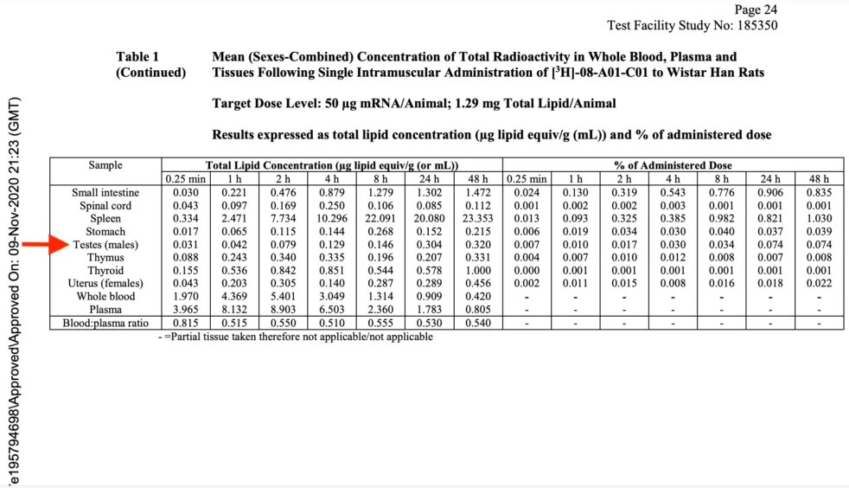
5.) mRNA vaccines resulting in “anti-sperm antibodies” – that is to say, antibodies that treat sperm as an “invader” and damage or kill it – is a known adverse event related to this form of vaccination.
6.) mRNA vaccines cause a staggering drop in semen concentration and total motile count.
7.) By suppressing the discussion of this information, public health agencies, medical professionals, and governments globally denied and continue to deny men full and valid informed consent.
Source: https://dailyclout.io/groundbreaking-new-book-sends-shockwaves-through-pfizers-criminal-enterprise/
I say that this affects males of all ages including those who are pre-puberty and post puberty and that the effects are life long and have an adverse effect on males and on families. These vaccines do not serve the Public Interest and the Common Good.
38. I say that there is strong evidence to suggest that the Hepatitis outbreak in children in 2022 was and is linked to covid19 vaccines
On April 15 2022, the World Health Organization issued a global alert about a new form of severe acute Hepatitis with an unknown aetiology (cause) affecting previously healthy children in the UK over the last month. Tests have excluded all previously known Hepatitis viruses. The announcement came after the UK Health Security Agency (UKHSA) detected higher than usual rates of liver inflammation (hepatitis) in children.
Source: https://www.gov.uk/government/news/hepatitis-liver-inflammation-cases-in-children-latest-updates
This occurred a few weeks after mass covid19 vaccinations of children in the UK and other countries.
A previous scientific study conducted on behalf of Pfizer in the latter half of 2020, found that the contents of the Covid-19 vaccines and the spike protein that they instruct a person’s cells to produce, do not remain at the injection site, and instead circulate to all parts of the body for a minimum of 48 hours. The largest concentration of the Pfizer Covid-19 injection was observed in the liver, with 16% of the administered dose being observed in the organ after 48 hours. Chart from scientific study below.
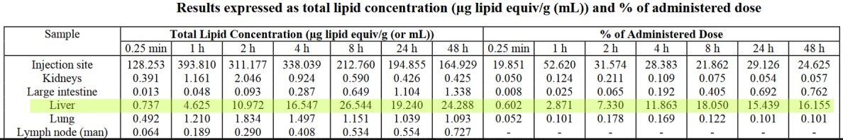
Source: https://phmpt.org/wp-content/uploads/2022/03/125742_S1_M4_4223_185350.pdf
In animals that received the BNT162b2 injection, reversible hepatic effects were observed, including enlarged liver, vacuolation, increased gamma-glutamyl transferase (γGT) levels, and increased levels of aspartate transaminase (AST) and alkaline phosphatase (ALP). According to the researchers’ transient hepatic effects induced by LNP delivery systems have been reported previously.
Source: https://phmpt.org/wp-content/uploads/2022/03/125742_S1_M4_4223_185350.pdf
A new study, published 21st April 2022, has concluded that Covid-19 vaccination can elicit a CD8 T-cell dominant hepatitis. Title of scientific paper below:
SARS-CoV-2 vaccination can elicit a CD8 T-cell dominant hepatitis
Boettler et al. 2022. Journal of Hepatology
https://www.sciencedirect.com/science/article/pii/S0168827822002343
The abstract of the scientific study reads as follows –
“Autoimmune hepatitis episodes have been described following SARS-CoV-2 infection and vaccination but their pathophysiology remains unclear. Here, we report the case of a 52-year-old male, presenting with bimodal episodes of acute hepatitis, each occurring 2-3 weeks after BNT162b2 mRNA vaccination and sought to identify the underlying immune correlates.”
In Layman’s terms, what the scientists discovered is that liver inflammation (hepatitis) can occur in some individuals after covid19 vaccination and shares some typical features with autoimmune liver disease.
Liver biopsy revealed spike-specific CD8 T cell infiltrate hinting at vaccine induced autoimmune hepatitis syndrome.
Martin-Navarro et al. 2022
https://www.journal-of-hepatology.eu/article/S0168-8278(22)03076-8/fulltext
Liver biopsy revealed spike-specific CD8 T cell infiltrate hinting at vaccine induced autoimmune hepatitis syndrome. Vaccine mRNA was detected in cytoplasm of hepatocytes (liver cells).Severe acute hepatitis occurred twelve days after dose two of Pfizer. The authors indicate that based on this, and similar data their "results suggest that lipid nanoparticles bearing mRNA molecules encoding SARS-CoV-2 proteins can reach hepatocytes."
To subject small children, and young adults and adults to these risks and dangers and the other dangers mentioned in this affidavit and in prior sworn affidavits and in the books of evidence is criminal. Crimes have been committed.
39. I state that official documents from Astrazeneca released in Britain under FOI show that the contents of the Astrazeneca covid19 vaccine including spike proteins accumulate all over the body including in the organs in a similar manner to the Pfizer and Moderna vaccines. And that the Astrazeneca covid19 vaccine has been discontinued in Britain due to safety concerns over abnormal clotting caused by the vaccine.
Sources: https://icandecide.org/wp-content/uploads/2022/11/2022-10-24-IR0751D_Production_MHRA_000001-000166-166-pages.pdf
and
https://icandecide.org/press-release/ican-obtains-disturbing-information-about-astrazenecas-covid-19-vaccine-from-the-uk-equivalent-of-the-fda/
40. I further state that the Consequences of subjecting children and young adults to covid19 vaccinations which were in experimental stage until mid 2023 are very serious, dangerous, and life altering
A documentary film titled
‘MRNA 'VACCINE' GENOCIDE 2021-2022: TESTIMONIES FROM THE VICTIMS AND MEDICAL STAFF’
viewable online at
https://odysee.com/@Adverse:c/video_2022-03-16_13-10-03:9?src=embed&t=1372.820724
This is Exhibit 52 and shows the horrific injuries, illnesses, disabilities and deaths inflicted upon children and young adults by the covid19 vaccines. This is also happening in Ireland also and we will have the vaccine injured testifying in this High Court case in Ireland.

41. I further state that a newborn baby died from blood clots after receiving Blood Transfusion from covid19 vaccinated people in Washington state in the USA
The parents of the child demanded a blood transfusion from an unvaccinated person but the hospital refused to do this and gave a blood transfusion from stocks of covid19 vaccinated people. This is the subject of press and media reports in the USA.
News reports
https://www.infowars.com/posts/american-tragedy-baby-boy-dies-of-massive-blood-clot-after-hospital-refused-non-vaxxed-blood-transfusion/
and https://twitter.com/dchomecoming/status/1602834803711156224?ref_src=twsrc%5Etfw%7Ctwcamp%5Etweetembed%7Ctwterm%5E1602834803711156224%7Ctwgr%5E0c957d95c0aa63f57ca2d69882dc88f13d2d7597%7Ctwcon%5Es1_&ref_url=https%3A%2F%2Fexpose-news.com%2F2023%2F01%2F02%2Fbaby-in-usa-dies-after-receiving-blood-transfusion%2F

42. I say that the Pfizer internal documents released under Federal Court order in 2022 in the USA have revealed that Pfizer vaccines caused Vaccine -Associated Enhanced Disease (VAED) also known as ‘antibody dependent enhancement’. This is very serious and we are seeing evidence of this in Ireland and many other countries. This weakens the immune system and makes vaccinated people more susceptible to becoming infected with variants of covid19 and infected with other viruses and bacteria including Strep A and pneumonias which can be life threatening.
The screenshot of Pfizer document is below.

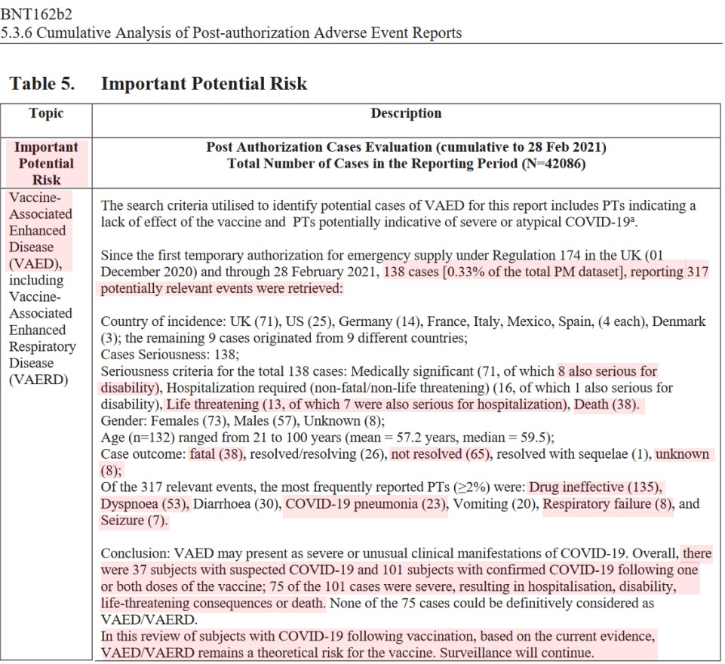
Source: https://phmpt.org/wp-content/uploads/2022/04/reissue_5.3.6-postmarketing-experience.pdf

Pfizer claimed in their confidential document that up to 28th Feb 2021, they had received 138 cases reporting 317 potentially relevant events indicative of Vaccine-Associated Enhanced Disease. Of these 71 were medically significant resulting in 8 disabilities, 13 were life-threatening events, and 38 of the 138 people died. Of the 317 relevant events reported by 138 people, 135 were labelled as ‘drug ineffective’, 53 were labelled as dyspnoea (struggling to breathe), 23 were labelled as Covid-19 pneumonia, 8 were labelled as respiratory failure, and 7 were labelled as seizure. Pfizer also admitted that 75 of the 101 subjects with confirmed Covid-19 following vaccination, had severe disease resulting in hospitalisation, disability, life-threatening consequences or death.

The Irish government and health authorities should be investigating this and putting medical teams and procedures in place to
(i) address the issue of Vaccine -Associated Enhanced Disease (VAED) associated with the covid19 vaccines (ii) deal with the illnesses and diseases being caused by Vaccine -Associated Enhanced Disease (VAED) also known as ‘antibody dependent enhancement’
(iii) deal with the illnesses and disabilities being caused by these unsafe covid19 vaccines and expand hospitals and medical personnel and work hours to cope with this.
(iv) bring criminal charges against those people responsible for causing these harms to large numbers of Irish people
Their refusal to do so amounts to criminal negligence and malfeasance in public office, especially as they were the very people who promoted the covid19 vaccines which are now fuelling Vaccine -Associated Enhanced Disease (VAED) and many cases of new bacterial and viral infections which in addition to other types of vaccine injuries, illnesses and disabilities are putting enormous pressure on Irish hospitals in Winter 2022 and into 2023. It’s the worst hospital crisis in Irish history. Shall the Irish government and health authorities do the above to protect the Irish people and nation or will they continue to act in a criminal manner and against the Common Good and the Public Interest ?
43. I further say that there are more published scientific studies providing evidence of severe weakening of the immune system caused by covid19 vaccines. This makes covid vaccinated people more vulnerable to other viral infections including RSV, and bacteria infections including fatal infections, and to cancers or cancers coming out of remission. This is deadly serious and has been overlooked by government and health authorities in Ireland and a few other countries.
Class switch towards non-inflammatory, spike-specific IgG4 antibodies after repeated SARS-CoV-2 mRNA vaccination
Irrgang et al. 2022. Science Immunology
https://www.science.org/doi/10.1126/sciimmunol.ade2798
IgG4 levels are raised to abnormally high levels permanently making the immune system too tolerant of covid19. This may explain repeated covid19 infections of the vaccinated and “long covid”. It also makes people more vulnerable to other diseases.
Scientific analysis of this is at
https://dailysceptic.org/2022/12/29/does-vaccination-weaken-our-resistance-to-covid-19-and-if-so-how/
and https://www.rintrah.nl/the-trainwreck-of-all-trainwrecks-billions-of-people-stuck-with-a-broken-immune-response/
and https://palexander.substack.com/p/alarming-irrang-et-al-class-switch
and https://jessicar.substack.com/p/the-immunological-mechanism-of-action
and https://igorchudov.substack.com/p/booster-caused-immune-tolerance-explains

Increased PD-L1 surface expression on peripheral blood granulocytes and monocytes after vaccination with SARS-CoV2 mRNA or vector vaccine
Loacker et al. 2022
https://pubmed.ncbi.nlm.nih.gov/36245120/
Elevated PD-L1 levels can undermine the functions of and reduce the number of NK cells and T cells. This can lead to serious infections and more aggressive cancers. Read scientific analysis of this paper at https://arkmedic.substack.com/p/philadelphia-2023

And in another scientific paper
mRNA vaccines against SARS-CoV-2 induce comparably low long-term IgG Fc galactosylation and sialylation levels but increasing long-term IgG4 responses compared to an adenovirus-based vaccine
Buhre et al. 2023. Frontiers of Immunology
https://www.frontiersin.org/articles/10.3389/fimmu.2022.1020844/
Scientific analysis of this paper on https://igorchudov.substack.com/p/immune-tolerance-igg4-class-switch

Extended SARS-CoV-2 RBD booster vaccination induces humoral and cellular immune tolerance in mice
Gao et al. 2022
https://www.sciencedirect.com/science/article/pii/S2589004222017515
‘We found that the protective effects from the humoral immunity and cellular immunity established by the conventional immunization were both profoundly impaired during the extended vaccination course.’
Scientific analysis of paper at https://alexberenson.substack.com/p/very-urgent-after-four-shots-covid
SARS–CoV–2 Spike Impairs DNA Damage Repair and Inhibits V(D)J Recombination In Vitro
Jiang et al. 2021
https://www.mdpi.com/1999-4915/13/10/2056
This adversely affects p53 which is involved in suppressing cancer. Its loss makes people vulnerable to cancers, including more aggressive cancers. This research shows SARS-CoV-2 spike protein obliterates 90% of the DNA repair mechanism in lymphocytes, a type of white blood cells that help your body fight infection and chronic disease, including cancer.
Scientific analysis of this is at
https://arkmedic.substack.com/p/welcome-to-gilead?utm_source=substack&utm_campaign=post_embed&utm_medium=web
Innate immune suppression by SARS-CoV-2 mRNA vaccinations: The role of G-quadruplexes, exosomes, and MicroRNAs.
Seneff et al. 2022. https://www.ncbi.nlm.nih.gov/pmc/articles/PMC9012513/
“We identify potential profound disturbances in regulatory control of protein synthesis and cancer surveillance. These disturbances potentially have a causal link to neurodegenerative disease, myocarditis, immune thrombocytopenia, Bell’s palsy, liver disease, impaired adaptive immunity, impaired DNA damage response, and tumorigenesis.”
These scientific studies corroborate others showing the covid19 vaccines are causing:
- Suppression of the body’s defence against cancer
- Suppression of the body’s defence against viruses and bacteria
- Exhaustion of the very components of the immune system that protect against those two things.
43a. I further say that this weakening of the human immune system caused by covid19 vaccines is causing increased reactivation of Shingles a very painful and debilitating condition in people. Our books of evidence present scientific evidence of this. New scientific studies corroborate this.
Persistent varicella zoster virus infection following mRNA COVID-19 vaccination was associated with the presence of encoded spike protein in the lesion
Sano et al. 2022 https://onlinelibrary.wiley.com/doi/10.1002/cia2.12278
Herpes zoster following BNT162b2 mRNA COVID-19 vaccination in patients with autoimmune inflammatory rheumatic diseases: a case series
Furer et al. 2021. https://academic.oup.com/rheumatology/article/60/SI/SI90/6225015?login=false
A systematic review published in November 2021 also concluded that the COVID-19 jab increases the risk of shingles reactivation if you’ve had it before or have known risk factors for it.
Can SARS-CoV-2 vaccine increase the risk of reactivation of Varicella zoster? A systematic review
Desai et al. 2021
https://pubmed.ncbi.nlm.nih.gov/34719084/
VAERS data, as of December 16, 2022, shows there were 15,225 reports of shingles after the COVID-19 jab. Most cases (for which ages are given) have occurred in younger individuals between the ages of 25 and 51, which is younger than normal. There are even 170 cases in 12- to 25-year-olds.
Source: https://openvaers.com/covid-data/shingles
Innate immune suppression by SARS-CoV-2 mRNA vaccinations: The role of G-quadruplexes, exosomes, and MicroRNAs.
Seneff et al. 2022. https://www.ncbi.nlm.nih.gov/pmc/articles/PMC9012513/
In it, they describe how the COVID-19 shots suppress your innate immune system by inhibiting the type-1 interferon pathway, which is the first-stage response to all viral infections. Type-1 interferon also keeps latent viruses in check, so if your interferon pathway is suppressed, latent viruses can start to emerge. This makes the body more vulnerable to latent viruses.
Regulators in the European Union are also warning that repeat COVID-19 shots can weaken overall immunity.
https://www.business-standard.com/article/international/covid-19-pandemic-frequent-boosters-can-weaken-immunity-says-eu-122011201707_1.html
Increasing the cases and severity of this painful, debilitating and disabling condition named ‘Shingles’ does not serve the Common Good and the Public Interest.
44. I say that a a group consisting of 17,000 medical doctors, hospital consultants, top scientists, professors, and medical professionals, named ‘Global Covid Summit’, have publicly called for an end to all covid19 vaccinations since May 2022 due to their lack of safety and effectiveness and this has relevance to our court case. And they made a separate Declaration calling for an immediate end to all covid19 vaccinations of children.
The Global Covid Summit made this public statement in may 2022 and they made the following declaration
Our Global COVID Summit of 17,000 physicians and medical scientists from all over the world have reached consensus on the following foundational principles:
- We declare and the data confirm that the COVID-19 experimental genetic therapy injections must end.
- We declare doctors should not be blocked from providing life-saving medical treatment.
- We declare the state of national emergency, which facilitates corruption and extends the pandemic, should be immediately terminated.
- We declare medical privacy should never again be violated, and all travel and social restrictions must cease.
- We declare masks are not and have never been effective protection against an airborne respiratory virus in the community setting.
- We declare funding and research must be established for vaccination damage, death and suffering.
- We declare no opportunity should be denied, including education, career, military service or medical treatment, over unwillingness to take an injection.
- We declare that first amendment violations and medical censorship by government, technology and media companies should cease, and the Bill of Rights be upheld.
- We declare that Pfizer, Moderna, BioNTech, Janssen, Astra Zeneca, and their enablers, withheld and wilfully omitted safety and effectiveness information from patients and physicians, and should be immediately indicted for fraud.
- We declare government and medical agencies must be held accountable.
Source: Global Covid Summit web site at https://globalcovidsummit.org/
We are morally compelled to defend the health and well-being of all children, and hereby declare that:
• Superior innate immunity, natural immunity, and minimal risk of COVID-19 disease in children must be recognized.
• Due to unprecedented adverse safety signals, administration of the COVID-19 injections should be halted immediately for all age groups, most especially children.
• COVID-19 injections should not be approved for children 6 months to under 5 years of age during the upcoming June 2022 FDA deliberations.
• Masks should never be required for children.
• School masking, testing, quarantine, and COVID-19 injection mandates should cease immediately.
• Neither Remdesivir nor Paxlovid should be approved, used, or recommended for children.
• Any legislation that denies parents the right of medical-decision making for their minor children, such as currently proposed in the state of California, should be halted.
• Adverse outcomes from the use of COVID-19 genetic injections must be rigorously studied and investigated with the goal of identifying potential remedies and assisting injured people.
• Physician concerns, especially regarding the safety of any medical intervention, must never again be silenced. Physicians must be allowed to use their professional expertise to provide care to individual patients without threat or conflict of interest from governing regulatory agencies, employers, hospitals, and pharmaceutical companies.
Challenge to Our Colleagues:
To our physician colleagues who provide medical care to children,
We are united in our loyalty to our oath to ‘First, Do No Harm.’ The COVID-19 public health policies imposed on society have had disastrous consequences for children and adolescents. If you are questioning these policies, the risk versus benefit profile of the COVID-19 genetic injections in children, or have seen pediatric injuries, including death, due to the COVID-19 injections, you are not alone. We stand with you.
Please join us as we work to protect our children. We represent thousands of physicians who share your concerns, and together we have the strength to stand on the right side of history. When COVID-19 injections were first introduced, these adverse events were not widely known. Over time, safety data signals have risen to never-before-seen numbers, and many of us are caring for vaccine-injured patients in our clinical practices. It is time to stand up and speak out as a unified group. This is the largest public health disaster in our lifetime, and as professionals we must rise as one voice to speak for the vulnerable amongst us.
To add your assent to this and the other Global Covid Summit declarations, sign here.
Mary Talley Bowden, MD, Ear, Nose, and Throat Specialist
Angie Farella, MD, General Pediatrician
Meredith Grebowicz, MD, General Pediatrician
Kamli Jura, MD, General Pediatrician
Stephen Kebe, MD, General Pediatrician
Katarina Lindley, DO, FACOFP, Family Practitioner
Mark McDonald, MD, Child and Adolescent Pyschiatrist
Kimberly Milhoan, MD, FASA, Pediatric Anesthesiolgist
Kirk Milhoan, MD, FAAP, FACC, General Pediatrician, Pediatric Cardiologist
Prabhat Mishra, MD, Pediatric Anesthsiologist
Renata Moon, MD, FAAP, Pediatric Hospitalist
Michelle Perro, MD, General Pediatrician
Bethany Rife, MD, General Pediatrician
Monique Robles, MD, MS Bioethics, Pediatric Critical Care Physician
Kristen Roeder, MD, General Pediatrician
Molly Rutherford, MD, Family Practitioner
Monica Wehby, MD, FAANS, FACS, Pediatric Neurosurgeon
Source: Global Covid Summit web site at https://globalcovidsummit.org/
I submit this as Exhibit 63 to the court.
News report about summit at https://rumble.com/v14mzwi-highlights-global-covid-summit.html
45. I say we the Plaintiffs, will bring those people injured, made ill or disabled by the covid19 vaccine and those who lost loved ones from the covid19 vaccine into the High Court to testify and provide their testimony to the High Court. All were victims of the covid19 vaccine and deserve to be heard in court and treated with respect and dignity in court. They can no longer be ignored and fobbed off by the Irish government and health authorities.
We noticed at the last hearing in the High Court on December 16th 2022, that some barristers and solicitors not associated with our case laughed at, sneered at, and mocked us and the vaccine injured while we were pleading our case before the High Court judge. We ask that in all future hearings of this case before the High Court that legal personnel not associated with our case are asked by the judge to remove themselves from the court room, as the court should not be a venue for abuse, mockery, sneering and insults of persons who have been injured, made ill or suffered personal losses from these vaccines. Courts are not forums for abuse, mockery, and insults of people. We will be bringing in children and women who have been damaged by these covid19 vaccines and would ask that the High Court respect these victims.
46. I say that the covid19 vaccine injured and those made ill or disabled by this vaccine and those at risk of vaccine injury or premature death should be given the following medical tests so as to identify the damage caused by the covid19 vaccines. These are derived from published scientific papers, and Embalmers, Medical Doctors and Pathologists. And that the HSE and government and other state bodies which promoted the covid19 vaccinations have a legal duty of care to encourage vaccinated people to get such tests. And this information should be given to the general public by the government and health authorities and by RTE and the press and media for the purpose of
(i) diagnosing and treating the vaccine injured and
(ii) for the purpose of Disclosure and informed consent so that adults and parents and guardians can assess vaccine safety and give their full and valid informed consent for these covid19 vaccinations or refusal of them.
      - CK-MB, troponin, and NT-proBNP which were elevated in 100%, 99.5% and 78.3% of subjects, respectively in one scientific trial.
      - ST-segment abnormality which was the most common electrocardiogram feature in one trial.
      - Cardiac magnetic resonance imaging, which is the gold-standard approach for diagnosing myocarditis, and was abnormal in all patients in one scientific study. Also check for Late Gadolinium Enhancement which Is associated with Sudden Cardiac Death. Myocardial Edoema. Local left ventricular wall-motion abnormalities
      - QRS duration and QT interval. Is it decreased significantly, is there increased or abnormal heart rate. Abnormal electrocardiography (ECG) findings. Check for Ventricular Fibrillation and Significant arrhythmias.
      - d-dimer tests for abnormal blood clotting and tests for blood oxygen levels for evidence of enhanced hypoxia.
      - Vascular ultrasound is a noninvasive test healthcare providers use to determine how blood flows in arteries and veins in your arms, neck and legs. This will identify dangerous blood clots. Massive blood clots have been removed by Pathologists and Embalmers from the bodies of dead covid19 vaccinated people.
      - CT pulmonary angiography for Pulmonary Embolism. And a proximal lower limb compression ultrasound (CUS) for Pulmonary Embolism
      - Tests and MRI, CAT and other scans for subclinical myocarditis, pericarditis and evidence of heart inflammation as found in scientific studies in Thailand and Switzerland referenced on pages 31-32 in our last sworn affidavit filed in the High Court on December 12th 2022.
      - C-reactive protein and TNF-a for evidence of enhanced inflammation. Evidence of severe inflammation has been found in the bodies of dead covid19 vaccinated people by Pathologists.
      - Tests for Transverse myelitis — inflammation of the spinal cord and tests for other demyelinating diseases. Tests for Myelin oligodendrocyte glycoprotein antibody-associated disease (MOGAD), Acute disseminated encephalomyelitis, and MS.
      - For those with liver problems after vaccination. Liver biopsy and look for spike-specific CD8 T cell infiltrate hinting at vaccine induced autoimmune hepatitis syndrome.
      - Amyloid-beta and phosphorylated tau for evidence of increased predisposition to Alzheimer’s disease, and serum HMGB1, CXCL13, and Dickkopf-1 for evidence of an increased disposition to autoimmune disease
47. Criminal investigations and Prosecution cases
I say that the fact that many Irish people are being killed as seen in very high mortality figures and excess mortality figures and big increases in those injured and made seriously ill and disabled by the covid19 vaccines and that they did not give their full and valid informed consent for the covid19 vaccines has led to criminal investigations and cases which are ongoing in Ireland. The crimes involved here include manslaughter, murder, poisoning, assault and battery, assault causing grievous bodily harm, conspiracy to commit crimes, corruption and conflicts of interest, frauds, endangering the public, malfeasance in public office, etc. Cover ups of these crimes are also being investigated. I cite the following Pulse numbers from the Garda (Irish Police) and the British Police force:
Garda (Police) Pulse number: 19714695
Garda (Police) Pulse number: 21600642
Garda (Police) Pulse number: 20471822
Garda (Police) Pulse number: 20597002
Garda (Police) Pulse number: 20429196
British Metropolitan Police Number: 6029679/21 and Incident number: CWRT-01035030

British Incident numbers
1391 of 12/10/2020
1904 of 06/01/2022
Police Complaint reference: CO/03072/20
International Criminal Court Case Number: OTP-CR-473/21.
48. I say that more Emergency High Court Orders of Discovery and of Performance will be sought in order to provide the High Court with the necessary evidence
In consideration of the facts and scientific and statistical evidence which clearly show a major threat to public health in Ireland from these covid19 vaccines and loss of many lives and instigation of serious illnesses and disabilities in the covid vaccinated, and an accompanying threat to Irish national security, we will be seeking seven Emergency Court Orders, five of Discovery and two of Performance.
- The first is an Emergency Order of Discovery for death data for covid19 vaccinated people and unvaccinated people for 2021 to 2022 and into 2023 from the CSO and GRO. Real time statistics which are accurate up to the latest week. Including covid19 vaccinated deaths misclassified as unvaccinated deaths. People dying shortly after getting the first covid19 vaccine were misclassified as unvaccinated.
- The second is an Emergency Order of Discovery for Central Statistics Office statistics for excess mortality figures for
a) different age groups
b) for covid19 vaccinated and unvaccinated people
for 2019 – 2022 and into 2023. Real time statistics which are accurate up to the latest week.
- The third is an Emergency Order of Discovery for disability statistics for Ireland for all age groups and for covid vaccinated and unvaccinated people for the period 2019 to 2022 and into 2023 from the Department of Social Protection and all private disability insurers in Ireland. And myocarditis rates and pericarditis rates and late gadolinium enhancement rates for covid19 vaccinated people compared to unvaccinated people. Real time statistics which are accurate up to the latest month.

- The fourth is an Emergency Order of Discovery from the HSE and Department of Health for statistics for all “long covid19 patients” who are covid19 vaccinated and unvaccinated. Real time statistics which are accurate up to the latest month.
- The fifth is an Emergency Order of Discovery for all the conflicts of interest of all members of NPHET, the chief medical officer, all members of NIAC, the executives of the HPRA and the HPRA itself, the Minister for Health and the executives of the HSE in the period 2020 to 2022.
- The sixth is an Emergency Court Order of Performance to compel all Coroners and the State Pathologists to carry out autopsies using the German pathology findings mentioned here and in previous affidavits of all dead covid19 vaccinated people under 80 years old who died suddenly in 2021 and 2022 and into 2023.
- The seventh is for an Emergency Order of Performance for a full public commission of inquiry into the use of early treatments for coivd19 which was highly successful in the USA and saved many lives there but was blocked here in Ireland. And that medical doctors such as Dr. Pierre Kory and many other doctors are given an opportunity to testify as to the effectiveness of these early treatments for covid19 and that the Irish public is fully informed about this via the commission of inquiry and the press and media, and that the scientific and medical truth, facts and evidence are finally revealed to the general public.
This threat to many thousands of Irish lives is significant, serious and ongoing, and Irish courts and legal system and the Irish people and nation can no longer tolerate cover ups which place many lives in imminent danger, undermine law and order, justice under law, the courts and the legal system and the health and future of the Irish people and nation. There must be full exposure, full transparency and full accountability. Such transparency and full accountability is vital for the obtaining of full and valid informed consent for these covid19 vaccines and for medical drugs and medical procedures.
49. I say that the Legal Standing or Locus Standi of one Plaintiff, David Egan, is valid and legal
Philip Lee LLC has stated in correspondence to us that it presumes to challenge the legal standing or Locus Standi of David Egan in this High Court case. David Egan has outlined the grounds for his legal standing or Locus Standi on page 62 in the sworn affidavit filed with the High Court and given to the defendants on December 12th 2022. These are all valid legal grounds which have been accepted by the Irish courts in the past.

If Philip Lee LLP presumes to challenge the legal standing or Locus Standi of me, David Egan, then it is my legal and Constitutional right to rebut this presumption and to challenge the legal standing or Locus Standi of an LLP to bring a case before any court. Philip Lee LLP is an LLP, this means it is a Limited Liability Partnership. The nature of this LLP firm of Solicitors registered with the LSRA ( Legal Services Regulatory Authority) , is such that pursuant to certain of the provisions of the Partnership Act 1890 as cited in the Legal Services Regulation Act 2015, this firms registration is not consistent with the Partnership Act 1890, and therefore fails to meet the criteria to be considered as a qualifying Limited Liability Partnership under the 2015 Act. Section 1 of the partnership act 1890 is not consistent with the LSRA at section 123, 170-2 . This inconsistency between the two acts is fatal in legal terms. I cite ‘Section 123, (6) The Partnership Act 1890 shall apply to limited liability partnerships to the extent that it is not inconsistent with this Chapter’ of Legal Services Regulation Act 2015. Letters Patent is not synonymous with Patent of Precedence.
If the pleadings in regards to the LLP's are recognized by the High Court, Philip Lee as owner of Philip Lee LLP may be committing an Offence under Section 64 of the Solicitors Act 1954. If his Firm is NOT a Limited Liability Partnership his firm is a Corporate and has no right of audience in any Court of Law
I cite Section 64 of the Solicitors Act 1954 below:
Bodies corporate. | 64.—(1) A body corporate or director, officer or servant thereof shall not do any act of such nature or in such manner as to imply that the body corporate is qualified, or recognised by law as qualified, to act as a solicitor.
  (2) Where there is a contravention of subsection (1) of this section, the body corporate shall be guilty of an offence under this section and shall be liable on summary conviction thereof to a fine not exceeding one hundred pounds and, where the act was done by a director, officer or servant of the body corporate, he also shall be guilty of an offence under this section and shall be liable on summary conviction thereof to a fine not exceeding twenty-five pounds.
  (3) In sections 55 , 58 and 59 of this Act, references to unqualified persons, and references to persons, include references to bodies corporate.

50. I say that Fraud is being pleaded here in this court case and we provide additional grounds below.
Further counts of Fraud are to be added to the existing 10 counts of fraud stated on pages 95 - 96 of the previous sworn affidavit filed in the High Court on December 12th 2022. There are now a total of 21 grounds for Fraud.

11) I refer to Points 19, 19a and 19b above in this affidavit where Pfizer’s internal documents clearly show that the covid19 vaccines were unsafe and could cause many types of serious illnesses, disabilities, and premature deaths. Its an admission of guilt by Pfizer. Yet Pfizer and the EMA and the Irish government and health authorities told the general public that the covid19 vaccines were “safe and effective”, and they repeated this continuously in the press and media in 2021 and 2022 and into 2023. This is a clear case of fraud. And they obtained informed consent by fraud and deception which is the main issue in our High Court case.

12) Leaked documents from the European Medicines Agency (EMA) state that there is no biological characterization of the spike protein and the mode of action is not described. This is an essential requirement for vaccine approval. No regulators, including the EMA know what protein is being expressed in the body after vaccination with mRNA vaccines. This problem has not been rectified by Pfizer. This means that the Pfizer covid19 vaccine should not have been approved by the European Medicines Agency as it did not meet essential requirements. This amounts to fraud. And the European Medicines Agency (EMA) do not know anything about the proprietary lipids used in the Pfizer vaccine, nothing about their pharmacology and manufacturing process, but this is an essential requirement for vaccine approval. This is another fraud. There are substantial breaches of Irish laws, the Irish Constitution, international Human Rights laws and binding international treaties here.
The secret involvement of the US Department of Defense in covid19 vaccine development, testing, manufacturing and contracting in the private sector and the implications of this for safety testing or lack thereof was not disclosed to the general public in the USA, Canada and the European Union. This Non Disclosure and its negative impact on covid19 vaccine safety testing and reporting to the public, vaccine safety, and on full informed consent amounts to fraud. Also there are substantial breaches of US laws, the US Constitution, international Human Rights laws and binding international treaties.
These frauds were identified by Katherine Watt and she provided a public lecture about this online at https://www.bitchute.com/video/8ftbShzrkjl9/ (starting at point 19:45)
and legal and historical information about this at:
https://bailiwicknews.substack.com/p/american-domestic-bioterrorism-program
and https://bailiwicknews.substack.com/p/repost-biotech-idolatry-dod-pfizer
and https://sashalatypova.substack.com/p/reviewing-the-dod-contracts-for-covid
and https://substack.com/profile/8540123-katherine-watt

13) Scientific studies show that the mRNA does not stay at the site of the injection in the arm, it gets distributed around the body. Spike proteins are manufactured all over the body including in tissues, organs and blood vessels and are distributed throughout the body. The mRNA and spike proteins can last in the body for months, possibly years according to scientific studies. This has caused serious harms and even deaths to vaccinated people. The spike proteins pose serious health risks and dangers over time to vaccinated people. For example, spike proteins accumulating in the female reproductive organs have had dire consequences for girls and young women and unborn babies and spike proteins accumulating in the male reproductive organs have had dire consequences for boys and young men. We have detailed some of this in this affidavit and prior affidavits. These facts were not explained to vaccine recipients and to the general public. The Irish government and health authorities and the EMA did not explain this to vaccine recipients and the general public. This was deliberately covered up. They falsely told the general public that the mRNA and spike proteins remained at the injection site. The net effect of this is fraud and obtaining the informed consent of people by fraud and deception. And losses have resulted from this fraud including deaths, illnesses, disabilities, loss of jobs, loss of careers, and loss of families and homes.
Marc Girardot’s Bolus Theory presents scientific evidence of the massive destruction and damage caused to the human body by wide dispersal of mRNA and spike proteins throughout the body, to the organs and the blood vessels - https://covidmythbuster.substack.com/p/the-cytotoxic-bolus-theory-on-the

14) I further say that accurate statistics to measure the safety and effectiveness of the covid19 vaccines have not been provided in Ireland due to failures of the CSO, the HPRA, the HSE and Department of Health to gather and store accurate statistics of deaths, illnesses and disabilities for vaccinated and unvaccinated persons from Quarter 1 2021 onwards. And gather accurate Coroner and Autopsy data for dead vaccinated and unvaccinated people as outlined Points 17a and 17b above. And provide these statistics to the general public on the Internet. This has made it impossible to assess the safety and effectiveness of the covid19 vaccines and all claims made by them stating the vaccines are safe and effective are unproven and fraudulent. And completely undermined informed consent for thosee persons who received the vaccines and boosters.

15) While on the subject of Fraud, it has come to our attention that a Freedom of Information request was made to the HSE on the 22nd December 2020 by a Mr. Robert Pye for information about the isolation of the sars-cov2 virus. The HSE replied on the 23rd December 2020 and revealed that it had no information, no evidence, and no proof that the sars-cov2 virus had been isolated and that it existed. This is an extraordinary admission by the HSE considering the fact that HSE officials and Department of Health officials including the Minister and CMO had been spreading fear and panic in the press and media about this sars-cov2 virus also known as “covid19”. The HSE appears to be involved in a fraud, but we are hoping they will clear up this matter and clarify the issue for the High Court and the general public, and provide evidence of the existence of the sars-cov2 virus also known as “covid19” and its full genome and a scientific trial to prove transmission of the virus between humans, which will rectify this matter for the court and the general public.
I submit Exhibit 38 to the court showing this.
A Freedom of Information request was made to the HSE on the 28th December 2020 by a Mr. Robert Pye for information about the safety and effectiveness of the covid19 vaccines. The HSE replied and said they had no such information to give him. The HSE had no proof and no evidence that the covid19 vaccines were safe and effective, and it appears that the HSE have implicated themselves in a fraud.
I submit Exhibit 39 to the court showing this.
16) Dr. Kathryn Edwards, a member of Pfizer’s data safety monitoring board (DSMB), was previously a paid adviser to Pfizer over several years. DSMBs are supposed to be independent, they cannot be independent if members have had previous financial and business relationships with the company. In a court case in the USA, lawyer Aaron Siri showed to the court that Dr. Kathryn Edwards had a serious conflict of interest which completely undermined her and discredited her and undermined the safety monitoring process for Pfizer covid19 vaccines, making any claims about safety defective and fraudulent. An American news broadcast about this is at
https://thehighwire.com/videos/the-deposition-of-the-godmother-of-vaccines-dr-kathryn-edwards/
and news report at
https://childrenshealthdefense.org/defender/kathryn-edwards-pfizer-covid-vaccine-conflict/
17) I further say that the failure of the HSE, the Department of Health and the CSO to gather and provide accurate, timely and up to date statistics of deaths, illnesses and disabilities and hospitalizations for the covid19 vaccinated and the unvaccinated to the general public and on their web sites so that vaccine safety and effectiveness can be independently assessed and verified by the general public including parents and guardians means that the HSE and the Department of Health and government are totally discredited, not fit for purpose and their claims about vaccine safety and effectiveness are unproven, false, misleading and fraudulent. And this fraud has caused losses to the general public in terms of deprivation of full and valid informed consent for the vaccinations, and of vaccine injuries, illnesses, disabilities and premature deaths and loss of jobs, careers, homes, families and considerable financial losses. Point 11b. above in this affidavit presents this in a fuller context.

18) the Chief Medical Officer in Ireland for 2021 and 2022 was Tony Holohan and he claimed in the press and media during this time that the covid19 vaccines stop transmission of the virus. This was a lie and a deception and it deceived the Irish public. This lie was repeated by the Minister for Health and the Taoiseach and by RTE. It was the main reason for the introduction of vaccine passports which were unlawful, unconstitutional and illegal. The covid19 has never been proven to stop transmission according to Pfizer after the trials in 2020 and other vaccine makers and according to the testimony of Janine Small a Pfizer executive who testified before the EU Parliament in 2022. Tony Holohan engaged in lies and fraud to convince the Irish public to get the vaccine. This is serious as Tony Holohan was trusted and widely seen as a god or hero or messiah by most Irish people during this time. This fraud has had serious consequences for many Irish people.
On a related point if the covid19 vaccines were truly “safe and effective” as claimed by Tony Holohan and the Minister for Health and the Taoiseach and by RTE, then why are Pfizer and other covid19 vaccine manufacturers indemnified and protected from being sued in the courts ? and why was this protection in the EMA contracts and Irish government contracts ? their public statements repeated many times of the covid19 vaccines being “safe and effective” should have meant that there was no need for indemnification and protection from being sued as the vaccines were “safe”. This most clearly exposes the lie and the fraud.
19) the vaccine ingredients have not been independently scientifically analyzed to identify ingredients and conformance with the vaccine label by the European Medicines Agency, the Irish health and regulatory authorities, the MHRA and the FDA. And regular independent sampling of vaccine batches was not undertaken to identify ingredients. This is a major failing by these regulators and health authorities. The general public have been put at serious risk for this failure.
Independent scientists have found some dangerous items in these covid19 vaccines and have published reports on this which we supplied in our previous affidavits and books of evidence. Yet the Irish government and health authorities are alleging that the covid19 vaccines are “safe and effective” when they have not examined the ingredients of these vaccines and whether the ingredients are safe or not, thus their claim is false. This is fraud.
20) the tests for the covid19 virus and the covid19 vaccines are not based on an actual virus isolated from an infected person and its full genome identified and mapped. They are based on a synthetic computer-generated virus RNA code. This is very poor quality and inadequate science. The NIH database itself reveals that the original Hu1 reference strain was not isolated from a human host because no isolation date is given and no specific person is specified as the host, and no part of the body is specified as providing the virus and no pathology lab is specified as a location in any of the 3 iterations to what became the reference coding for the vaccines. So the reference strain that is used to generate every covid vaccine (except the Chinese and the Indian whole virus vaccines) is not from a physical virus. It is a synthetic computer-generated virus RNA code. It was given to the NIH and the western countries by the Chinese, but the Chinese communist regime has proven itself to be untrustworthy in the past. If it had been isolated from a human, then the MHRA and NIH database would describe that human and we would know which hospital pathology department processed the swab. But it does not. This has been verified in Freedom of Information requests to the MHRA in Britain. This correspondence was published on a British web site at
https://expose-news.com/2023/01/23/synthetic-pandemic-covid-manmade-vaccines-deadly/
The governments and health authorities have no proof or evidence that the synthetic computer-generated virus RNA code is equivalent to the sars-cov2 virus.

21) In this affidavit and prior affidavits and in our books of evidence and in the Pfizer internal documents released under federal court order in the USA there is clear evidence that the regulatory authorities including the FDA, the EMA and the Irish regulator and regulatory bodies in several other countries knew about the dangers of these covid19 vaccines and the significant risk of premature deaths and serious illnesses and disabilities but they refused to tell the general public about this or take actions to protect the general public including suspend or end these vaccinations and subject them to rigorous new safety tests and ingredients tests. These regulatory bodies refused to regulate. This is an important legal point, as they got money from the government and private bodies to regulate and monitor vaccines and medical drugs but they refused to regulate. This in itself is a fraud. And the other fraud relates to Non Disclosure of dangers to the general public while falsely telling them these vaccines were “safe and effective”. In Points 62 and 63 below of this affidavit I say there are serious Conflicts of Interest and regulatory capture involved in the approval of covid19 vaccines and boosters. More grounds for fraud are laid out in those points.
Finally, I cite the court precedent of Lord Denning in Lazarus Estates Ltd v Beasley [1956] where the learned judge famously said
“Fraud unravels everything. The court is careful not to find fraud unless it is distinctly pleaded and proved; but once it is proved, it vitiates judgments, contracts and all transactions whatsoever”.
Everything based on fraud is unraveled by the fraud and becomes null and void in law including contracts, government policies, laws, statutory instruments, government approvals, government contracts, executive orders, vaccinations and vaccination centres, arrests, vaccine mandates, vaccine passports, forced business closures and court judgments. This fraud removes the legal indemnity or protection from being sued for the vaccine companies and all of those people who injected this experimental vaccine into people and those people who recommended them to get it or mandated them to get it, and all those persons including politicians and senior civil servants who approved the vaccines for the general public and all those people and organizations who promoted and marketed the vaccine as “safe and effective” and encouraged many people to get the vaccination. They are all liable in the civil courts and the criminal courts. This precedent set by the Judge Lord Denning applies here in our High Court case and for all other related court cases.
Courts in the past have upheld that giving a person poison whether by injection or by tablet or food item and not telling the person about this fact, and not getting their full and valid informed consent and this leads to harms for the person who received it means the poisoner cannot have legal indemnity as there is fraud involved, the gaining of informed consent by deception, poisoning, assault and battery and other crimes involved.

51. I further say that in relation to the pleading of fraud and that fraud can result in loss of legal indemnity mentioned in Point 50 above, the Australian Medical Professionals Society has stated that medical doctors and medical professionals who injected people with covid19 vaccines do not have legal indemnity. They have informed their members about this. I cite information about this below.
https://amps.redunion.com.au/important-covid-19-vaccine-indemnity
and
https://vaccinationispolitical.files.wordpress.com/2022/11/mc22-018819-signed-highlighted-1.pdf?utm_medium=email&_hsmi=2&_hsenc=p2ANqtz-_ezaLRtOajj3cEu2ttco1cMGfb3KPxpD9jCPVtnw4nPTw64TMRpKp3VwZAdZe28a-YEbX-4UMQn3SNy1NNM23rXyA8aePyysKjD9ksuHVi7X4c82s&utm_content=2&utm_source=hs_email
and
https://principia-scientific.com/amps-warns-medical-professionals-of-indemnity-risks/
Courts in the past have upheld that giving a person poison whether by injection or by tablet or food item and not telling the person about this fact, and not getting their full and valid informed consent and this leads to harms for the person who received it means the poisoner cannot have legal indemnity as there is fraud involved, the gaining of informed consent by deception, poisoning, assault and battery and other crimes involved.

52. I say that that Dr. Joseph Mercola, a highly experienced medical doctor in the USA provided a brief medical and scientific analysis of the dangers and ineffectiveness of covid19 vaccines on December 27th 2022 and this has relevance to our court case. Read this at
https://www.theepochtimes.com/health/pfizers-shots-arent-safe-and-were-never-shown-to-be_4947190.html

53. I further say that two medical doctors, one also a scientist provided a credible and fact based scientific analysis of how the covid19 vaccines and spike proteins cause abnormal blood clotting and premature deaths. It is based on published scientific studies and clinical findings and autopsy findings.

Scientific Study by Dr. Yuhong Dong and Dr. Jordan Vaughn, November 2022
https://www.theepochtimes.com/health/why-spike-protein-causes-abnormal-blood-clots-200-symptoms_4842684.html
If the Irish government and health authorities had any integrity, any intelligence and expertise, and any respect for the Irish people and nation and it’s laws and Constitution they would investigate this and carry out clinical trials on the effects of the spike proteins inside the bodies of vaccinated people, both living and dead.
54. Expert Witnesses
I say that we are bringing in Expert Witnesses including medical doctors, scientists, professors, pathologists, coroners and embalmers into the High Court to testify on our behalf. I am providing a List of these Expert Witnesses to the court and to the defendants in accordance with the court and legal rules of Disclosure. And that we may add to this list of Expert Witnesses over time.
55. I state that there is official UK government statistical evidence of why the covid19 vaccines are losing effectiveness. And also reasons why the boosters continue to be given and lose effectiveness within a short period of time.
The UK Health Security Agency (UKHSA) in Britain used to publish a weekly Vaccine Surveillance Report, with each report containing four weeks worth of data on Covid-19 cases, hospitalisations, and deaths by vaccination status. 5 of these published Vaccine Surveillance Reports containing data from August 16th 2021 to January 2nd 2022 were analysed, in order to get a clear picture of the effect the Covid-19 vaccines were having on the immune systems of the vaccinated population, and to measure the loss of effectiveness of these vaccines over time.
The Sources for this are:
https://assets.publishing.service.gov.uk/government/uploads/system/uploads/attachment_data/file/1018416/Vaccine_surveillance_report_-_week_37_v2.pdf
https://assets.publishing.service.gov.uk/government/uploads/system/uploads/attachment_data/file/1025358/Vaccine-surveillance-report-week-41.pdf
https://assets.publishing.service.gov.uk/government/uploads/system/uploads/attachment_data/file/1032859/Vaccine_surveillance_report_-_week_45.pdf
https://assets.publishing.service.gov.uk/government/uploads/system/uploads/attachment_data/file/1039677/Vaccine_surveillance_report_-_week_49.pdf
https://assets.publishing.service.gov.uk/government/uploads/system/uploads/attachment_data/file/1045329/Vaccine_surveillance_report_week_1_2022.pdf
https://expose-news.com/2022/10/28/facebook-admits-covid-vaccination-causes-ai-d-s/
Exhibit 31 provides a chart of these statistics from the UKHSA
56. I say the scientific evidence shows there is no proven link between covid19 infections and the massive rise in myocarditis cases and pericarditis cases from mid 2021 onwards. And that the scientific and statistical evidence clearly shows that the massive rise in myocarditis cases and pericarditis cases is in the covid19 vaccinated, and that evidence of this has been given in this affidavit and our previous affidavits and our books of evidence. I cite a leading scientific study below.
The Incidence of Myocarditis and Pericarditis in Post COVID-19 Unvaccinated Patients-A Large Population-Based Study
Tuvali et al. 2022. J Clin Med
https://pubmed.ncbi.nlm.nih.gov/35456309/
The scientific study states ‘ Post COVID-19 infection was not associated with either myocarditis (aHR 1.08; 95% CI 0.45 to 2.56) or pericarditis (aHR 0.53; 95% CI 0.25 to 1.13). We did not observe an increased incidence of neither pericarditis nor myocarditis in adult patients recovering from COVID-19 infection.’
Circulating Spike Protein Detected in Post–COVID-19 mRNA Vaccine Myocarditis
Yonker et al. 2023. Circulation
https://www.ahajournals.org/doi/10.1161/CIRCULATIONAHA.122.061025
The HART group consisting of medical doctors, scientists, pathologists and profesors in Britain published the following scientific report in 2023
Myocarditis began with vaccine rollout
HART group. 2023
https://www.hartgroup.org/myocarditis-began-with-vaccine-rollout/
57. I say that the use of Ivermectin to successfully treat covid19 has been verified in published scientific studies and by top scientists and medical doctors worldwide including the BIRD group in Britain. Ivermectin has proven to be safe and effective, and much safer than covid19 vaccines. The evidence for this in our Book of Evidence number 15 and other books of evidence. According to top medical doctors and scientists the use of Ivermectin and other effective medicines and Early medical drug treatment to treat covid19 and bring about full recovery mentioned in our previous affidavit and our books of evidence and which were available to the public since May 2020 could have prevented 80% of covid19 deaths. If the HSE and Irish health authorities were genuine and honest about saving lives they would have done this, but they appear to be in the business of selling covid19 vaccines which have proven to be unsafe and ineffective.
58. I say that new scientific evidence corroborates our existing evidence and clearly shows that the covid19 vaccines lose all effectiveness after 5 months. Vaccines and boosters are losing effectiveness after 3 months and all effectiveness after 5 months due to vaccine induced mutations which create newer variants, immune priming and antibody dependent enhancement. And that the Ineffectiveness of covid19 vaccines is also based on use of the outdated Wuhan strain of 2020 in vaccines and the use of outdated strains in boosters as the virus keeps mutating including mutating to escape the vaccines and boosters. All of these factors created Negative Effectiveness for covid19 vaccines and boosters, which means they increase one’s risk of getting infected. This is Basic Science. All time peak infections occurred after mass vaccination. A total failure for the vaccine and boosters and glaringly obvious.
The risk of Omicron infection increases dramatically with the number of vaccine doses, by up to 300% for three or more doses, a study has found, in one the most striking illustrations of negative vaccine efficacy yet to emerge. This corroborates the scientific evidence in our books of evidence at www.data-analytica.org/evidence.htm and sworn affidavits filed in the court.
Effectiveness of the Coronavirus Disease 2019 (COVID-19) Bivalent Vaccine
Shrestha et al. 2022
https://www.medrxiv.org/content/10.1101/2022.12.17.22283625v1.full.pdf
In this Cleveland Clinic study of the effectiveness of COVID vaccines in people with a history of previous SARS-CoV-2 infection and those without found those who had COVID but weren’t vaccinated appeared to have acquired strong natural immunity. People previously infected with SARS-CoV-2 were less likely to be reinfected than fully vaccinated individuals who never had the virus — suggesting the vaccine is of no benefit to people who already had COVID. Evidence has emerged that proves the risk of a COVID19 infection goes up with the number of doses of the jab and this is presented in a chart in this scientific study.
See graph in Exhibit 48 which I present to the court.
They admit that this is unexpected and they call into question the effectiveness of the mRNA vaccine. The title of the scientific paper is below.
News report about this in The Defender -
https://childrenshealthdefense.org/defender/cleveland-clinic-previous-covid-infection-vaccine-no-benefit/
Video lecture by Dr. John Campbell
https://rairfoundation.com/watch-banned-video-of-dr-john-campbell-exposing-more-injections-equals-greater-chances-of-covid/
Necessity of Coronavirus Disease 2019 (COVID-19) Vaccination in Persons Who Have Already Had COVID-19
Shrestha et al. 2022
https://doi.org/10.1093/cid/ciac022

Vaccine effectiveness against SARS-CoV-2 Delta and Omicron infection and infectiousness within households in the Netherlands between July 2021 and August 2022
Hoeve et al. 2023
https://www.medrxiv.org/content/10.1101/2023.01.10.23284386v1
This cohort study of 45,000 Dutch individuals aged 18-85 (med age 61) followed from July 21'- July 22' found mRNA vaccine effectiveness VS Omicron infection was:
- - 36% from dose 1+2
- - 30% from booster
Additionally, this study looked at secondary attack rate (SAR%) of the virus across household residents who were vaccinated and unvaccinated. Turns out, SAR was 48.27% higher in boosted individuals during BA 4/5 prevalence VS those who were unvaccinated.
That means, there was a 48.27% increased probability of infection from 1 booster compared to being unvaccinated.
COVID-19 primary series and booster vaccination and immune imprinting
Chemaitelly et al. 2022
https://www.medrxiv.org/content/10.1101/2022.10.31.22281756v1
Extended SARS-CoV-2 RBD booster vaccination induces humoral and cellular immune tolerance in mice
Gao et al. 2022
https://www.sciencedirect.com/science/article/pii/S2589004222017515
‘We found that the protective effects from the humoral immunity and cellular immunity established by the conventional immunization were both profoundly impaired during the extended vaccination course.’
Scientific analysis of paper at https://alexberenson.substack.com/p/very-urgent-after-four-shots-covid
Imprinted SARS-CoV-2 humoral immunity induces convergent Omicron RBD evolution
Cao et al. 2022. Nature
https://archive.ph/hNI0K#selection-1259.0-1259.78
This paper presents evidence of antibody dependent enhancement which is making the covid19 vaccines ineffective.

Antibody Response to Omicron
Wang et al. 2023
https://www.nejm.org/doi/full/10.1056/NEJMc2213907

Bivalent Covid-19 Vaccines — A Cautionary Tale
Dr. Paul A. Offit
https://www.nejm.org/doi/full/10.1056/NEJMp2215780
Mechanisms of SARS-CoV-2 Evolution Revealing Vaccine-Resistant Mutations in Europe and America
Wang et al. 2021
https://pubs.acs.org/doi/10.1021/acs.jpclett.1c03380
Neutralization against BA.2.75.2, BQ.1.1, and XBB from mRNA Bivalent Booster
Davis-Gardner et al. 2022 NEJM
https://archive.ph/CUWlW
Effectiveness of second booster compared to first booster and protection conferred by previous SARS CoV-2 infection against symptomatic Omicron BA.2 and BA.4/5 in France
Tamandjou et al. 2023
https://www.medrxiv.org/content/10.1101/2023.01.11.23284137v1

The effect of previous SARS-CoV-2 infection and COVID-19 vaccination on SARS-CoV-2 Omicron infection and relation with serological response – a prospective cohort study
De Gier et al. 2023
https://www.medrxiv.org/content/10.1101/2023.01.09.23284334v1.full

Outbreak of SARS-CoV-2 Infections, Including COVID-19 Vaccine Breakthrough Infections, Associated with Large Public Gatherings — Barnstable County, Massachusetts, July 2021
Brown et al. CDC, 2021
https://www.cdc.gov/mmwr/volumes/70/wr/mm7031e2.htm
In July 2021, following multiple large public events in a Barnstable County, Massachusetts, town, 469 COVID-19 cases were identified among Massachusetts residents who had traveled to the town during July 3–17; 346 (74%) occurred in fully vaccinated persons. Testing identified the Delta variant in 90% of specimens from 133 patients.

Children aged 5 to 11
Effectiveness of mRNA-1273 against infection and COVID-19 hospitalization with SARS-CoV-2 Omicron subvariants: BA.1, BA.2, BA.2.12.1, BA.4, and BA.5
Tseng et al. 2022. New England Journal of Medicine
https://www.medrxiv.org/content/10.1101/2022.09.30.22280573v1
The group analyzed data from the North Carolina COVID-19 Surveillance System and the COVID-19 Vaccine Management System, with records on 887,193 children aged 5 to 11 available. That included data on vaccination from Nov. 1, 2021, to June 3, 2022, and data on clinical outcomes such as a positive COVID-19 test from March 11, 2020, to June 3, 2022. The group employed a Cox regression model to estimate the vaccine effectiveness. Researchers found that for kids in the age group, the effectiveness peaked at 60 percent to 70 percent several weeks after the first dose. It then dropped, nearing zero at week 18 for previously uninfected children and week 20 for previously infected children. After that, the effectiveness was pegged as turning negative, which means the vaccinated children were more likely to contract COVID-19 than unvaccinated children.

This very large French study reported that a second mRNA booster was less effective than the first at every comparable time interval - and that after four months it actually raised the risk for infection compared to people who had not received it

Alarming antibody evasion properties of rising SARS-CoV-2 BQ and XBB subvariants
Wang et al. 2022. Cell
https://www.cell.com/cell/pdf/S0092-8674(22)01531-8.pdf
“Recent BQ and XBB subvariants ofSARS-CoV-2 demonstrate dramatically increased ability to evade neutralizing antibodies, even those from people who received the bivalent mRNA booster orwho are immunized and had previous breakthrough Omicron infection. Additionally, both BQ and XBB are completely resistant to bebtelovimab, meaning there are now no clinically authorized therapeutic antibodies effective against these circulating variants.”

Vaccine effectiveness against SARS-CoV-2 infection with the Omicron or Delta variants following a two-dose or booster BNT162b2 or mRNA-1273 vaccination series: A Danish cohort study
Hansen et al. 2021
https://www.medrxiv.org/content/10.1101/2021.12.20.21267966v3
CDC data shows that covid19 vaccines did not reduce the covid19 mortality rate. See Chart of CDC data below created by medical doctors in ‘physicians for informed consent’ an organization for medical doctors.
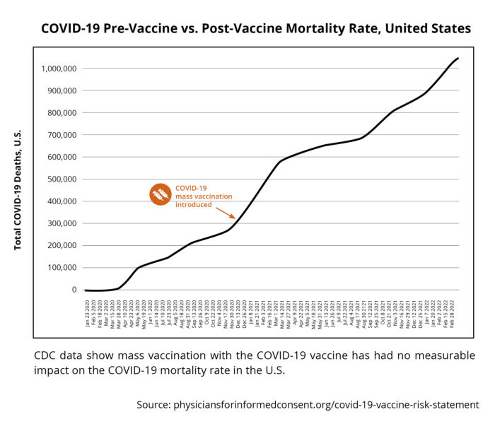
Source: https://physiciansforinformedconsent.org/ and
https://boriquagato.substack.com/p/if-covid-vaccines-stop-covid-deaths

CDC Report into Omicron
https://www.cdc.gov/mmwr/volumes/71/wr/mm7148e1.htm?s_cid=mm7148e1_w
Association Between 3 Doses of mRNA COVID-19 Vaccine and Symptomatic Infection Caused by the SARS-CoV-2 Omicron and Delta Variants
Accorsi et al. 2022. JAMA
https://jamanetwork.com/journals/jama/fullarticle/2788485
The BNT162b2 mRNA vaccine against SARS-CoV-2 reprograms both adaptive and innate immune responses
Föhse et al. 2021
https://www.medrxiv.org/content/10.1101/2021.05.03.21256520v1
Scientific analysis of this paper at https://jessicar.substack.com/p/the-bnt162b2-mrna-vaccine-against

Vaccine effectiveness after 1st and 2nd dose of the BNT162b2 mRNA Covid-19 Vaccine in long-term care facility residents and healthcare workers – a Danish cohort study
Helms et al. 2022
https://www.medrxiv.org/content/10.1101/2021.03.08.21252200v1

Waning of first- and second-dose ChAdOx1 and BNT162b2 COVID-19 vaccinations: a pooled target trial study of 12.9 million individuals in England, Northern Ireland, Scotland and Wales
Kerr et al. 2022
https://academic.oup.com/ije/advance-article/doi/10.1093/ije/dyac199/6770060?login=false

"Repeated vaccine effectiveness analysis continues to show lower for symptomatic Omicron disease compared to Delta. There is evidence of waning of protection against symptomatic disease with increasing time after second dose, and by 10 weeks after the booster dose, with a 15 to 25 per cent reduction in vaccine effectiveness after 10 weeks," the UKHSA wrote in its latest technical brief.
https://www.deccanherald.com/science-and-environment/booster-protection-fades-within-10-weeks-against-omicron-uk-study-1064231.html
An article in the Wall Street Journal in January 2023 cites several published scientific studies showing antibody dependent enhancement is leading to the ineffectiveness of covid19 vaccines -
Are Vaccines Fueling New Covid Variants?
Wall Street Journal, January 1, 2023
https://archive.ph/miwI6#selection-133.5-133.48
‘ “Such rapid and simultaneous emergence of multiple variants with enormous growth advantages is unprecedented”. Under selective evolutionary pressures, the virus appears to have developed mutations that enable it to transmit more easily and escape antibodies elicited by vaccines and prior infection.’

WSJ Latest to Suggest COVID Vaccines May Be Fueling New Variants
https://childrenshealthdefense.org/defender/wall-street-journal-covid-new-variants/
A warning about loss of vaccine effectiveness and antibody dependent enhancement by top scientist Dr. Geert van den Bossche in 2021
https://www.voiceforscienceandsolidarity.org/scientific-blog/c-19-pandemia-quo-vadis-homo-sapiens
Outbreak of SARS-CoV-2 Infections, Including COVID-19 Vaccine Breakthrough Infections, Associated with Large Public Gatherings — Barnstable County, Massachusetts, July 2021
Brown et al. 2021
https://www.cdc.gov/mmwr/volumes/70/wr/pdfs/mm7031e2-H.pdf
Out of 469 cases studied among Massachusetts residents who attended public gatherings, a staggering 346 were among vaccinated individuals, with 74% of them experiencing Covid-19 symptoms and 1.2% being hospitalized.
Transmission of SARS-CoV-2 Delta Variant Among Vaccinated Healthcare Workers, Vietnam
Chau et al. 2021
https://papers.ssrn.com/sol3/papers.cfm?abstract_id=3897733
The study followed 900 hospital staff members in Vietnam who received the Oxford/AstraZeneca vaccine in March and April 2021. Despite all staff members testing negative for Covid-19 in May, the first case among the vaccinated group was detected on June 11th. Upon retesting, 52 additional cases were immediately identified and the hospital was forced into lockdown. Over the following two weeks, an additional 16 cases were discovered. The peak viral loads among the infected, vaccinated group were found to be 251 times higher than those of the unvaccinated staff in March-April 2020.

Effects of Vaccination and Previous Infection on Omicron Infections in Children
Lin et al. 2022. New England Journal of Medicine.
https://www.nejm.org/doi/full/10.1056/NEJMc2209371

Association of Prior BNT162b2 COVID-19 Vaccination With Symptomatic SARS-CoV-2 Infection in Children and Adolescents During Omicron Predominance
Fleming et al. 2022. JAMA
https://jamanetwork.com/journals/jama/fullarticle/2792524

Risk of Infection and Hospitalization Among Vaccinated and Unvaccinated Children and Adolescents in New York After the Emergence of the Omicron Variant
Bauer et al. 2022
https://jamanetwork.com/journals/jama/fullarticle/2792525

Impact of Delta on viral burden and vaccine effectiveness against new SARS-CoV-2 infections in the UK
Pouwels et al. 2021
https://www.medrxiv.org/content/10.1101/2021.08.18.21262237v1
This study from the UK Department of Health & Social Care reveals that Covid-19 vaccines are potentially harmful and ineffective at preventing infection and transmission. 82% of the positive PCR tests in the study were fully vaccinated individuals.

Effects of Previous Infection and Vaccination on Symptomatic Omicron Infections
Altarawneh et al. 2022
https://www.nejm.org/doi/full/10.1056/NEJMoa2203965?query=featured_home

Rates of SARS-CoV-2 transmission and vaccination impact the fate of vaccine-resistant strains
Rella et al. 2021
https://www.nature.com/articles/s41598-021-95025-3
News report: https://childrenshealthdefense.org/defender/vaccinated-people-key-role-evolution-dangerous-covid-variants/

Other scientific data confirms this. The Ministry for Health in Israel found that most of the people infected with covid19 in Summer 2021 were covid vaccinated. The following chart from the Ministry for Health in Israel shows this:
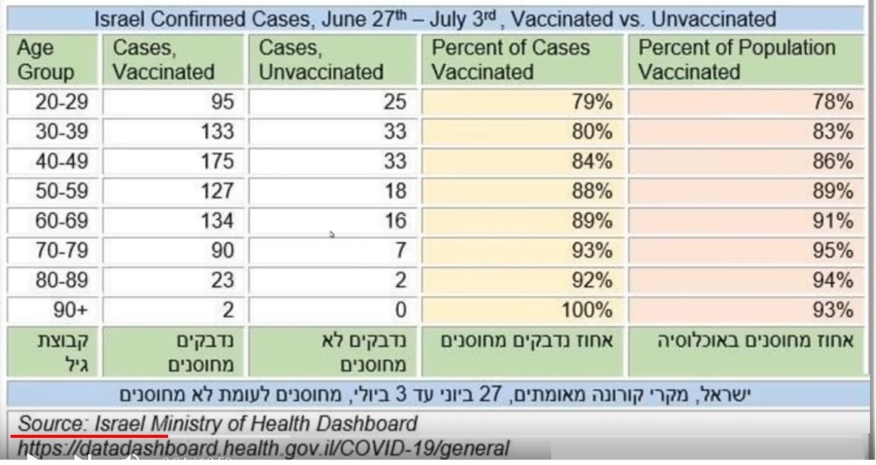
Source: https://datadashboard.health.gov.il/COVID-19/general
Official Government Statistics from Australia
Australia is an excellent case study as it very few covid19 cases until it introduced the covid19 vaccines and boosters. The following chart depicts this fact.
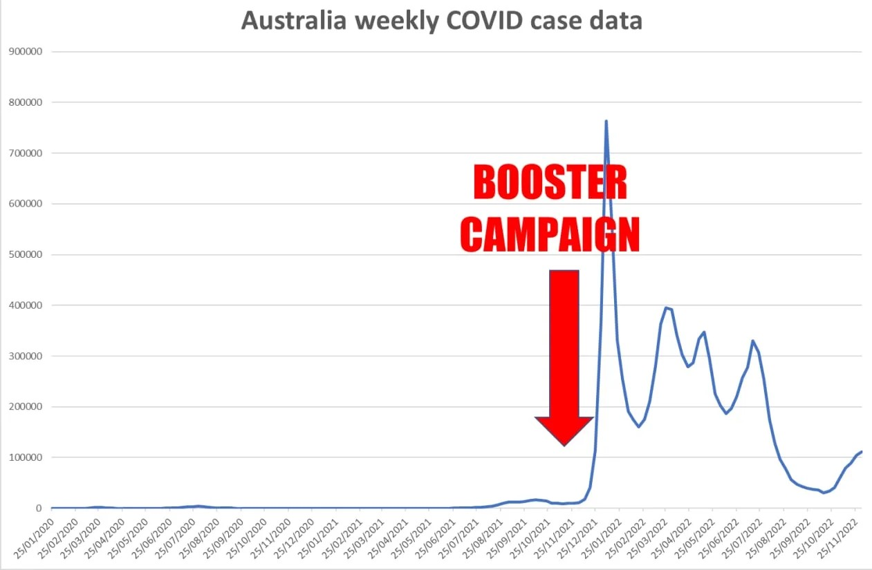

Source: https://www.covid19data.com.au/
Published scientific study which may explain the root causes of this ineffectiveness
A recent scientific study provides another scientific reason for the higher infection rates in covid19 vaccinated people. This is excessive immune tolerance for and reduced immune resistance against covid19 caused by the vaccine. This is dose dependent. Study below:
Class switch towards non-inflammatory, spike-specific IgG4 antibodies after repeated SARS-CoV-2 mRNA vaccination
Irrgang et al. 2022. Science Immunology
https://www.science.org/doi/10.1126/sciimmunol.ade2798
Scientific analysis of this is at
https://dailysceptic.org/2022/12/29/does-vaccination-weaken-our-resistance-to-covid-19-and-if-so-how/
and https://www.rintrah.nl/the-trainwreck-of-all-trainwrecks-billions-of-people-stuck-with-a-broken-immune-response/
and https://palexander.substack.com/p/alarming-irrang-et-al-class-switch
and https://igorchudov.substack.com/p/booster-caused-immune-tolerance-explains

I further say that official statistics released by the German authorities show that the covid19 vaccines were proven ineffective in 2022. The German government and RKI published data in January 2022, amid public concerns about the effectiveness of the COVID-19 vaccine.
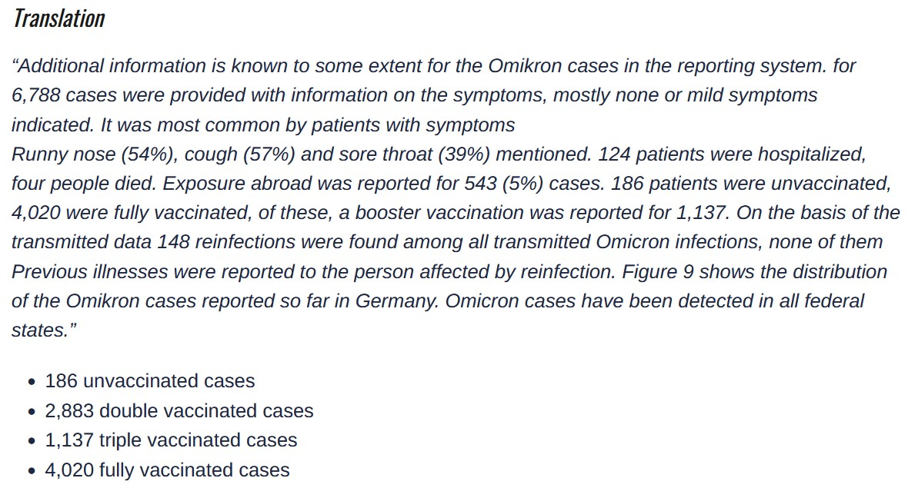
Source: RKI, Germany https://www.rki.de/DE/Content/InfAZ/N/Neuartiges_Coronavirus/Situationsberichte/Wochenbericht/Wochenbericht_2021-12-30.pdf?__blob=publicationFile
In Germany at the time, 70.53% were fully vaccinated, 2.97% were partially vaccinated and 26.5% were unvaccinated. Source: https://ourworldindata.org/covid-vaccinations
So the unvaccinated had 186 cases out of 26.5% of the population. While the fully vaccinated had 4020 cases out of 70.53% of the population. So the vaccinated Omicron case incidence was 57 per 1 per cent of the population (830,000 is 1% of the 83 million German population). While the unvaccinated Omicron case incidence was just 7.02 per 1 per cent of the population.
The vaccinated were (57.0/7.02 =) 8.12 times more likely to be infected with Omicron than the unvaccinated in Germany .
Vaccine effectiveness = immune system effectiveness = (1 - 8.12)/8.12 = -7.12/8.12 = -87.7%. This is minus 87.7%. Therefore, at the beginning of January 2022, fully vaccinated Germans had a 87.7% lower immune response than the unvaccinated had to Omicron. This is negative effectiveness.
An important new scientific study in 2022 corroborates our evidence showing ineffectiveness of the vaccine.
Estimated Effectiveness of COVID-19 Vaccines Against Omicron or Delta Symptomatic Infection and Severe Outcomes
Buchan et al. 2022. JAMA
https://jamanetwork.com/journals/jamanetworkopen/fullarticle/2796615

Waning of vaccine effectiveness against moderate and severe covid-19 among adults in the US from the VISION network: test negative, case-control study
Ferdinands et al. 2022
https://www.bmj.com/content/379/bmj-2022-072141
CDC
A new CDC study at https://www.cdc.gov/mmwr/volumes/71/wr/mm7148e1.htm?s_cid=mm7148e1_w
is based on test results from a nationwide CDC testing program called Increasing Community Access to Testing, which provides free tests to people in portions of the United States. It was published in the CDC’s self-published journal. Researchers analyzed hundreds of thousands of tests and stratified the results by the number of doses received and age. They found that a bivalent after two doses provided 41 percent protection for people aged 18 to 49, 50 percent protection for those 50 to 64, and just 32 percent for people aged 65 or older. The protection was 43 percent, 25 percent, and 19 percent following receipt of a bivalent after three shots. Fourth dose protection estimates were 28 percent for people aged 50 to 64, and 23 percent for people aged 65 or older. The study didn’t analyze effectiveness against severe disease. Protection against severe disease from the old boosters was waning considerably against newer Omicron subvariants, according to an October study, and more so with new variants such xbb. Vaccines and boosters are a losing all effectiveness after 5 months due to vaccine induced mutations, immune priming and antibody dependent enhancement.
A CDC Report about Omicron and variants in September 2022 corroborates this negative effectiveness for the vaccine / booster
https://www.documentcloud.org/documents/22273715-cdc-slides-sept-1
news report: https://www.theepochtimes.com/covid-19-vaccine-effectiveness-plunges-against-omicron-cdc-data_4704255.html
A CDC Report about Omicron and variants in July 2022 corroborates this negative effectiveness for the vaccine / booster
https://www.cdc.gov/mmwr/volumes/71/wr/mm7129e1.htm?s_cid=mm7129e1_w
Statistical Research of official Danish data by Dr. Chris Martenson shows that the covid19 vaccines have been totally ineffective against the Delta and Omicron variants. The vaccines are more likely to cause covid19 infection than prevent it.
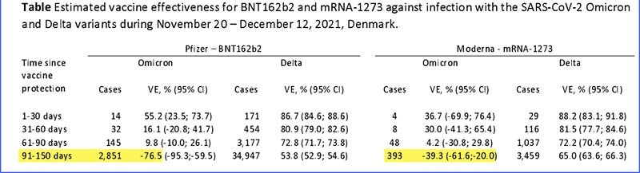
Source: https://twitter.com/chrismartenson/status/1603385981075431426
59. I further say there is more corroborating scientific evidence showing that natural immunity is superior to covid19 vaccine induced immunity.
Severe Acute Respiratory Syndrome Coronavirus 2 (SARS-CoV-2) Naturally Acquired Immunity versus Vaccine-induced Immunity, Reinfections versus Breakthrough Infections: A Retrospective Cohort Study
Gazit et al. 2022
https://academic.oup.com/cid/article/75/1/e545/6563799?login=false
Necessity of COVID-19 vaccination in previously infected individuals
Shrestha et al. 2021
https://www.medrxiv.org/content/10.1101/2021.06.01.21258176v3
59a. I say that the UK is not recommending and administering covid boosters for under 50’s and that this move is borne of the fact that the scientific and medical evidence showing the dangers of the vaccine and boosters for this age group have become apparent to the government and health authorities there. And that the ineffectiveness of these vaccines and boosters is also known to them. This is highly significant.
News report: U.K. Becomes Latest Country to Ban Covid Boosters for Under-50s
https://dailysceptic.org/2023/01/25/u-k-becomes-latest-country-to-ban-covid-boosters-for-under-50s/
Also Denmark’s regulators and government no longer recommend Covid vaccination for under 50 year olds due to the unfavourable risk benefit profile.
60. I say again in this affidavit as in the previous ones that illegal censorship, threats and blackmail was used against medical doctors and scientists and that a gun has been put to the heads of medical doctors by medical councils and professional bodies to keep silent about covid19 vaccine injuries, illnesses, disabilities and deaths, and the ineffectiveness of covid19 vaccines, and ineffectiveness of and harms caused by covid19 lockdowns, and the availability of effective medicines for treating covid19 since May 2020, I present a listing of video interviews with Irish medical doctors online which confirm that this indeed was the case and still is the case - https://www.google.com/search?q=dr+gerry+waters&tbm=vid
Loss of license to practice, loss of income, loss of career, loss of family, los of family home etc. were huge threats to use against medical doctors and scientists. These illegal threats and blackmail shut them down. I also present tweets from Dr. Ahmed Malik who is a Consultant Orthopaedic Surgeon who works from various practices in the UK including hospitals in London and Buckinghamshire to confirm that this is the case there also. He has spoken out publicly that this threat should be removed from medical doctors and they should have the right to speak out about covid19 vaccine injuries, illnesses, disabilities and deaths.
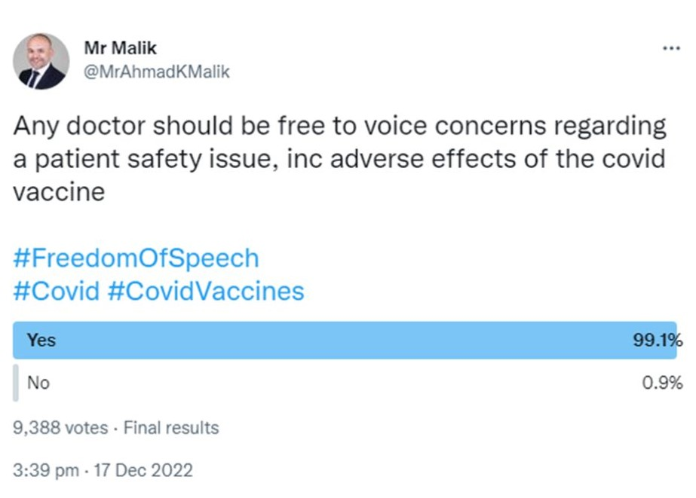
And he posted a video about his concerns about the injuries, illnesses and deaths caused by the covid19 vaccines at https://twitter.com/MrAhmadKMalik/status/1604400405865168897
Three days earlier, Dr. Malik had tweeted: “Young fit people suddenly dying: strokes, heart attacks, unusual clots, cancers, is it all random? Could it be due to the mass experiment that has been carried out on humanity? Even if there is a small possibility, we need to stop and investigate?
Viewable at https://twitter.com/MrAhmadKMalik/status/1603294362586136576 and screenshot below:
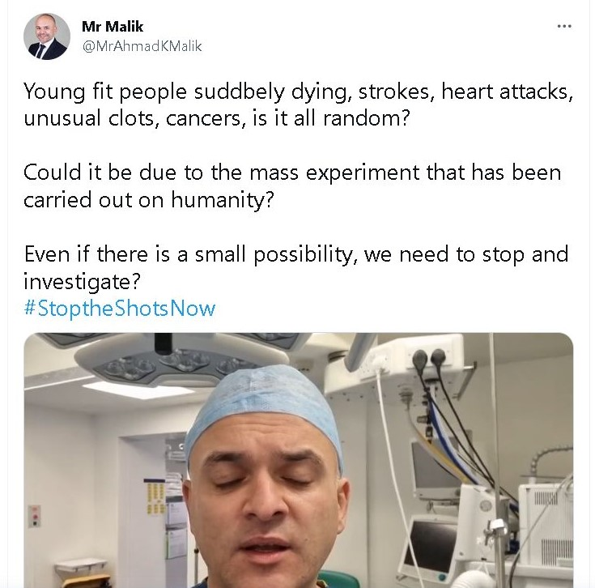
This censoring of medical doctors is corroborated by a top Australian medical doctor Dr. Kerry Phelps who was also an MP in the Australian Parliament. Dr. Kerry Phelps is also a past president of the Australian Medical Association. Dr. Kerry Phelps and her partner were both severely injured by the covid19 vaccines and she is calling for a national investigation into the illnesses and disabilities caused by covid19 vaccines. I cite news article about this below
‘Top Australian Doctor Reveals She is Vaccine Injured and Says Doctors Are Being Censored’
20 December 2022. Daily Sceptic
https://dailysceptic.org/2022/12/20/top-australian-doctor-reveals-she-is-vaccine-injured-and-says-doctors-are-being-censored/
61. I state that while on the subject of illegal censorship, threats and blackmail, it is well known and well established that Illegal and unConstitutional censorship of Twitter took place and that this also occurred on Facebook and social media platforms and the mainstream press and media which is now the subject of an important court case in the USA involving Constitutional rights and Human Rights has had a negative impact on public perceptions about the covid19 vaccines in Ireland and in several countries and completely undermined informed decision making and informed consent for these vaccines.
New evidence has emerged of Illegal and unconstitutional censorship on Twitter. This censorship blocked all criticism of the lockdowns and covid19 vaccines. This subverted and undermined democracy and the Constitution and Constitutional rights in many countries where Twitter is widely used including in Ireland.
https://dailysceptic.org/2022/12/27/latest-twitter-files-reveal-company-suppressed-vaccine-sceptics-even-eminent-doctors/
The Trusted News Initiative mentioned in prior affidavits and our books of evidence was and is an illegal, unConstitutional and unlawful plot to censor the press and media and social media on the Internet in several countries including Ireland. And this illegal activity had the support of some senior officials in the White House in the USA. This is the subject of new federal court proceedings in the USA in 2023.
Court case in the USA about this illegal and unconstitutional censorship which has adversely affected many countries
Court document - https://childrenshealthdefense.org/wp-content/uploads/TNI-Complaint-1.10.22.pdf
News reports - https://childrenshealthdefense.org/defender/lawsuit-trusted-news-initiative-antitrust-first-amendment-censoring-covid-content/
and https://childrenshealthdefense.org/defender/pfizer-scott-gottlieb-censor-twitter-natural-immunity-covid-risk-et/
and https://childrenshealthdefense.org/defender/white-house-covid-censorship-twitter-facebook/
and https://childrenshealthdefense.org/defender/twitter-files-elon-musk-suspend-accounts-journalists/ and https://principia-scientific.com/white-house-pressured-facebook-to-censor-accurate-covid-vax-data/
I remind the High Court of the important words of an Irish-American President, John F. Kennedy in 1963
"No official of my administration, whether his rank is high or low, civilian or military, should interpret my words as an excuse to censor the news, to stifle dissent, to cover up our mistakes or to withhold from the press and the public the facts they deserve to know."
62. I further say that there is more evidence of Conflicts of Interest and Corruption and Regulatory Capture involving Pfizer and that this has had an impact on Ireland and its vaccination policies and on our court case.
In Point 31 in the previous affidavit filed in the High Court, we outlined some of the corruption and massive fines paid by Pfizer in the past. It should be noted by the High Court that Pfizer and its legal teams always denied any wrong doing and corruption in the past and in the present. Pfizer paid $200 million in a 1994 settlement suit and that the company was responsible for the deaths of eleven Nigerian children who took part in an experimental drug test. Pfizer’s legal team any wrong doing in court.
In 1996, Pfizer gave an experimental drug to 200 Nigerian children without informing their parents that an approved cure existed or that their children were subjects of a medical experiment. Eleven children died. Others suffered brain damage, organ failure, or paralysis. Eventually, in 2007, the Nigerian government got involved and sued Pfizer for $7 billion for “carrying out illegal trials” that “killed or disabled children.” In 2002, Pfizer agreed to pay $49 million to settle allegations that the drug company defrauded the federal government and 40 states by charging too much for its cholesterol treatment Lipitor. In 2009, Pfizer paid $750M to settle 35,000 claims that its drug, Rezulin, was responsible for 63 deaths and dozens of liver failures. The FDA did not remove Rezulin from the market until three years after the UK had, despite a mounting death toll.
In 2010, Pfizer was ordered to pay $142 million in damages for violating federal anti-racketeering laws by its fraudulent sale and marketing of Neurontin. The jury found that Pfizer violated the RICO act. In 2010, Pfizer admitted that it paid $20 million to 4,500 doctors and other medical professionals for consulting and speaking on its behalf during the last six months of 2009. The disclosure was required due to a settlement agreement for the illegal promotion of drugs. In 2012, the SEC charged Pfizer with violating the Foreign Corrupt Practices Act for bribing foreign healthcare professionals in Bulgaria, China, Croatia, the Czech Republic, Italy, Kazakhstan, Russia, and Serbia. Pfizer settled for $60 million. In 2012, Pfizer paid $1.2 billion to settle claims by nearly 10,000 women that its drug, Prempro, caused breast cancer. This included punitive damages for the pharmaceutical giant withholding warnings about the risk of breast cancer. In 2012, Pfizer paid $1.2 billion to settle claims by nearly 10,000 women that its drug, Prempro, caused breast cancer. This included punitive damages for the pharmaceutical giant withholding warnings about the risk of breast cancer. In 2013, Pfizer paid $273 million to settle claims by over 2000 people that its drug, Chantix, caused suicidal thoughts and severe psychological disorders. In all of these court cases, the legal teams of Pfizer denied any wrong doing and claimed innocence.
In 2012, Senator Bernie Saunders stated the following to the US Congress – “Virtually every major drug company has either been convicted of fraud or reached a settlement." "Is fraud the business model of the pharmaceutical industry?"
This gives some perspective to the way big pharmaceutical companies and vaccine comapanes do business and how they defend their actions in courts, and gives perspective to the covid19 vaccines scandal worldwide, including in Ireland. The excess deaths, the massive number of injuries, illnesses, disabilities and deaths caused by covid19 vaccines need to be seen from this perspective. The evidence clearly shows that bribery, corruption, deception and manipulation, cover ups, and conflicts of interest and regulatory capture are part of this business model for over three decades. The Regulators ignored the dangers of these medical drugs as they were captured by Big Pharma ; this is known as ‘regulatory capture’.
63. I say that Point 62 above outlines the way Pfizer did business and other big vaccine companies did business and outlines the role of conflicts of interest and regulatory capture and the breaking of laws in today’s world. There are serious Conflicts of Interest and regulatory capture involved in the approval of covid19 vaccines and boosters
In the UK, the MHRA gets 86% of its funding from the Pharmaceutical companies and in the USA the FDA gets 65% of its funding from the Pharmaceutical companies and the European Medicines Agency (EMA) receives over 89% of its funding from Pharmaceutical companies and the Australian TGA gets 96% of its funding from them. The Regulators are funded by Big Pharma. This is a clear conflict of interest. This conflict of interest completely undermines the validity of approvals for vaccines and drugs and has contributed to non regulation, non enforcement and non oversight. The quick approval of the covid19 vaccines without full investigations of their safety and effectiveness and their ingredients by Regulators shows a major defect and failing in the Regulatory processes. The NIAC and HPRA in Ireland followed the orders of the EMA in Europe and let them decide on covid19 vaccinations for Ireland, according to documents received by us in this court case.
The Gates Foundation is the second largest contributor to the World Health Organization and The Gates Foundation has large investments in vaccine companies and Big Pharma. This is a clear conflict of interest. GAVI consists of and represents Big Pharma companies and it is another big contributor to the WHO. This is another conflict of interest. Both The Gates Foundation and GAVI have considerable power and influence over the WHO. These conflicts of interest can determine the polices and actions and direction of the WHO. For example, the WHO declaring pandemics and epidemics acts as a revenue and profit driver for vaccine companies, Big Pharma, GAVI members, and The Gates Foundation. The WHO is not an independent organisation and has several conflicts of interest and it is not accountable and not transparent. The WHO is not credible and should not be relied upon by the defendants in their affidavits and in this court case.
An article recently published in the British Medical Journal (BMJ) outlines this problem. Conflicts of interest are the driving force for approval of many vaccines and drugs and non regulation, non enforcement and non oversight of them, and placing the public in significant danger.

From FDA to MHRA: are drug regulators for hire?
Maryanne Demasi. 2022. BMJ.
https://www.bmj.com/content/377/bmj.o1538
Confirmation of Conflicts of Interest and Non Regulation and No Oversight
In January 2023, a Pfizer executive, Jordon Trishton Walker, revealed to a reporter for the Veritas Project that the Regulators were failing to regulate properly as many of their personnel hoped to get well paid jobs in Big Pharma companies. The safety of the general public was being completely ignored. He also revealed that Pfizer was secretly involved in gain of function studies to develop new covid19 vaccines. Their sole objective was more profit and a complete disregard for the safety of the general public. The High Court needs to take this point into consideration in its judgment and verdict.
Sources:
https://www.youtube.com/watch?v=ywlpArNWKxM and
https://www.projectveritas.com/news/pfizer-executive-mutate-covid-via-directed-evolution-for-company-to-continue/ and
https://rwmalonemd.substack.com/p/project-veritas-has-broken-pfizers?utm_source=substack&utm_medium=email#play
Many FDA, MHRA and EMA executives and senior officers worked in Big Pharma and for vaccine companies in the past, and many executives in Big Pharma and vaccine companies previously worked for the FDA, MHRA and EMA in the past. There is a revolving door between the regulatory bodies and Big Pharma. This has created serious conflicts of interest. For example, the activities of Scott Gottlieb who previously worked in the FDA but now works for Pfizer, who asked the Twitter management and board to remove and censor all criticisms of covid19 vaccines.
Documents released under court order in the USA reveal the FDA Licensed Pfizer Vaccine Without Following Normal Approval Process. A U.S. Food and Drug Administration official authorized the release of a Biologics License Application number for Pfizer’s COVID-19 vaccine while regulators were still deciding whether to approve the license, according to newly released documents.
News report at https://childrenshealthdefense.org/defender/fda-pfizer-covid-vaccine-documents-et/
and https://www.theepochtimes.com/exclusive-newly-obtained-emails-shed-more-light-on-cdcs-false-vaccine-safety-monitoring-statements_4768562.html
Document at https://www.documentcloud.org/documents/23566005-fda-meeting-summary
The FDA admitted in a letter to Pfizer in 2021 that it was unable to carry out safety tests on the Pfizer covid19 vaccine for myocarditis and pericarditis risks and they asked Pfizer to carry out these tests. This shows that the FDA was not able to regulate, not able to do necessary safety checks. I attach excerpts from this letter below. And there is no evidence to show that the EMA in Europe and HPRA in Ireland carried out safety tests on the Pfizer covid19 vaccine for myocarditis and pericarditis risks. Yet these regulatory bodies claimed the vaccines were “safe”.
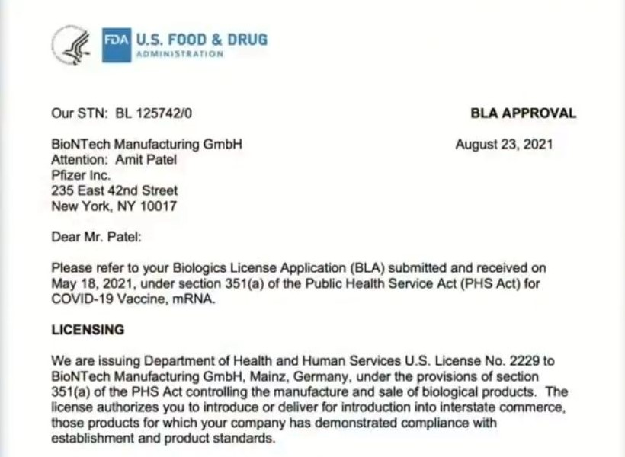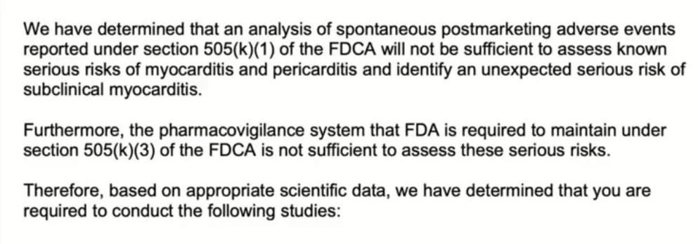
I say that while on the subject of failure to regulate and conflicts of interest which led to regulatory capture, the FDA approved the Moderna bivalent covid booster for millions of people based on antibodies in TEN MICE, who all got sick with Covid19 when challenged with the virus. And now, the FDA advisers are supposedly “angry” that Moderna did not present real-life data showing that bivalent-boosted people are 68% (3.2/1.9) more likely to get covid19. But the vaccinations continue and Moderna and other covid19 vaccine makers continue to profiteer. The EMA in Europe follows the lead of the FDA in the USA.

And the FDA failed to present a very important New England Journal of medicine study to Advisors before Vote to Recommend Bivalent Boosters. This is the subject of news reports in the USA - https://dailyclout.io/the-fda-failed-to-present-nejm-study-to-advisors-before-vote-to-recommend-bivalent-boosters/

CDC ignored Increased Risk of Ischemic Stroke From COVID Bivalent Boosters After Identifying ‘Safety Signal’
The CDC and U.S. Food and Drug Administration analysis of VSD data found:
- There was an increased risk of ischemic stroke in bivalent booster recipients ages 65 and older.
- The risk was present in the Pfizer formulation but not in Moderna’s.
- The signal was raised because of increased stroke risk in the 21 days following inoculation compared to the risk on days 22-42.
- The signal did not change the CDC’s recommendations for either bivalent boosters (Pfizer or Moderna).
Source: https://www.cdc.gov/coronavirus/2019-ncov/vaccines/safety/bivalent-boosters.html
news report: https://childrenshealthdefense.org/defender/cdc-ischemic-stroke-covid-bivalent-boosters-safety-signal/

CDC Knowingly Left Serious Adverse Events Off Post-Vaccination Surveys, Documents Show
The U.S. Centers for Disease Control and Prevention (CDC) didn’t include serious adverse events like heart inflammation on post-vaccination surveys even though the agency knew the issues could be linked to COVID-19 vaccines, documents show.
https://www.theepochtimes.com/health/cdc-left-serious-adverse-events-off-post-vaccination-surveys-despite-knowledge-of-possible-link-documents-show_4988809.html
The CDC and FDA said in operating procedure documents that officials would monitor VAERS to identify “potential new safety concerns for COVID-19 vaccines,” with the CDC performing PRR analysis. The CDC has issued multiple false statements on the data mining, but ultimately acknowledged it did not start performing the monitoring technique until 2022 — more than one year after the Pfizer and Moderna vaccines were authorized. And the FDA has also failed to monitor and publicly report these safety signals to the general public. Both the FDA and CDC have ignored hundreds of vaccine caused illnesses where safety signals were far above the threshold and they failed to communicate this to the general public. This is a major failure and points to no regulation and no regulatory oversight.
Source: https://childrenshealthdefense.org/defender/cdc-safety-signals-pfizer-moderna-covid-vaccines-et/

The Wall Street Journal published an article recently which pointed out these regulatory failures or regulatory capture.
The Deceptive Campaign for Bivalent Covid Boosters
Wall Street Journal. January 22, 2023
https://www.wsj.com/articles/the-deceptive-campaign-for-bivalent-covid-boosters-cdc-fda-biden-vaccines-moderna-pfizer-wuhan-imprinting-11674400955
Other news outlets reported on this - https://www.zerohedge.com/political/wsj-shreds-vaccine-makers-biden-admin-over-deceptive-booster-campaign
Dr. Aseem Malhotra, one of the top Cardiologists in Britain gave a brilliant interview with Tucker Carlson on Fox News on American television. He described the role of conflicts of interest in the approval and distribution and injecting of covid19 vaccines and boosters and the dangers of these vaccines and boosters.
The failures of Regulators and the failed Regulation system are also explained. Link at
https://www.youtube.com/watch?app=desktop&v=w3MPnBpfrRk
These are good examples of regulatory capture and conflicts of interest, the FDA and CDC in the USA and the EMA in Europe and the NIAC and HPRA have completely ignored safety signals for these covid19 vaccines and their policy is to ignore them and not to inform the general public. And continue to put the public at significant risk of serious injuries, illnesses, disabilities and premature deaths. And to ignore the deprivation of informed consent. There is no accountability and no transparency in these Regulatory bodies. There are NO independent bodies and scientists and lawyers, independently funded to independently assess , evaluate, monitor and make accurate and honest public statements about the safety and effectiveness and ingredients of vaccines and medical drugs and legally approve them. This deficiency needs to be rectified by governments, laws, Constitutions, international treaties, and courts.
This failure to inform the general public while they repeated the mantra that the vaccines were “safe and effective” amounts to fraud. This fraud completely undermined informed consent in the USA and also in Europe and Ireland. It is another count of fraud for our court case, and is included in our pleading of Fraud.
64. I further say that conflicts of interest are playing a major role in vaccine approvals by governments, regulators and health authorities and their refusal to look at safety signals and take effective actions to safeguard the public. In Britain, the new Prime Minister Rishi Sunak was a co-founder of Theleme Partners, an investment firm in 2009. This firm has been a major investor in Moderna since it was set up in 2011 with just 10 employees. When Rishi Sunak was Chancellor of the Exchequer he approved a UK government covid19 vaccine deal worth many billions of pounds for Moderna. This profited both Moderna and Theleme Partners which Rishi Sunak co-founded and had financial interests in. He did not declare conflicts of interest. And in December 2022, while Rishi Sunak was prime Minister, a partnership deal was formed between Moderna and the UK government to build a new factory to produce Moderna vaccines and products. This deal was worth tens of millions of pounds. This will profit Moderna and Theleme Partners. And again, Rishi Sunak did not declare conflicts of interest. This is important in light of facts being revealed in investigations in the USA, especially in the US Senate and Congress, around the origins of the covid19 virus and the people, organisations and companies involved in dangerous gain of function studies. This is presented in Point 74 below.
64a. I further say that the conflicts of interest pointed out above and in this affidavit and prior affidavits also have a negative bearing on this High Court case in the sense that the expert witnesses for the defendants have conflicts of interest. David Walsh is an employee of the HSE and is thus conflicted in opposing the protective courts order. Mr David Walsh is not a medic, a scientist or health care professional so if we were to adopt the technocratic approach we would say that his affidavit carries no weight. Lucy Jessop is Director of the National Immunisation Office and is conflicted. Louise Kendrick is deputy CMO and is conflicted. Others are also conflicted. Their conflicts of interest create a strong bias and an inability to be impartial, independent and fully truthful.
Their alleged “expert” opinions or reliance on such opinions, and their affidavits, exhibits and policies all rely on the Pfizer covid19 vaccine trial of 2020 which had many defects and major errors and proved itself to be a fraud. This was outlined in the previous affidavit filed with the High Court in December 2022 and is one of the grounds for Fraud which we are pleading in this court case. Expert witnesses who rely on a fraud or “expert” opinions based on a fraud are totally discredited. Their affidavits, their exhibits, their official policies and opinions which rely on and proceed from this fraud are totally discredited and cannot be admissible in any court. I will ask the High Court judge and High Court to implement this in the interests of justice, due process, fair trials, truth, integrity and honor in this court case. I cite again the court precedent set by Judge Lord Denning regarding fraud in Lazarus Estates Ltd v Beasley [1956] where the learned judge stated fraud unravels everything and makes it null and void.
In truth and reality, any experts or other voices who raised opposition to the covid19 vaccine campaign were silenced, censored, blackmailed and publicly cancelled e.g. Dr Gerry Waters and several other medical doctors around Ireland countless scientists worldwide such as Nobel Laureate Prof Montagnier and the inventor of the PCR test Dr Kary Mullis, eminent epidemiologists and immunologists such as Dr Geert Van Den Bosch, Prof John Ioannidis, Dr Peter McCullough, and one of the original inventors of mRNA as a vaccination technology, Dr Robert Malone. Coercion and censorship of expert witnesses such as medical doctors, scientists, professors, pathologists, and medical professionals creates a false science, a fake science, a corrupted science, and scientists and doctors who are “bought and paid for” and corrupted, an insidious corruption fuelled by conflicts of interest. The High Court must not indulge this corruption of science in this court case.
Dr Jessop as a medical practitioner and member of the NIO and NIAC must be familiar with the principle of informed consent, the precautionary principle, and the Hippocratic oath to do no harm ? in light of the facts and evidence presented in this affidavit and previous affidavits and the books of evidence, which show clear breaches of these medical and scientific principles, does she still adhere to these medical and scientific principles or not ?
Dr Jessop is qualified in public health and clinical medicine it’s extraordinary that she could have such confidence in vaccines that are still today in Phase 3 clinical trials. Even more so that these clinical trials are bizarre in that they’ve had the control groups removed. Even more so again that the trials have been reported in the BMJ as having been fraudulently run. Even more so again that the vaccines employ highly novel, never before approved, first in kind mRNA vaccine technology and also that they are the first human vaccines approved against a respiratory coronavirus for human use. The confidence of a doctor in the total absence of any medium to long term safety data is bizarre, especially so as she claims to be a proponent of evidence based medicine. This is blind hope and speculation and not based on any evidence. The fallout from rushed vaccines, that is, from the 2009 swine ‘flu vaccine Pandemrix, will also be well known to her in her various professional roles. She will be well aware of the litigation ongoing today for many lives ruined by life altering and highly debilitating adverse effects, namely narcolepsy and cataplexy for vaccines and drugs which the health authorities claimed were “safe and effective”.
Dr. Jessop’s claim that expert groups and guidance has resulted in the bizarre decisions to definitively recommend experimental vaccines as ‘safe and effective’ in the absence of supporting data. Many experts with opposing views to this narrative have been silenced through censorship of the media nationally and globally. The big lies of safe and effective from the HPRA, HSE, DOH, government, politicians and main stream and state media are not the truth, no matter how many times they are repeated or by how many technocratic so called “experts”. A vaccine by pre- covid-19 pandemic definition was supposed to prevent infection by pathogens they target. It doesn’t take a doctor or public health expert to realise a massive vaccine failure when a massive increase in covid19 infections is reported after over 90% of adults were injected.
In further reply to Dr. Jessup, prudent nonclinical development and Phase 1 and 2 studies traditionally take many years to complete. Many vital studies were skipped, for example studies to rule out integration of mRNA into DNA, genotoxicity studies, reproductive toxicity studies and tumorgenicity studies. Given her extensive qualifications, public health experience and medical degrees she has no excuse for calling these vaccines safe and effective without a firm evidence base. She is in effect gambling with the lives of men women and children by recommending their use. There is no defence. Being truthful about these facts is a minimum starting point for obtaining informed consent.

It undermines the credibility of Dr. Jessop that she got ‘basic science’ so wrong in her affidavit. The mRNA in the vaccines has indeed been shown to integrate into human DNA. Normally such studies involving gene therapies are conducted long before a single person is dosed. In this case the studies were carried out by researchers unrelated to the manufacturers and regulators after billions of people worldwide had been injected. Integration of this mRNA into DNA can result in constant production of a pathogenic spike protein in a persons body. This spike protein is thrombogenic, oncogenic, immunosuppressive and clearly associated with deaths. I cite one such study below:
Intracellular Reverse Transcription of Pfizer BioNTech COVID-19 mRNA Vaccine BNT162b2 In Vitro in Human Liver Cell Line
Aldén et al. 2022
https://pubmed.ncbi.nlm.nih.gov/35723296/
This study is from February 2022, and her lack of knowledge about this is appalling.
The Defendents’ experts have failed to keep up with the scientific, statistical and autopsy data from around the world showing the high number of injuries, illnesses, disabilities and deaths caused by the covid vaccines and boosters. They cite old outdated studies which are not relevant in light of new knowledge and data. They state that vaccination of children will ‘protect those around them’. This is untrue, was not based on evidence and a lie, and we have exposed this in our previous affidavits and books of evidence. Highly suspect clinical trial data showed a miniscule reduction in absolute risk after a very short time period. Real world data supports an increase in transmission and infections. Recent studies from the Cleveland clinic actually point to a higher risk of infection that increases with the number of vaccinations. I refer the defendants’ experts to Point 58 of this affidavit.
In response to the defendents’ experts constant allegation of vaccine effectiveness, the following was sent by a Pharmacist based in Tipperary to Minister for Health Donnelly in January 2022.
“Covid-19 fatalities in Ireland and so far this season there are 50% more deaths associated with the virus compared to last year’s season,
8/9/2020 – 12/1/2021 620 Covid-19 deaths without vaccination, and
8/9/2021 – 12/1/2022 has 923 Covid-19 deaths with 94% of the adult population ‘fully vaccinated’ (Our World in Data).
This is highly suggestive of a negative effectiveness in preventing Covid-19 deaths. The infection rate is at an all-time high and the vaccines should be immediately withdrawn based on the same criteria as were used for the emergency use authorisation (prevention of symptomatic infection). Again, this factual data can easily be verified by the HPRA or anyone else, the full data set is downloadable here: https://ourworldindata.org/covid-deaths”

Dr. Jessup states that “several lines of clinical evidence conform that ADE is not an issue”, what is this evidence? The real world evidence presented is very damning and supports that ADE has happened ad is happening. Look at the Irish data for infections of covid vaccinated people and hospitalizations and deaths of vaccinated people in 2021 and 2022 and similar evidence worldwide cited in Point 58 in this affidavit and in previous affidavits and in the books of evidence. In fact the evidence shows that fully vaccinated people have had several re-infections with covid19 variants. If the Pfizer clinical trials were not unblinded the data would show us much more information about ADE. Observe the constant mutations of the sars-cov2 virus as it mutates to avoid the vaccines and boosters through newer variants. And this is causing the vaccines and boosters to become totally ineffective after 5 months. This was correctly predicted by Dr. Geert van den Bossche and Dr. Mike Yeadon in 2020. The evidence for ADE is all around us, but those people who refuse to look for it or are paid not to find it will never find it !.
The defendants’ experts state “The vaccines we are offering child have gone through all the usual steps needed to develop and approve a safe and effective vaccine”. These steps include a few years of preclinical development, genotoxicity, reproductive toxicity studies, and years of randomised controlled trials. This statement is a complete lie and a deception of parents of children. I refer them to Exhibit 2 which shows that the vaccines were known to be unsafe, in Pfizer FDA documents Table 7 shows 42,000 suspected adverse events and over 1223 deaths within 90 days. No other medicine in history would have been approved with this, and any approved medicine would be withdrawn.

The defendants’ experts state ‘the vaccine is the single most effective way to reduce deaths’. Where is the evidence, there is none available from randomised controlled trials. Real world evidence shows higher covid19 deaths post mass vaccination in Ireland when comparing 2022 / 2021 vs. 2020. No vaccines in 2020 and 94% adult uptake in later part of 2021.And the big rise in excess mortality which has accompanied mass covid19 vaccinations completely discredits the statement above from the defendants’ experts.
The defendants and their experts claim that the covid19 vaccines and boosters can help people with Multisystem Inflammatory Syndrome, but the facts and evidence prove the opposite as evidenced in these published scientific studies below:
https://www.ncbi.nlm.nih.gov/pmc/articles/PMC8781649/
https://pubmed.ncbi.nlm.nih.gov/34852213/
https://www.ncbi.nlm.nih.gov/pmc/articles/PMC8843319/
https://pubmed.ncbi.nlm.nih.gov/34326117/
https://pubmed.ncbi.nlm.nih.gov/35320702/
https://pubmed.ncbi.nlm.nih.gov/35275051/
https://pubmed.ncbi.nlm.nih.gov/35747051/
https://pubmed.ncbi.nlm.nih.gov/35248401/
https://pubmed.ncbi.nlm.nih.gov/34326117/
https://pubmed.ncbi.nlm.nih.gov/35719439/
https://pubmed.ncbi.nlm.nih.gov/34978781
https://pubmed.ncbi.nlm.nih.gov/34955518/
https://pubmed.ncbi.nlm.nih.gov/35062704/
The scientific evidence worldwide shows that the spike proteins cause or worsen inflammation in the human body.
The defendants’ experts criticized our cited scientific studies for being pre-print. Most of these scientific studies have now passed peer review and are peer reviewed published scientific studies. I ask the defendants’ experts how many covid19 vaccine or booster trials have they been involved in or supervised ? have they undertaken randomized controlled scientific studies to establish the safety and effectiveness of the covid vaccines and boosters ? they claim the vaccines and boosters are “safe and effective”, have they personally been involved in scientifically proving that ?

While on the subject of vaccine safety, we would like to inform Dr. Jessup and Dr. Louise Hendrick and the other experts that we now have peer reviewed studies showing the vaccine induced antibodies (against the S spike protein) are associated with heart damage and immune cell infiltration into cardiac tissue damage. The autopsies were carried out in deceased persons who died unexpectedly soon after vaccination. The same inflamed tissues were devoid of antibodies that would be present following natural infection with SARS-CoV-2 such as N nucleocapsid antibodies. This is highly suggestive of vaccination causing these deaths and the campaign should be halted pending full investigation. The Precautionary Principle should be applied. Is Dr. Jessup and Dr. Hendrick familiar with the Precautionary Principle ?
Dr. Jessup and Dr. Hendrick and other experts hired by the Defendants stated that correlation does not mean causation in their affidavits to us. I have dealt comprehensively with that issue in Point 33 of this affidavit. The evidence for Causation is strong and well founded and conforms to the Bradford Hill criteria.

In reply to Dr. Hendrick, both the HPRA and EMA have a duty of care to the Irish people to ensure that vaccines are safe and effective and that all the ingredients are identified and known to be safe, and also a duty to monitor the vaccines for safety and suspend or stop them if they are found to be unsafe. Indeed the HPRA has the legal power to test these vaccines themselves for this, but refused to do so. The HPRA and EMA cited by the Defendants’ experts in their affidavits have refused to carry out detailed analysis of the vaccines and boosters to identify all of the ingredients despite warnings given to them about graphene and other dangerous items being in the vaccines and boosters. They have fobbed off concerned members of the public. This is gross negligence by the HPRA and EMA a dereliction of their statutory obligations to ensure the safety of medicinal products on the Irish market, irrespective if they have conditional or full EMA authorisations. This discredits the statements of HPRA and EMA in relation to vaccine safety and discredits the defendants and their experts who rely on them.
Dr. Hendrick mentions counting of covid deaths as PCR positive in 28 days prior to death. Why are the same criteria not applied to the covid vaccines and boosters ? We have much evidence to suspect the vaccines and boosters ? can she provide any reasons for this ? are they political or scientific ?
Dr. Hendrick stated that covid19 is referred to as ‘an exceptional risk to human life and public health’. We have higher excess mortality today with no apparent plausible explanation except for the vaccines and boosters and there are no emergencies, no lockdowns and no investigations. This is curious as our agencies such as the HSE, CMO, NPHET and Department of Health appeared to be very concerned about saving lives during covid19 pandemic? Why is no attempt being made to safeguard human life now?
Dr. Jessup, Dr. Hendrick and other experts hired by the Defendants expressed a strong belief in NIAC and fully supported them in relation to covid vaccines and boosters and this is evident in their affidavits to us. NIAC vaccine advice for children and parents assumes that the covid vaccines reduce transmission. This was false and known to be false by manufacturers, regulators and from volumes of peer reviewed literature and simple observation of population level data at the time NIAC made their recommendation to allow covid vaccination of children. It was also admitted to be false by a Pfizer executive testifying in the EU Parliament in 2022. On this basis, NIAC strongly recommended the vaccination of children living with immunocompromised adults or with younger children with complex medical needs. What is the justification for this if the vaccines do not prevent transmission? Has NIAC been reduced down to a marketing firm for the covid19 vaccine companies which ignores important scientific evidence and facts ? This totally discredits the state bodies and the defendants and their experts who relied on NIAC and its advice and recommendations. The whole government covid19 vaccination policies were based on NIAC’s recommendations and these were cited in the affidavits and exhibits sent to us.
The published scientific studies provided by the Defendants contain studies with conflicts of interest either by the authors or those who funded the studies. In the past, the Tobacco industry funded many scientific studies and experts to try and prove that smoking was harmless, safe, healthy and good for a person.

A pharmacist based in Tipperary summed up the failings and shortcomings of the HPRA, NIAC, the EMA, the CMO and NPHET, and the Minister for Health and Department of Health in respect of these covid19 vaccines and boosters, and I put this to the defendants and their experts:
‘These vaccines are highly suspect, they are indeed killing people, they need to be properly and immediately investigated on foot of these concerns. I have serious concerns about the origin, traceability, specifications, quality controls and authenticity of the products being administered to Irish people. No other medicinal product can be tolerated to have such wildly differing batch-to-batch variability in their adverse events profile.’

The defendants and their experts in this court case in their affidavits claimed that covid19 was a ‘national public health emergency’ and that this justified their position, yet they do not mention that the massive rise in excess mortality in late 2021 and into 2022 and into 2023 in Ireland and many other countries is also a ‘national public health emergency’. More people have died from mid 2021 onwards than died in the covid19 pandemic. This high number of excess deaths are a ‘national public health emergency’. In fact, the defendants and their experts are completely ignoring this. None of them have mentioned it and none will mention it out of fear of repercussions from their political masters. This excess mortality and the accompanying massive rise in illnesses and disabilities from the adverse effects of the vaccines and boosters which have led to over-crowded hospitals which experienced their worst crisis ever have mostly resulted from the actions of the Defendants and their political masters. This is one of the key factors in this court case.
The only rational and logical explanation for the bizarre views of these expert witnesses and affidavits and so called “experts” around Ireland and their actions which have caused harms to many people is that provided by the Milgram experiment where people unquestioningly follow orders given to them by those in perceived authority, even if the people carrying out those orders know what they are doing is wrong, or at least ought to know it’s wrong. This was the administration of potentially fatal electric shocks in the Milgram experiment. Their deference to authority, their blind obedience and their total submission to authority is clouding their judgment and scientific reasoning here. Science needs to be free all of this in order to be objective, truthful and accurate.

I apply the same replies to the affidavits and exhibits of other experts provided by the Defendants in this court case. I will reply further in due course to the very large number of affidavits and exhibits and reports I received from the defendants. This will take additional time, as we do not have the vast resources and personnel of the state to do this.
The choice here in this court case is between Order and Chaos. The courts have a duty to uphold Order. In this case, we have the chaos of corruption, conflicts of interest, censorship and coercion, cover ups, lies, deception, obfuscations, frauds, willful ignorance, mass fear and paranoia fuelled by the press and media, vast enrichment of a few people at massive public expense including increased deaths, the vaccine injuries, illnesses, disabilities and premature deaths creating chaos for many families and communities, the excess mortality, and the over-crowded hospitals in crisis and unable to cope.
65. I say that in Florida, in the USA a medical doctor, Dr. Eduardo Balbona saved a covid19 vaccinated young adult (21 years old) from early death caused by the covid19 vaccine and in the video below he reveals the science behind the damage caused by covid19 vaccines. The mother of the child Heather Hudson also testified about the effects of the covid19 vaccine on her child. The video is at https://rumble.com/v217nny-the-advocate-the-mother-and-the-doctor-raise-concerns-regarding-the-mrna-sh.html
This has great relevance to the Irish people and nation especially those damaged by these vaccines and to the issue of informed consent for these vaccines. And great relevance to the so called “experts” in Ireland who presume to know it all, while denying obvious truths, facts and evidence.
66. I further say that the FDA in the USA in their virtual meeting of September 17th 2021 where the issue of covid19 boosters was discussed, Mr. Steve Kirsch stated the following to the FDA and members present at the meeting
"we were falsely mislead by (Pfizer) about the safety of the vaccine…Heart attacks are 71 times higher than other vaccines…the vaccines are killing two people for every one life saved”
Mr. Steve Kirsch and other statisticians have statistical and scientific evidence to back up this claim.
This is viewable online at https://www.youtube.com/watch?v=WFph7-6t34M&t=15600s
This is Exhibit 44 for the court
67. I further state that many British medical doctors have formed a new organization named
‘Doctors for Patients UK’
to protect patients and call for a halt to the covid19 vaccinations as they present a risk and danger to patients. Their web site is at https://doctorsforpatientsuk.com/
and these medical doctors have put a video presentation online at https://vimeo.com/783103991
The facts presented by these medical professionals in Britain have great relevance to the Irish people and nation and for this court case.
68. I say that Dr. Paul Offit, a medical doctor and a Professor in the USA, and a leading member of the FDA’s vaccine advisory committee and one of the top vaccine experts in the world, has written in the New England Journal of Medicine, the world’s top medical journal, calling for an end to the mass vaccination of anyone at low risk from the virus. Children are at very low risk from the virus and this risk has become lower due to the Omicron variants.
https://www.nejm.org/doi/full/10.1056/NEJMp2215780
News report at
https://dailysceptic.org/2023/01/13/fda-vaccine-committee-member-calls-for-end-to-mass-covid-vaccination/
70. I say that an Open Letter to the Prime Minister of New Zealand, Jacinta Arden, detailing the scientific facts and evidence about covid19 vaccines and calling for an end to covid19 vaccinations and government investigations of crimes and frauds in relation to covid19 vaccines and the origins of the sars-cov2 virus . It was written by Dr. Carlton Brown BVSc, MBA and is viewable online at www.data-analytica.org/Letter.pdf
It should be noted that Jacinta Arden resigned as Prime Minister of New Zealand suddenly and in disgrace in January 2023. This is relevant. The facts presented by this medical professional in his letter have great relevance to the Irish people and nation and for this High Court case.
71. I further say that I wish to add further to Point 23 on page 70 of the previous affidavit filed in December 2022, regarding the issue of deprivation of Informed Consent. Voluntary informed consent was NOT and could NOT be obtained in the face of unConstitutional governmental coercion via medical apartheid laws and vaccine passports and the removal of fundamental, constitutional human rights such as the right to bodily autonomy, the freedom to choose to refuse medical treatments and the freedom to travel and socialise without submitting to dangerous medical experimentation.
And the HSE, NIAC, HPRA and Department of Health giving false assurances of vaccine / booster safety in the total absence of any medium to long term safety data was a fraud which led to the obtaining of informed consent by fraud and deception. Information was purposely being withheld from these Healthcare Personnel (HCPs), information which was known to regulators, including the HPRA and EMA, the vaccine manufacturers and the HSE. The released Pfizer documents include important safety data concerning the experimental vaccines that was reported to the manufacturers by our own HPRA, inclusive of suspected deaths and failed pregnancies.

I have created a proposal for an Informed Consent National Program which would be Effective in Ireland in exhibit 68a.
72. I say that in compliance with the rules of Disclosure, I have included a List of our Expert Witnesses for this court case, including medical doctors, scientists, medical professionals, professors, pathologists, embalmers and others. Some have completed their sworn affidavits and others need more time to do so.
73. I say that to corroborate evidence of illegal non disclosure and allegations of fraud in contracts between Pfizer and governments including the EU Commission, the Israeli Ministry of Health stated before the Jerusalem District Court in Israel that it was unable to locate the agreement signed with Pfizer regarding the sharing of epidemiological information on covid19 vaccines. He also said that he did not know if the agreement had even been signed.
Source: https://www.i24news.tv/fr/actu/coronavirus/1671136463-israel-le-ministere-de-la-sante-incapable-de-retrouver-l-accord-signe-avec-pfizer
and https://www.kan.org.il/Item/?itemId=140464
In 2020, Israel struck a deal with Pfizer, promising to share vast troves of medical data with Pfizer in exchange for the continued flow of its “hard-to-get vaccine.” The agreement document was made public in January 2021 with large parts of it redacted. The MoH claimed last week (December 2022) that this agreement could not be found.
This is eerily similar to the saga relating to Pfizer’s contract with the European Union and many hundreds of pages of the contract blacked out or redacted and Ursula von der Leyen’s claim of not being able to find texts she exchanged with Pfizer’s CEO Albert Bourla to secure “vaccines.” Is “losing” documents and blacking out or redacting documents going to become a global phenomenon? Is this their last defence in courts, this being to destroy the evidence?
Source: https://expose-news.com/2022/10/13/biggest-corruption-scandal-in-the-history-of-the-world/
This illegal non disclosure of highly relevant information to the general public has completely undermined informed consent in Ireland and several other countries. It corroborates our previous sworn affidavits and books of evidence that full and valid informed consent has not been given and is not being given for these vaccines.
74. Finally, I say that in the interests of public safety in Ireland and other countries, and informing the general public about continuing threats to public health, the big question to be answered is - has the sars-cov2 virus been engineered through gain of function studies in laboratories and does it qualify as a Bioweapon ? are the covid19 vaccines and boosters which use the spike protein which was believed to be engineered through gain of function studies, and caused mass deaths, illnesses and disabilities worldwide qualify as a Bioweapon also ? this is the subject of US Senate and Congress investigations and parliamentary investigations worldwide and the subject of police, military and security investigations worldwide and the subject of ongoing scientific research worldwide. So far, the scientific evidence cited below and throughout this affidavit and in previous affidavits and in our books of evidence suggest that both the virus and the vaccine and boosters may qualify as Bioweapons. It is important to get to the root causes and truth of the matter as the same could occur again and again causing major losses for Ireland and other countries, and indeed this has been predicted by some powerful individuals.
They come within the definition of a Bioweapon according to scientific and legal definitions internationally and have the characteristics of Bioweapons. These may have been developed either intentionally or
un-intentionally, and the virus may have leaked from a laboratory or was deliberately released, and this has led to the loss of many lives and to serious illnesses and disabilities for many people in Ireland and worldwide and to large scale financial losses for people, businesses, organizations, and governments worldwide, and that this has criminal liability and civil liability, the latter which is being addressed in this High Court case. And that these alleged Bioweapons have had serious consequences for the Irish people and nation. And that great efforts have been made to cover this up and conceal important information from the general public including parents and guardians, and deprive people of the Disclosure necessary for full and valid informed consent. Evidence is coming to light of the same parties being involved in the creation of the virus and the development of the vaccines and that profit motives and greed may have played a part in this. It is now a National Security matter in Ireland and other countries in addition to being a High Court matter and criminal court matter.
The evidence suggests Bioweapons and this requires more thorough investigations by police, prosecutor, parliamentary, and military authorities as this threat remains, and there is talk in the press and media of future pandemics very similar to this one. And it could occur again and again causing major losses for Ireland and other countries. How many Bioweapon Pandemics are being planned for the future or could occur or will occur through laboratory leaks ? According to Mr. Bill Gates in his public statements more such pandemics are on the way, how does he know this and what exactly is meant by this ? Bill Gates held the Event 201 conference in the USA in October 2019 which simulated a coronavirus pandemic and government reactions to it worldwide 2 months before sars-cov2 or covid19 was discovered in China and 5 months before the covid19 pandemic was declared worldwide. He seems to have unusual prediction abilities or prophecy abilities. He has recently carried out a Catastrophic Contagion conference in Belgium in 2022 and this pandemic is predicted to occur in 2025. This will lead to large scale deaths worldwide. Bill Gates and his foundation is the biggest funder of the World Health Organisation (WHO) and he has a high degree of influence and power over it. This is important and relevant here as the WHO has the power to declare pandemics. Bill Gates and his foundation have massive investments in vaccine companies and Big Pharma, and indeed pandemics are highly profitable for them.
Who are the people, bodies, and institutions involved in the creation of the covid19 pandemic and these future pandemics ? what role will gain of function studies on viruses and other pathogens and other forms of experimentation on them play in these future pandemics ? are human beings unwitting and unwilling and un-informed guinea pigs or test subjects for this ? Are the lives of judges of the High Court and Supreme Court and other courts in Ireland, and lives of barristers, lawyers, legal personnel and their families and members of the general public in Ireland to be put at more risk from this ?
Bill Gates in his public statements online and offline and at conferences has promoted Global Depopulation. He wants to see a large and drastic reduction in the world population. Depopulation on a large scale would involve many people dying off. He claims to be working for this Depopulation objective. Is this desire of his related in any way to the invention of the sars-cov2 virus and gain of function studies in a laboratory, the covid19 pandemic and covid19 vaccine pandemic which led to a big rise in excess mortality in many countries. And is it related to the covid19 vaccines and the excess mortality witnessed after mass covid19 vaccinations worldwide ? And is it related in any way to the upcoming new pandemics which he predicted ? do these future pandemics serve an economic purpose, a political purpose, a global depopulation purpose ? Do the other people referenced in this affidavit who know Bill Gates and have worked with him including Tony Fauci, Francis Collins, Peter Daszak, Dr. Ralph Baric, the executives in the WHO, GAVI and CEPI and the UN, the leaders of the WEF, the top executives and biggest investors in Pfizer, Moderna, Johnson and Johnson and Astrazeneca share his views and objective ?
The High Court and Supreme Court and the circuit criminal court in Ireland have stated in the past that nobody is above the law including high status people, which includes those people who may have played a role in this coivd19 criminality mentioned in this affidavit and in previous affidavits and books of evidence. The Irish Constitution also upholds the principle of all persons being equal before the law.

Surely the safest way to avoid or deal with future pandemics is to identify the causal factors and who profits from them and who wants them. Gain of function studies to make pathogens more infectious and deadly should be banned worldwide and proper international monitoring put in place. Better security standards should be rigorously enforced in all level 3 or above laboratories and proper international monitoring put in place. And those people and organizations with profit motives to create or instigate new pandemics should be stopped from doing so. And cheap and out of patent medicines such as Ivermectin and many others with strong anti viral properties or anti pathogen properties should be re-purposed and designated to treat people during such pandemics instead of blocking, banning and censoring them. Scientists and medical doctors who identify new ways to stop and eliminate infections during a pandemic should be encouraged and allowed to treat patients, and not be stopped, blocked, banned, threatened and censored as happened in 2020 and 2021. And their scientific and medical innovations should be shared worldwide instead of being censored.
The Evidence
I say that the sars-cov2 infection also known as the ‘covid19 infection’ which is related to and has been accompanied by covid19 vaccines, and indeed these vaccines are derived from the spike protein of this virus, are all the subject of international investigations, including criminal investigations and cases and military investigations, court cases, and government and parliamentary investigations. And this has implications for Irish national security and for this High Court case. There has been further corroboration of scientific findings in our books of evidence regarding the origins of the covid19 virus. Scientists have found the origins of the sars-cov2 virus which causes covid19. The scientific evidence shows the virus has several important modifications to the furin cleavage site in it’s spike protein which do not occur naturally in nature - the furin cleavage site containing two CGG codons does not exist in ANY virus in nature. They could only have been engineered in a laboratory through gain of function research. These modifications to the virus were man made, deliberate and were full funded. Gain of function studies for this particular coronavirus had been taking place prior to 2020 in China, Canada, and in the USA. And the NIH in the USA and other governmental bodies funded this. Gain of function studies were directed at helping this virus infect humans and cause disease in humans and kill humans. This is a legal fact and a scientific fact. This dangerous research was banned briefly in the USA in 2014 but continued through subcontracting out to China and was lifted in the USA a few years later.
This gain of function capability has made development of an effective and safe covid19 vaccine extremely difficult, impossible and dangerous as the spike protein has homology with certain organs and cells inside the human body making autoimmune reactions and abnormal clotting more likely and common and the spike protein is a toxin and harmful to the human body and this same spike protein mutates at a very rapid rate to evade vaccines and immune systems. The combination of gain of function for this virus with its natural ability to mutate rapidly has made this virus more infectious and more difficult to control and eliminate. The scientific, medical and statistical evidence worldwide now shows that the covid19 vaccines are unsafe and ineffective. And they were rushed without proper safety tests and studies. The motivation here was vast profits, the accumulation of vast wealth and greed. This vaccine in it’s serious adverse effects including deaths and serious illnesses and disabilities qualifies it as a Bioweapon and the courts are obliged to view it as such. And the sars-cov2 virus insofar as it’s gain of function capability to infect humans and cause disease and death applies qualifies it as a Bioweapon and that the courts are obliged to view it as such. Thus there are two Bioweapons here in this court case – the sars-cov2 virus and the covid19 vaccine.

The spike protein produced by the vaccine and the gain of function capability of this virus are Bioweapons and are subject to criminal investigations and liabilities in Ireland and other countries. This is a matter for the Irish police and military to address, and to fully investigate and prosecute as well as for this High Court to address fully. In this case, courts have a duty of care to the Irish people and nation as defined in the Irish Constitution of 1937, and national laws and European Union laws and international treaties. The courts and Dail Eireann do not have the legal right to cover this up, or dismiss this or ignore it.
This new evidence corroborates other evidence about this in previous affidavits and our books of evidence. The US Congress and US authorities and individual State governments are investigating both the vaccine and the virus and its gain of function capabilities enabling it to infect humans and harm them and the motives for this. There are strong indications of criminal motives here driven by massive profits and wealth accumulation from so called “treatments” or “vaccines”.
In January 2023, in the US Congress, U.S. Rep. Jim Jordan (R-Ohio) Tuesday in which he used his time to outline seven facts that Dr. Anthony Fauci knew, and, more importantly, what Fauci did, and did not do, when he was made aware of these facts. This does not bode well for Fauci and those involved in the cover-up.
- Fauci understood that American tax dollars went to EcoHealth Alliance and that money was then funneled to the Wuhan Institute of Virology (WIV) lab in China.
- Fauci knew EcoHealth Alliance was given an exemption from the pause on gain-of-function research.
- Fauci knew that the security standards at the WIV lab in China were deficient.
- Fauci knew that EcoHealth Alliance was not in compliance with its grant reporting requirements and wasn’t adhering to the contract.
- Fauci knew that gain-of-function research was in fact being conducted in
the WIV lab in China.
- Fauci knew that the standard P3CO interagency review process wasn’t followed in approving the grant to EcoHealth Alliance.
- Fauci knew that the virus likely came from the lab where U.S. taxpayer dollars were sent … the very city where that lab is at, a deadly virus breaks out that would ultimately kill six million people around the world.
American news report about this at
https://childrenshealthdefense.org/defender/anthony-fauci-hid-covid-pandemic-facts/
and https://www.youtube.com/watch?v=VlC4PA_nQc0
It should be noted that Tony Fauci and the NIH had financial interests in Moderna and it’s covid19 vaccine and boosters. And the gain of function research for this virus involved Fauci, the NIH, Peter Daszak, Dr. Ralph Baric, Moderna and the Wuhan laboratory. The covid19 pandemic and vaccines has proven very profitable for them all. These conflicts of interest have been ignored by the press and media and by regulatory authorities and governments.
A Published scientific study in 2021 raised very important points about the origins of the sars-cov2 virus
The Evidence which Suggests that This Is No Naturally Evolved Virus
A Reconstructed Historical Aetiology of the SARS-CoV-2 Spike
Birger Sørensen, Angus Dalgleish& Andres Susrud
https://www.minervanett.no/files/2020/07/13/TheEvidenceNoNaturalEvol.pdf
Later one of the authors Dr. Angus Dalgleish wrote the following:
“I began to be highly alarmed that it was the vaccines causing these symptoms and that just as we had written ……. a genetically engineered virus had serious implications for vaccine design.”
“This paper, which was suppressed and therefore did not appear in print for many months, reported that the sequence of the virus was completely consistent with having been genetically engineered, with a furin cleavage site and six inserts at places that would make the virus very infectious, and the reason this had such tremendous implications for vaccine design was that 80% of these sequences had homology to human epitopes.”
“In particular, we had noticed a homology with platelet factor 4 and myelin.”
“The former is also certainly associated with what is known as VITT (low platelets and clotting issues) and the latter associated with all the neurological problems, such as transverse myelitis, both of which are now recognized as side effects of the vaccine even by the MHRA [Medicines and Healthcare Products Regulatory Agency in the U.K.].”
Source:
https://www.conservativewoman.co.uk/other-cancer-specialists-agree-with-me-about-vaccine-harm-but-the-authorities-still-wont-listen/
Scientific analysis of the facts and published scientific studies by Dr. Alex Washburne
https://alexwasburne.substack.com/p/the-totality-of-the-circumstances
and by Frisdtrom at https://www.minervanett.no/angus-dalgleish-birger-sorensen-coronavirus/the-evidence-which-suggests-that-this-is-no-naturally-evolved-virus/362529
Scientific news report
https://www.conservativewoman.co.uk/time-to-come-clean-about-covids-lab-origins/
Dr Alina Chan an MIT scientist in the USA published an important book about the origins of covid19 in 2021 which provides strong scientific evidence for a leak from a laboratory in Wuhan in China where coronaviruses were undergoing gain of function studies to enable them to infect humans.
The title of the book is Viral: The Search for the Origin of COVID-19 and it can be bought online and in bookstores.
Amazons stocks it at https://www.amazon.com/Viral-Search-COVID-19-Matt-Ridley/dp/006313912X
The Telegraph newspaper published an article about this on December 27th 2022 titled ‘The whistleblower who could blow open the Covid lab leak theory in 2023’ viewable at https://www.telegraph.co.uk/news/2022/12/27/whistleblower-who-could-blow-open-covid-lab-leak-theory-2023/
In 2021, Dr Alina Chan warned MP’s in the British Parliament there is a risk that Covid-19 is an engineered virus and could be classed as a ‘bioweapon’.
This was reported in the Telegraph newspaper on 15 december 29021 and is at https://www.telegraph.co.uk/news/2021/12/15/wuhan-lab-leak-now-likely-origin-covid-mps-told/

US Military Documents About Gain of Function Contradict Fauci Testimony Under Oath
Project Veritas, 2022
https://www.projectveritas.com/video/military-documents-about-gain-of-function-contradict-fauci-testimony-under/

Mr. Peter Daszak who was involved in these gain of function studies for coronaviruses including the sars virus boasted on television and live video about his work in this area. Fox news and other news channels reported on this in the USA. See link below:
https://www.youtube.com/watch?v=IdYDL_RK--w and
https://banned.video/watch?id=609af3cbb493572075b0c04a
Tony Fauci of the NIH collaborated in this scientific research with Mr. Peter Daszak.
News reports at https://yandex.com/search/?text=Peter+Daszak+gain+of+function
and https://www.google.com/search?q=Peter+Daszak+gain+of+function
and https://peterdaszak.com/
and the role of Dr. Ralph Baric in this was pivotal
https://yandex.com/search/?text=dr+ralph+baric+gain+of+function
The collaboration between Peter Daszak, Tony Fauci, Dr. Ralph Baric, Moderna, Doctor Shi Zhengli and officials at the Wuhan Institute of Virology in China, the WHO and it’s big funders and the big Foundations is the key factor in all of this, in the development of sars-cov2 and the pandemic and in what followed such as the government measures taken, and the development of experimental vaccines for it and the artificial demand created for them through lockdowns, mandates and mass fear and paranoia. And the massive profits accumulated by some of these aforementioned parties. The evidence in this affidavit and in the public domain shows that Peter Daszak and Tony Fauci were involved in efforts to block all scientific reports and studies which found that sars-cov2 was created in a laboratory and leaked out of it. Peter Daszak and Tony Fauci were behind a scientific study in 2020 which sought to hide or block all evidence of a laboratory leak. And Mr. Peter Daszak also got himself onto an international team to inspect the Wuhan lab in China in 2020/21 which allegedly found nothing. Later Mr. Peter Daszak was removed from this team due to conflicts of interest.
Government and state emails released under the Freedom of Information law in Britain show that top government scientists and independent scientists and researchers lied about the origins of the sars-cov2 virus and lied about gain of function studies carried out on it. And important information was deliberately concealed from the general public. News report below.
‘UK experts helped shut down Covid lab leak theory - weeks after being told it might be true’
The Telegraph newspaper, Britain,
November 23, 2022
https://www.telegraph.co.uk/news/2022/11/23/uk-experts-helped-shut-covid-lab-leak-theory-weeks-told-might/
‘The institute had also applied for funding to manipulate viruses by inserting a furin cleavage site (FCS) which is what makes Covid-19 so infectious in humans.’
Another Telegraph article about this on the 24th November 2022
https://www.telegraph.co.uk/news/2022/11/24/failure-investigate-origins-virus-not-no-10-parties-real-covid/
Another Telegraph article about this on 24th November 2022
‘Top virologists betrayed science with their Covid lab leak cover-up’
https://www.telegraph.co.uk/news/2022/11/24/top-virologists-betrayed-science-covid-lab-leak-cover-up/
A scientific presentation provided by Dr. John Campbell in Britain
https://www.youtube.com/watch?v=FckD6qL76uA
US Office of Inspector General report in January 2023 is highly critical of the NIH and its funding of EcoHealths’ gain of function studies for viruses in Wuhan in China
News report: https://www.dailymail.co.uk/health/article-11676679/Covid-lab-leak-fears-Federal-report-says-NIH-failed-tabs-Wuhan-lab.html
False and misleading papers published in the Lancet and in Nature Medicine in March 2021 led to cover up of scientific evidence showing the sars-cov2 emerged from a lab and there was some scientific evidence of gain of function research in relation to this virus
‘Statement in support of the scientists, public health professionals, and medical professionals of China combatting COVID-19’
Calisher et al. March 2021
https://www.thelancet.com/journals/lancet/article/PIIS0140-6736(20)30418-9/fulltext

The proximal origin of SARS-CoV-2
Andersen et al. March 2021
https://www.nature.com/articles/s41591-020-0820-9
A US Senate report on the origins and emergence of SARS-CoV-2 that resulted in the COVID-19 pandemic was most likely the result of a research-related incident in a lab
https://www.help.senate.gov/imo/media/doc/report_an_analysis_of_the_origins_of_covid-19_102722.pdf
and Asia Times at
https://asiatimes.com/2022/10/new-evidence-firmly-revives-wuhan-lab-origin-theory/
‘In March 2018, Shi partnered with Baric and a longtime collaborator, Peter Daszak, on a $14 million grant proposal to genetically manipulate bat coronaviruses to see how they might cause pandemics. The proposal called for possibly enhancing the viruses with something called a furin cleavage site to boost their entry into human cells.’
US Senate and Congress Investigations into this matter
News reports
https://www.google.com/search?q=%22fauci%22%2B%22gain+of+function%22
and https://yandex.com/search/?text=%22fauci%22%2B%22gain+of+function%22
Chain of events which led to the development of the sars-cov2 virus and its ability to infect humans
https://expose-news.com/2022/11/25/fauci-gates-created-covid-biolab/
New Scientific evidence shows that the sars-cov2 emerged from a lab and human engineering
Endonuclease fingerprint indicates a synthetic origin of SARS-CoV-2
Bruttel at al. October 2022
https://www.researchgate.net/publication/364599030_Endonuclease_fingerprint_indicates_a_synthetic_origin_of_SARS-CoV-2
Important Timeline of Events
In 2018, US Patent 7279327 for the chimeric adaption of the naturally occurring animal SARS Coronavirus to become infectious to humans targeting lung epithelial cells is transferred from University of North Carolina to he US National Institute for Health (NIH) – who funded it in the first place. Thus began the gain of function studies to create sars-cov2 or covid19. Later the NIH developed a close working relationship with Moderna and helped them develop patents.
https://patents.google.com/patent/US7279327B2/en
In Summer 2019, deletion of Wuhan Institute of Virology Corona Virus data bank. And in December 2019, Wuhan Municipal Health Commission report discussing COVID-19 pneumonia is deleted.
Moderna had all 7 patents applied for by June 12, 2019, which is quite impressive given that the WHO was only informed of a pneumonia type outbreak in Wuhan on December 31, 2019. So all the patents needed to protect Moderna’s particular covid19 vaccine monopoly were applied for 6 months before the outbreak of the covid19 disease that the vaccine is supposed to be curing.
In November 2019, University of North Carolina, Moderna and NIH began the sequencing of the 1273 amino acid spike protein vaccine (from the Wuhan Hu1 template) a month before the outbreak officially occurred. (From the interview between Dr David Martin and Reiner Fullmich)
https://by-julietbonnay.com/2021/08/we-made-sars-patent-office-evidence-video/
American news report about this and other matters: https://100percentfedup.com/bombshell-glenn-beck-reveals-nih-and-moderna-worked-on-mrna-vaxx-together-before-pandemic/
In 2020 and 2021 Moderna allowed Pfizer and other vaccine makers to use its patents to develop covid19 vaccines. But in 2022 Moderan is suing Pfizer for breach of patent rights and laws in relation to covid vaccines.
Source: https://rwmalonemd.substack.com/p/moderna-sues-biontechpfizer
Scientific Evidence suggesting Moderna may have created the sars-cov2 virus through gain of function work in a lab. Moderna has co-ownership of the covid19 vaccine patent with the NIH run by Tony Fauci.
https://expose-news.com/2022/03/17/exhaustive-proof-moderna-made-covid-19/
Dr. David Martin, a scientist and investigator based in the USA, has found and provided scientific evidence about the origins of the sars-cov2 virus and accompanying gain of function research and covid19 vaccine dangers for use in the American courts and is taking court cases himself. The evidence is very incriminating for the parties mentioned in this affidavit. This evidence corroborates our evidence and our affidavits and books of evidence. This is available at https://www.davidmartin.world/
and https://yandex.com/video/preview/1943959163475263168
and https://yandex.com/search/?text=dr.+david+martin+covid
Confirmation of Conflicts of Interest and Gain of Function Studies
In January 2023, a Pfizer executive, Jordon Trishton Walker, revealed to a reporter for the Veritas Project that the Regulators were failing to regulate properly as many of their personnel hoped to get well paid jobs in Big Pharma companies. The safety of the general public was being completely ignored. He also revealed that Pfizer was secretly involved in gain of function studies to develop new covid19 vaccines. Their sole objective was more profit and a complete disregard for the safety of the general public. The High Court needs to take this point into consideration in its judgment and verdict.
Sources:
https://www.youtube.com/watch?v=ywlpArNWKxM and
https://www.projectveritas.com/news/pfizer-executive-mutate-covid-via-directed-evolution-for-company-to-continue/ and
https://rwmalonemd.substack.com/p/project-veritas-has-broken-pfizers?utm_source=substack&utm_medium=email#play
News reports involving evidence about gain of function studies, NIH funding, and a lab leak in Wuhan
https://dailysceptic.org/2023/01/10/u-s-government-identified-as-original-source-of-lab-leak-theory-whats-really-going-on/
and https://dailysceptic.org/2022/12/21/how-suspicious-is-it-that-u-s-intelligence-spotted-the-coronavirus-in-wuhan-weeks-before-china-did/
and https://dailysceptic.org/2023/01/01/how-the-u-s-accidentally-proved-it-could-not-have-spotted-the-virus-in-china-in-november-2019/
and https://unglossed.substack.com/p/lab-leak-op-confirmed
The Center for Health Security in Johns Hopkins University in the USA which was involved in hosting Event 201 in 2019 mentioned above also published a prediction in 2017 called the ‘The SPARS Pandemic’ which predicted a coronavirus pandemic very similar to the covid19 pandemic and outcomes very similar to it. These very accurate predictions and the Event 201 itself warrant closer investigation by police, prosecutor and military authorities.
https://www.centerforhealthsecurity.org/our-work/Center-projects/completed-projects/spars-pandemic-scenario.html
and
In September 2019, the WHO published a report instructing all nations to prepare for a pandemic. This can be downloaded at https://www.gpmb.org/annual-reports/annual-report-2019
These very accurate predictions warrant closer investigation by police, prosecutor and military authorities.
and
In October 2019, at a conference hosted by the Milken Institute in the USA, upcoming pandemics emerging in China, government policies and the use of new mRNA vaccines were discussed by Dr. Tony Fauci head of the NIH and others. They proved to be very unusually accurate in their predictions.
https://covidcalltohumanity.org/2021/10/06/2019-video-shows-fauci-top-us-health-experts-plan-universal-flu-vaccination-flu-vaccination-of-6-month-old-babies/
These very accurate predictions warrant closer investigation by police, prosecutor and military authorities.
and
Dr. Lawrence Sellin, who contributed much to this effort to uncover the truth about COVID19, reported that a December 12, 2019 agreement was signed by Dr. Ralph Baric that he would receive the “mRNA coronavirus vaccine candidates developed and jointly-owned by NIAID and Moderna” This was 4 months before the pandemic was publicly declared but Moderna had prior knowledge of a pandemic and were expecting a massive demand for covid19 vaccines.
‘On DECEMBER 12, 2019 an agreement was signed (pg 105) that Dr. Ralph Baric of the University of North Carolina would receive “mRNA corona virus vaccine candidates developed and jointly-owned by NIAID and Moderna”@Rossana38510044 @ydeigin @BillyBosticksonhttps://t.co/taAbB9FIvp
— Dr. Lawrence Sellin (@LawrenceSellin) February 27, 2021’
These very accurate predictions and foreknowledge and actions ahead of time warrant closer investigation by police, prosecutor and military authorities.
Gain of function studies to create more infectious and deadlier viruses and pathogens continuing according to US government report in 2023
https://www.dailymail.co.uk/health/article-11659097/Legal-loopholes-vague-guidance-allowing-dangerous-gain-function-research-continue.html
Involvement of the US Department of Defence with Covid19 vaccine makers and US government covid19 vaccine policies which point to fears of a Bioweapons threat
Contracts: https://www.keionline.org/covid-contracts
News reports: https://www.bitchute.com/video/8ftbShzrkjl9/ and
https://bailiwicknews.substack.com/p/covid-19-injectable-bioweapons-as
and https://bailiwicknews.substack.com/archive?sort=new

Wuhan lab leak theory ‘accepted as likely behind closed doors at No 10’
The Telegraph, Britain 22 February 2022
https://www.telegraph.co.uk/news/2022/02/22/wuhan-lab-leak-believed-behind-closed-doors-likeliest-origin/
British news report
https://dailysceptic.org/2022/11/25/new-fauci-emails-reveal-lab-leak-cover-up-happening-in-real-time/

The scientific studies and reports and scientific news items in our books of evidence provide more details of the origins of the sars-cov2 virus and the people and institutions involved. These can be downloaded on
www.data-analytica.org/evidence.htm and are on a dvd which is Exhibit 68 for the High Court.
I will reply in due course to the very large number of affidavits and exhibits and reports I received from the defendants. This will take additional time, as we do not have the vast resources and personnel of the state to do this.

I ask that the High court judge here consider the facts of this case, the scientific, medical and statistical facts, the large amount of evidence we have in our books of evidence, the previous sworn affidavits, the legal facts, the court precedents set in Ireland and other similar jurisdictions, the national laws and international laws, the Constitutional articles, the proof of Causality, and the Precautionary Principle and National Security all of which apply here in this legal case to support our claim and that the judge judges in our favour and grants the injunction and any other remedies and reliefs the High Court judge deems appropriate in the circumstances.

Sworn before me by the said David Egan ______________________________________________
on the day of 2022
In the city / county of
Before me a Commisioner for Oaths / Practising Solicitor and the deponent

is personally known to me / is identified to me by
who is personally known to me / whose identity has been established by reference to a relevant document
containing document ID number:
and containing a photograph
___________________________________________________
Commissioner for Oaths / Practising Solicitor

Filed this by Solicitors name
On behalf of the Plaintiff as appropriate

